**EXPERIMENT NO.1**

**AIM** :- Installation of R and R Studio

**Theory:-**

To Install R:

1. Open an internet browser and go to www.r-project.org.

2. Click the "download R" link in the middle of the page under "Getting Started."

3. Select a CRAN location (a mirror site) and click the corresponding link.

4. Click on the "Download R for Windows" link at the top of the page.

5. Click on the "install R for the first time" link at the top of the page.

6. Click "Download R for Windows" and save the executable file somewhere on your computer. Run the .exe file and follow the installation instructions.

7. Now that R is installed, you need to download and install RStudio.

**OUTPUT :-**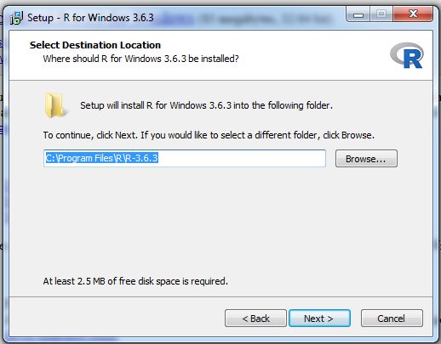

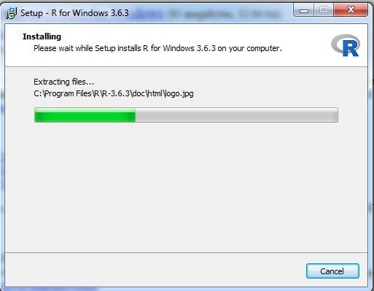

**To Install RStudio:-**

1. Go to [www.rstudio.com](http://www.rstudio.com/) and click on the "Download RStudio" button.

2. Click on "Download RStudio Desktop."

3. Click on the version recommended for your system, or the latest Windows version, and save the executable file. Run the .exe file and follow the installation instructions.

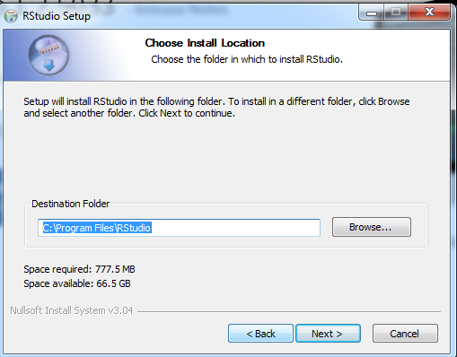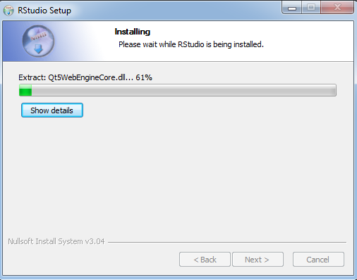

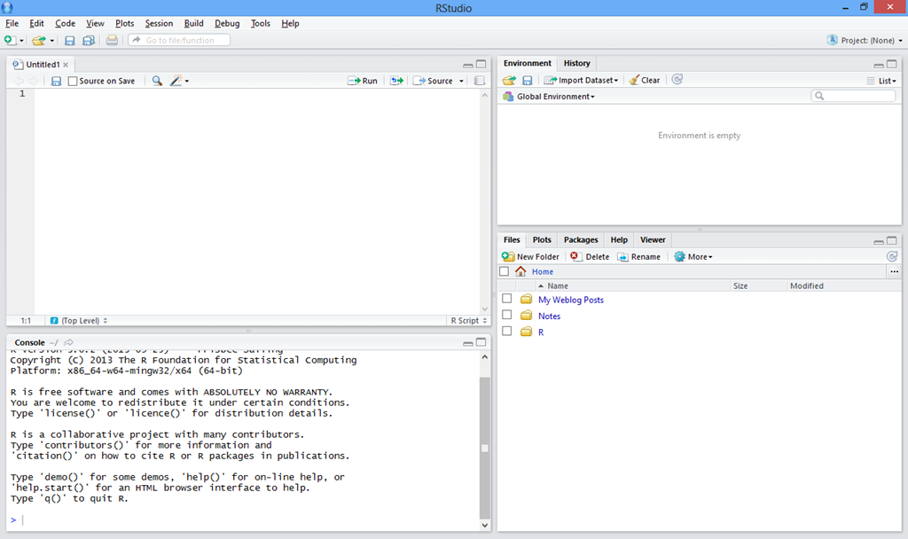

**EXPERIMENT NO. 2**

**AIM :-** Basic functionality of R Variables, Basic arithmetics, help command.

**Theory :-**

Basic R Commands:

Comments—

If you want to insert a comment (i.e., non-executable commands) anywhere in a

“program”, you need to preface the line of code with a # sign. Everything in the

line after the # sign will be considered a comment. Only starting a new line will

break the comment “mode”. This means that, if you have a multi-line comment to

make, you must have a # sign on every line.

==================================

Basic Arithmetic with R—

Below is a script called arithmetic.R . Start R, minimize R-Commander, then go

to FILE NEW SCRIPT, opening up a blank script window. Copy the lines below

into the script window.

**CODE :-**

# BASIC ARITHMETIC OPERATORS

2-5 # subtraction

6/3 # division

3+2*5 # note order of operations exists

(3+2)*5 # if you need, force operations using

# redundant parentheses

4^3 # raise to a power is ^

exp(4) # e^4 = 54.598 (give or take)

log(2.742) # natural log of 2.74

log10(1000) # common log of 1000

pi # 3.14159...

Now click once in the R-Console window, then right click and CLEAR WINDOW,

then click once back in the script window. Now click on EDIT RUN ALL. You

should get the below screen on R-Console (the output window).

**Variables—**

You can name variables, vectors, matrices, functions, and subroutines. You are

not restricted by the names you use, as long as they are not reserved for existing

functions (like the function sum()) in the R package you are using. Remember

that R is case sensitive, so the variable x is different from the variable X. Copy

the below into a new script window and RUN ALL in the R-Console window.

# VARIABLE NAMES

x <- 5

x # 1 way to print out contents of a variable

var1 <- 7/2

print(var1) # another way to print contents

valid.variable.name <- 18.6

# you can even have long variable names

# if you are of that kind of weirdness

valid.variable.name

Graphing—

Run the script below, noting that a new window opens up, the graphics window,

shown below.

# INTRO TO GRAPHING

# input a vector x with data

x <- c(2,4,4,6,6,5,5,7,3,7,3,8,9,7,9,6,4,3,4,4,6,2,2,1,2,4,6,6,8)

# input vector y of consecutive numbers

# 1 through 29

y <- c(1:29)

# make a histogram of x

hist(x)

# make a scatter plot of y vs x

plot(x,y)

# make a time plot of x, connecting dots

plot(x, type="b")

# make a histogram of a sampling of 20 from

# the binomial distribution B(12,.4)

y <- rbinom(20, 12, .4)

hist(y)

# make another binomial histogram, but using

a

# sample of 200

y <- rbinom(200, 12, .4)

hist(y)

# make a boxplot of x data

boxplot(x)

# make side by side boxplots of x and y data

boxplot(x,y)

**The Help Command—**

There are many ways to invoke the help menu commands. One way is to click

on the window on the top right side of the R-Console window.

Another way is to use the question mark after the red prompt > in the R-Console

window. For example, if you know the syntax of the command you are looking

for (like mean), you would type

>? mean

and the help information will show up on screen.

Another way is to use the help command. For example, to again find information

on the command mean you would type after the R-Console prompt

>help(“mean”)

If you don’t quite know what the official name of the command you are looking

for, you can still get R to assist you in searching for the command. For example,

if I wanted to find out the command for standard deviation in R, but don’t know

what it is (it is sd by the way), I could type the following in R-Console

>help.search(“standard deviation”)

And you will get a window with some possibilities which may be what you are

trying to find. R uses “fuzzy logic” to give you these possibilities, since you

cannot tell R the exact command you need.

**OUTPUT :-**

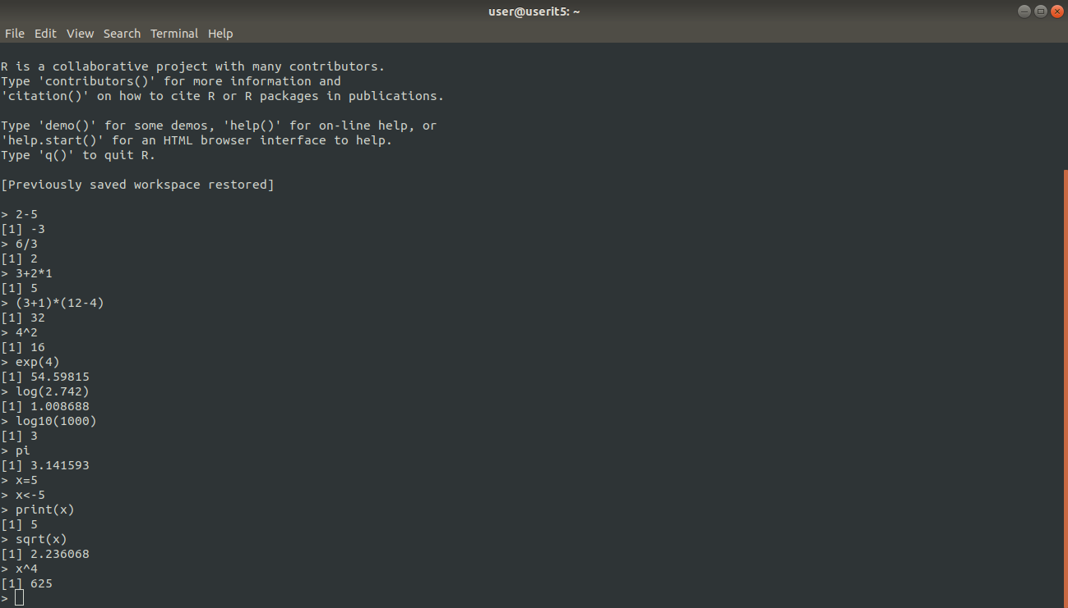

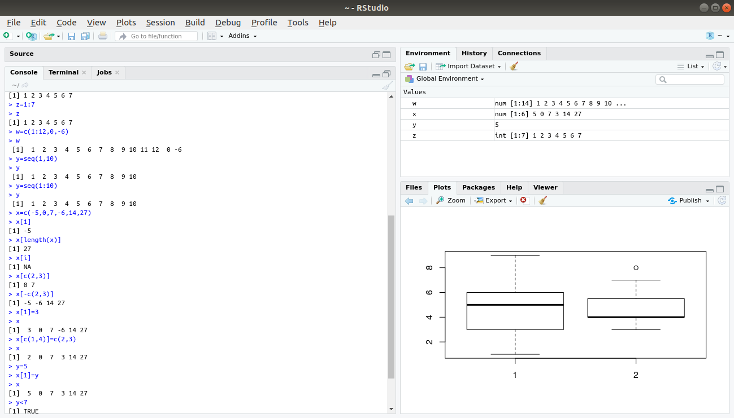

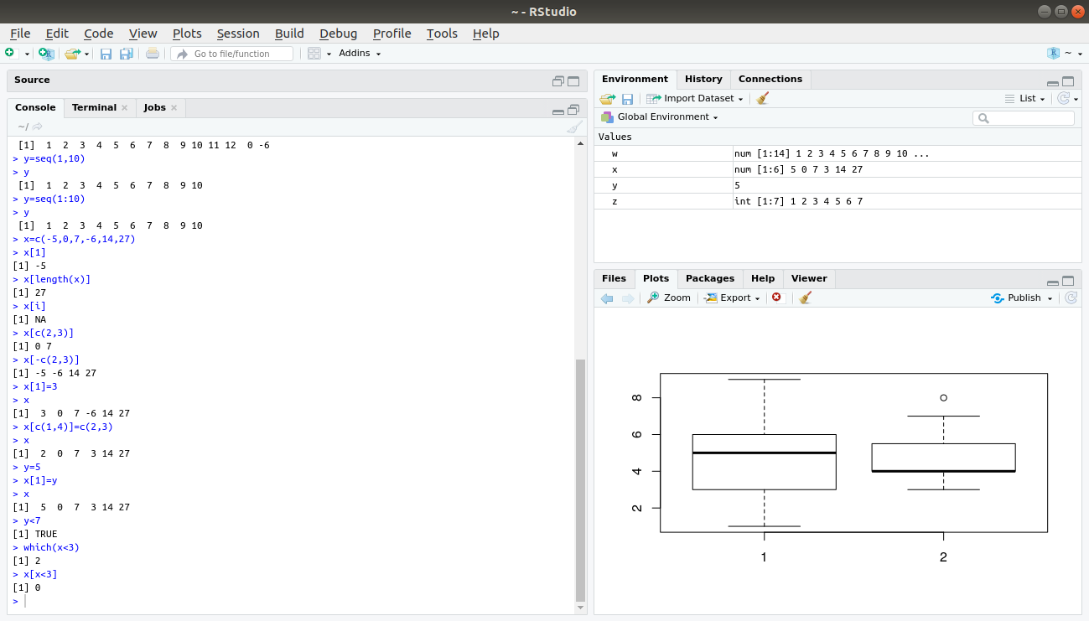

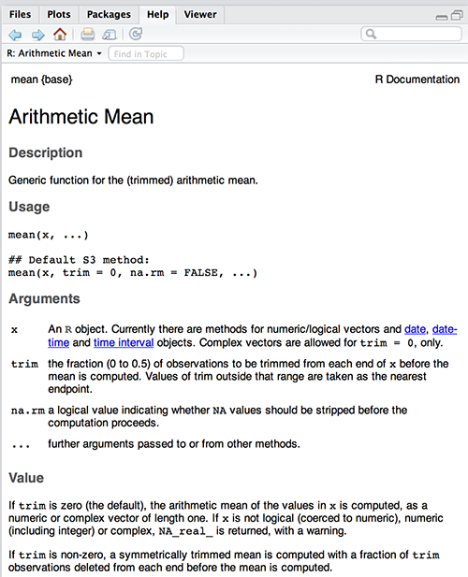

**EXPERIMENT NO.3**

**AIM :-** Basic data types & data Structures in R - Vector, metrics, List ,Data frame

**Theory :-**

Basic Data Types and Data Structures in R

Data structures are very important to understand because these are the objects you will manipulate on a day-to-day basis in R. Dealing with object conversions is one of the most common sources of frustration for beginners.

R has 6 basic data types. (In addition to the five listed below, there is also raw which will not be discussed in this workshop.)

1. character
2. numeric (real or decimal)
3. integer
4. logical
5. complex

Elements of these data types may be combined to form data structures, such as atomic vectors. When we call a vector atomic, we mean that the vector only holds data of a single data type. Below are examples of atomic character vectors, numeric vectors, integer vectors, etc.

character: "a", "swc"

numeric: 2, 15.5

integer: 2L (the L tells R to store this as an integer)

logical: TRUE, FALSE

complex: 1+4i (complex numbers with real and imaginary parts)

R provides many functions to examine features of vectors and other objects, for example

class() - what kind of object is it (high-level)?

typeof() - what is the object’s data type (low-level)?

length() - how long is it? What about two dimensional objects?

attributes() - does it have any metadata?

R has many data structures. These include

* atomic vector
* list
* matrix
* data frame
* factors

### **Vectors**

A vector is the most common and basic data structure in R and is pretty much the workhorse of R. Technically, vectors can be one of two types:

* atomic vectors
* lists

although the term “vector” most commonly refers to the atomic types not to lists.

**The Different Vector Modes**

A vector is a collection of elements that are most commonly of mode character, logical, integer or numeric.

You can create an empty vector with vector(). (By default the mode is logical. You can be more explicit as shown in the examples below.) It is more common to use direct constructors such as character(), numeric(), etc.

**Objects Attributes**

Objects can have attributes. Attributes are part of the object. These include:

* names
* dimnames
* dim
* class
* attributes (contain metadata)

You can also glean other attribute-like information such as length (works on vectors and lists) or number of characters (for character strings).

**Matrix**

In R matrices are an extension of the numeric or character vectors. They are not a separate type of object but simply an atomic vector with dimensions; the number of rows and columns. As with atomic vectors, the elements of a matrix must be of the same data type.

List

In R lists act as containers. Unlike atomic vectors, the contents of a list are not restricted to a single mode and can encompass any mixture of data types. Lists are sometimes called generic vectors, because the elements of a list can by of any type of R object, even lists containing further lists. This property makes them fundamentally different from atomic vectors.

A list is a special type of vector. Each element can be a different type.

Create lists using list() or coerce other objects using as.list(). An empty list of the required length can be created using vector()

### **Data Frame**

A data frame is a very important data type in R. It’s pretty much the de facto data structure for most tabular data and what we use for statistics.

A data frame is a special type of list where every element of the list has same length (i.e. data frame is a “rectangular” list).

Data frames can have additional attributes such as rownames(), which can be useful for annotating data, like subject_id or sample_id. But most of the time they are not used.

Some additional information on data frames:

* Usually created by read.csv() and read.table(), i.e. when importing the data into R.
* Assuming all columns in a data frame are of same type, data frame can be converted to a matrix with data.matrix() (preferred) or as.matrix(). Otherwise type coercion will be enforced and the results may not always be what you expect.
* Can also create a new data frame with data.frame() function.
* Find the number of rows and columns with nrow(dat) and ncol(dat), respectively.
* Rownames are often automatically generated and look like 1, 2, …, n. Consistency in numbering of rownames may not be honored when rows are reshuffled or subset.

## Data Frame Functions

* head() - shows first 6 rows
* tail() - shows last 6 rows
* dim() - returns the dimensions of data frame (i.e. number of rows and number of columns)
* nrow() - number of rows
* ncol() - number of columns
* str() - structure of data frame - name, type and preview of data in each column
* names() or colnames() - both show the names attribute for a data frame.]

**OUTPUT :-**

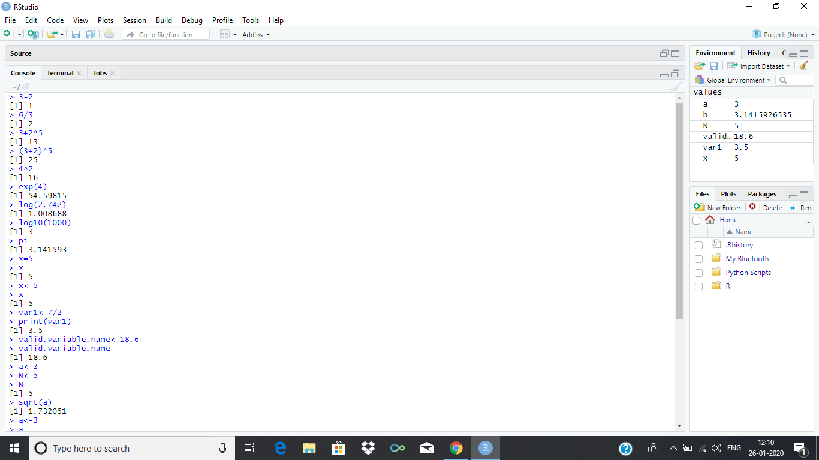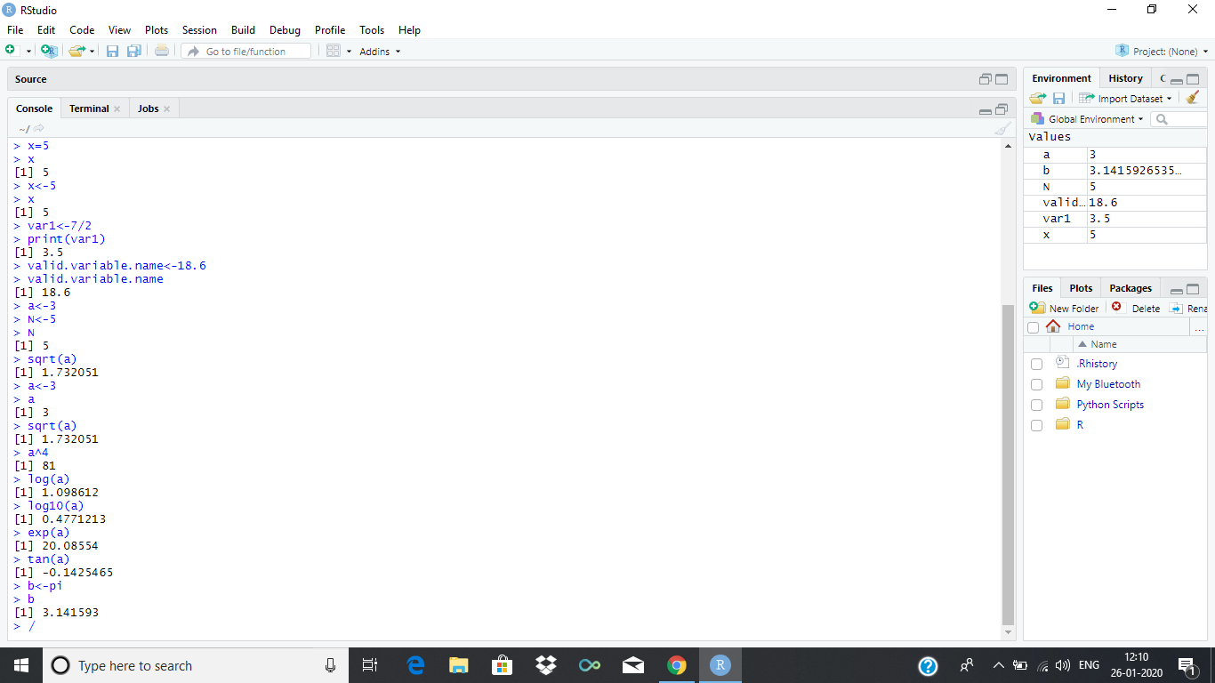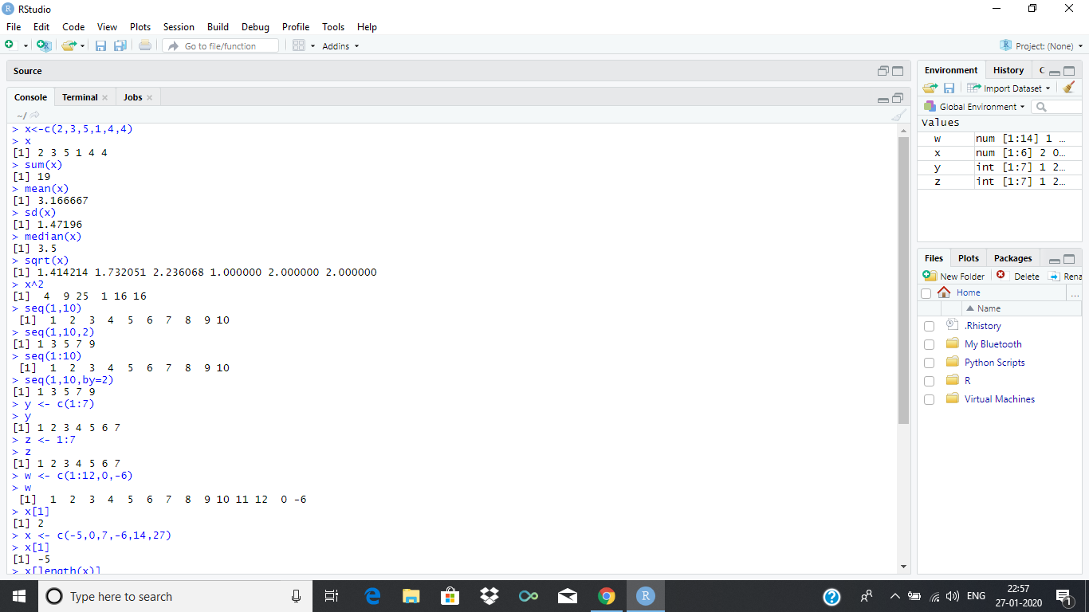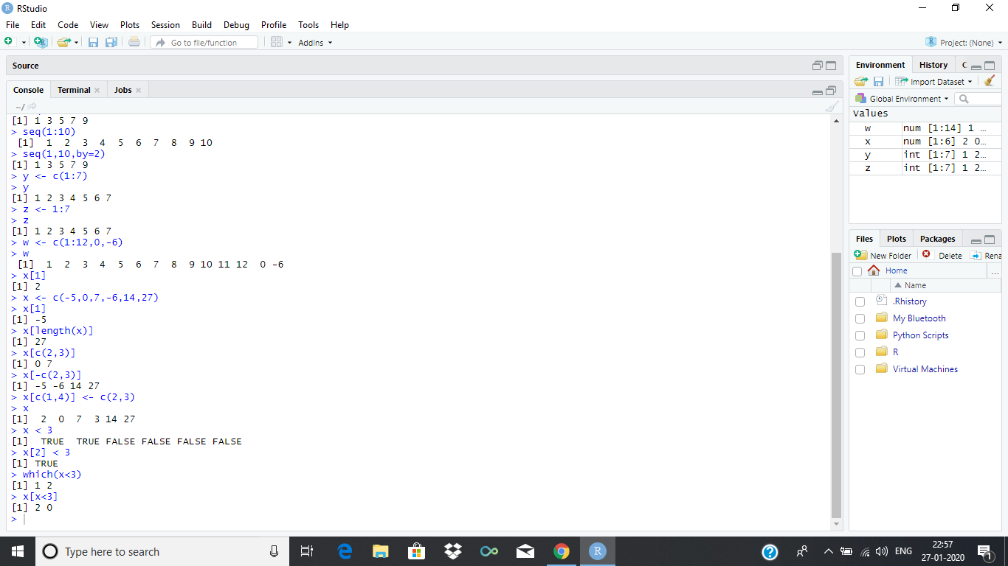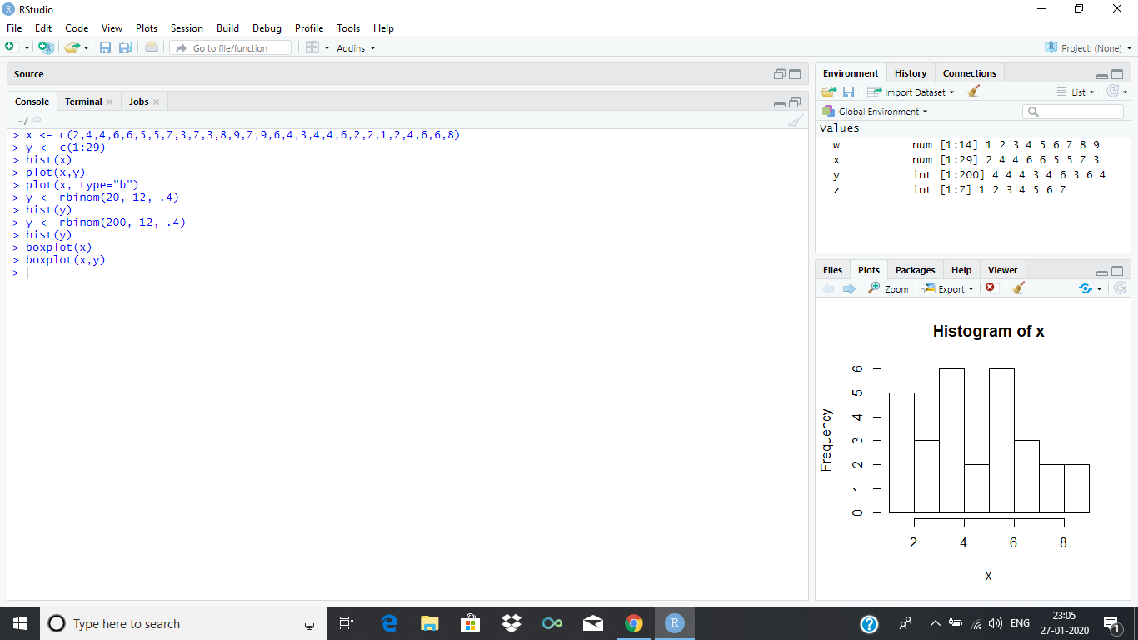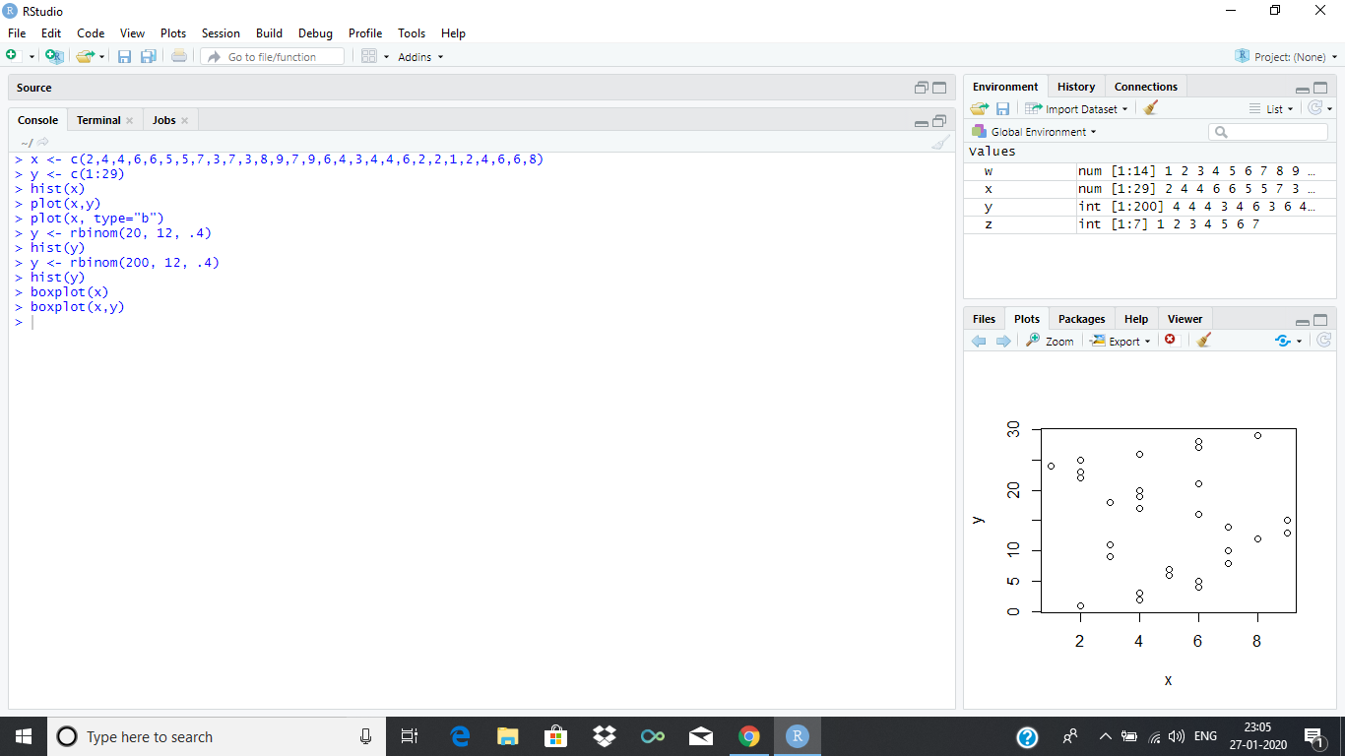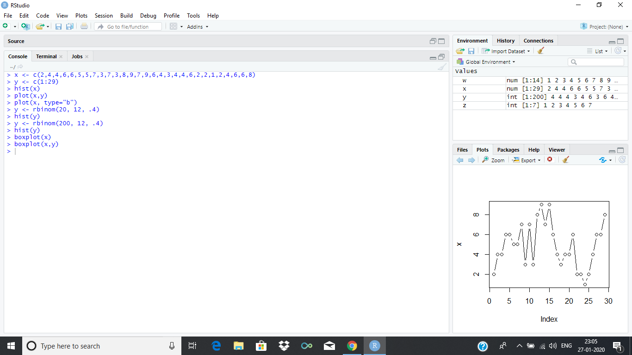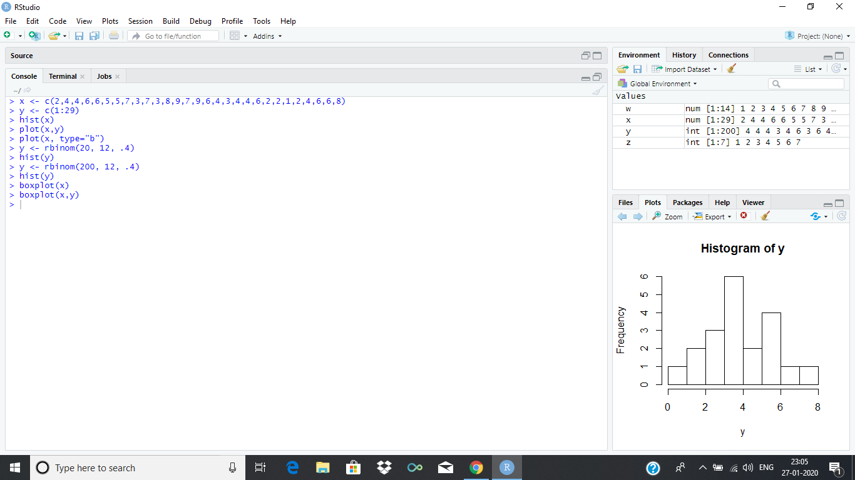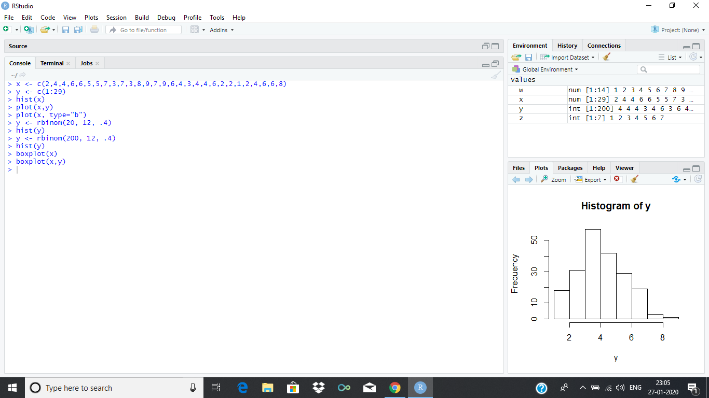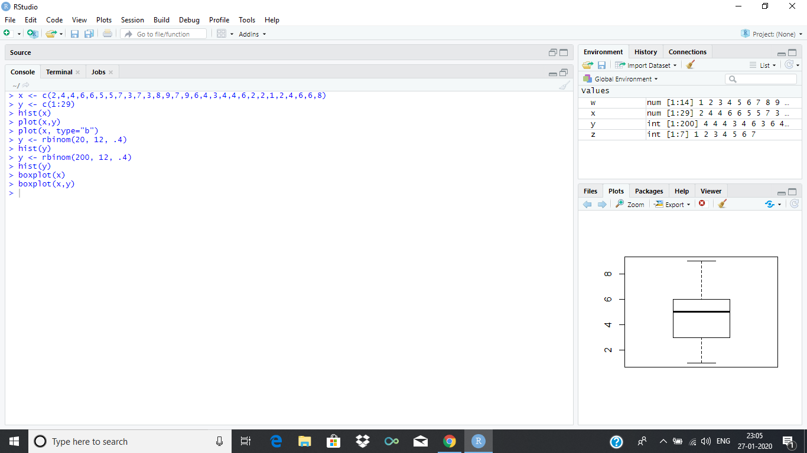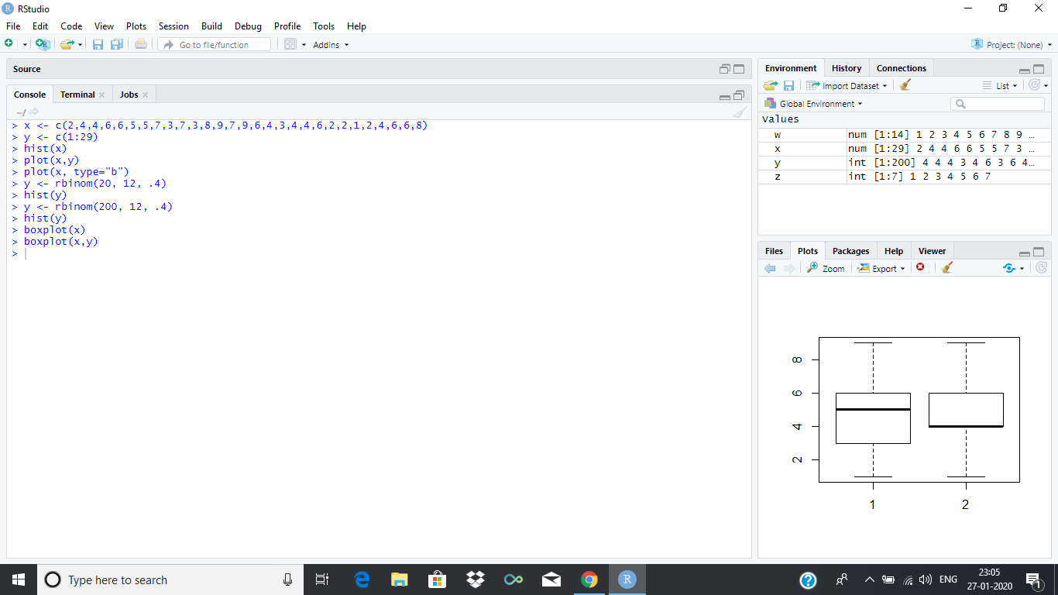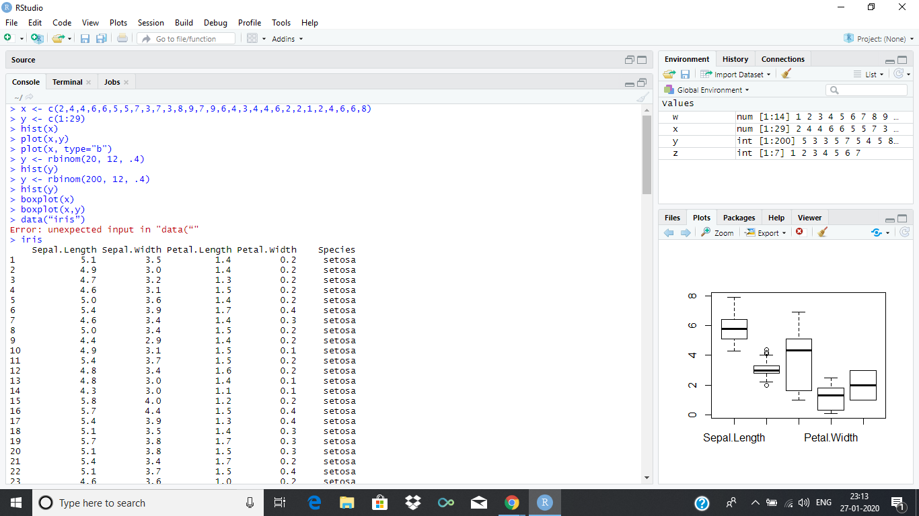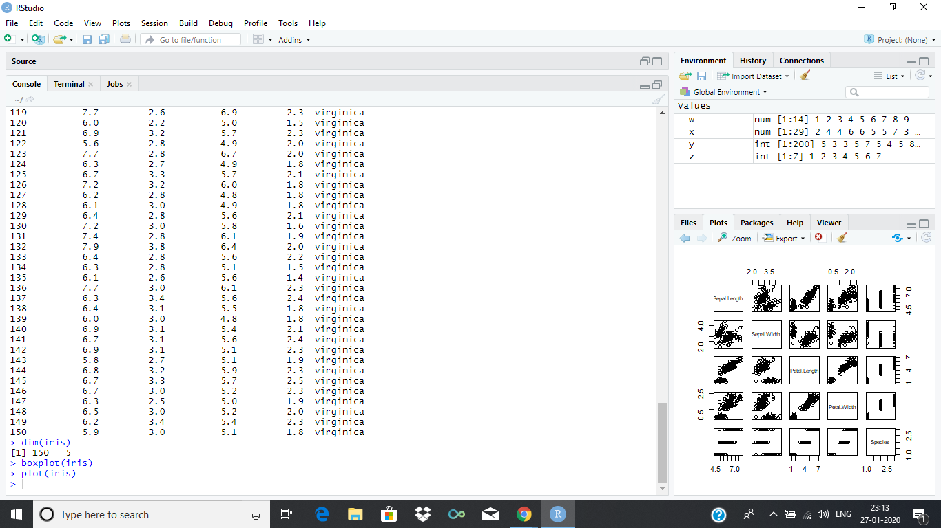

**EXPERIMENT NO. 4**

**AIM :-** Programming Constructs in R - Loops , Conditional Execution.

**Theory :-**

1. **For Loop**

# for loop in R

For (i in 1:5)

{

print(i^2)

}

**OUTPUT :-**

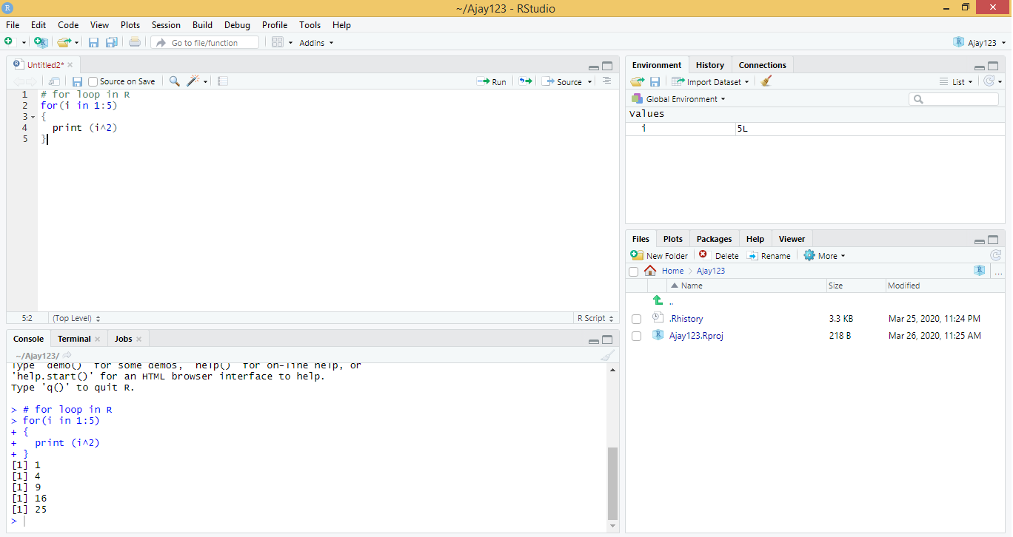

1. **Nested For Loop**

for( i in 1:5 )

{

for( j in 1:2 )

{

print( i * j )

}

}

**OUTPUT :-**

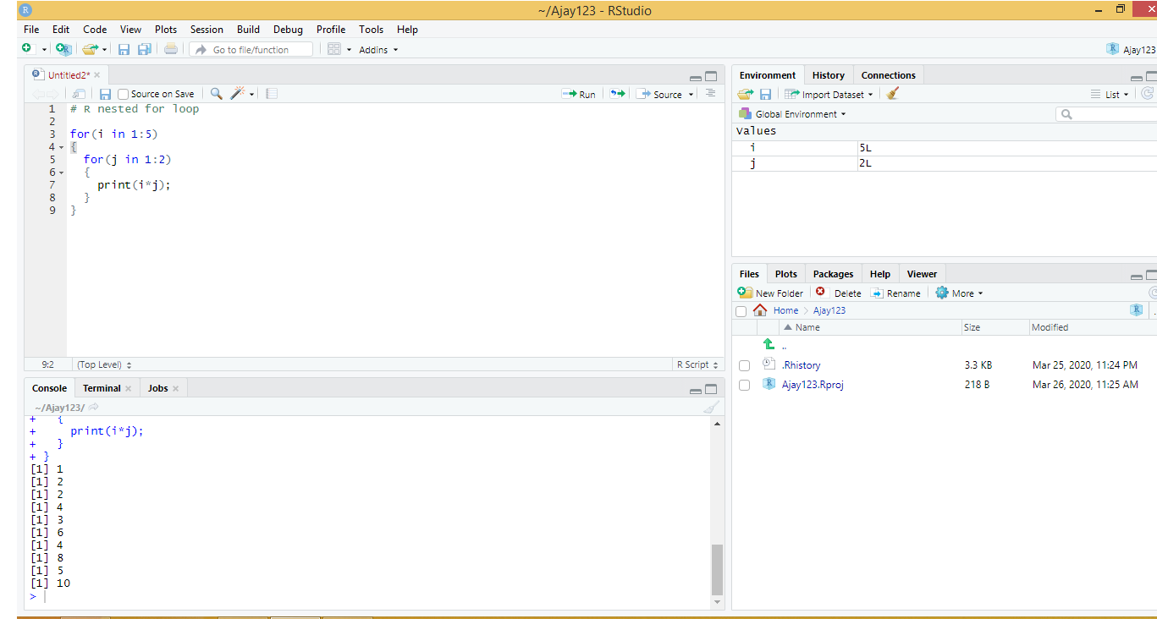

1. While Loop with next statement

i <- 1

while ( i <= 6) {

If ( i == 4) {

i = i+1

Next;

}

print( i * j)

}

**OUTPUT :-**

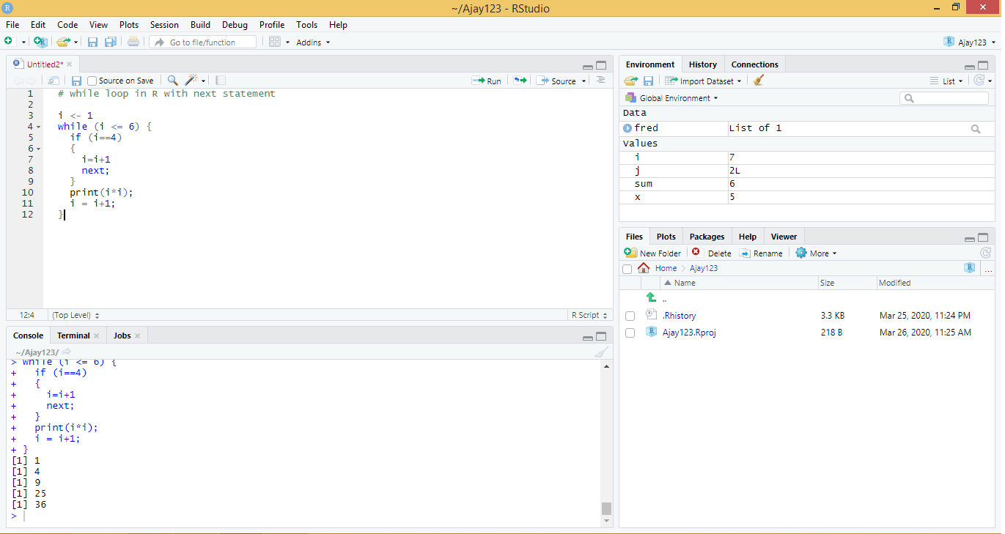

1. **If Loop**

**CODE -**

x <- 10

if ( x > 0)

{

print(“This is Positive number”)

}

**OUTPUT :-**

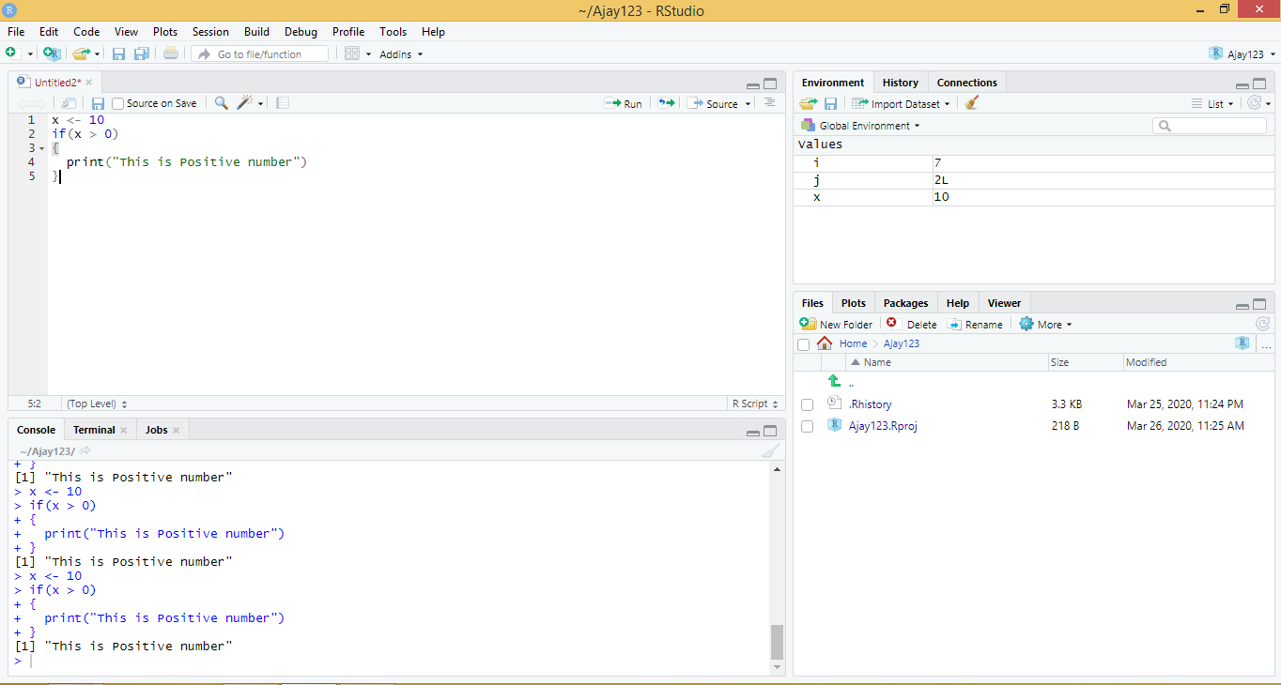

1. IF Else Loop

CODE

x <- 5

If (x > 0)

{

print(“Non-negative Number”)

}

Else

{

print(“Negative Number”)

}

**OUTPUT :-**

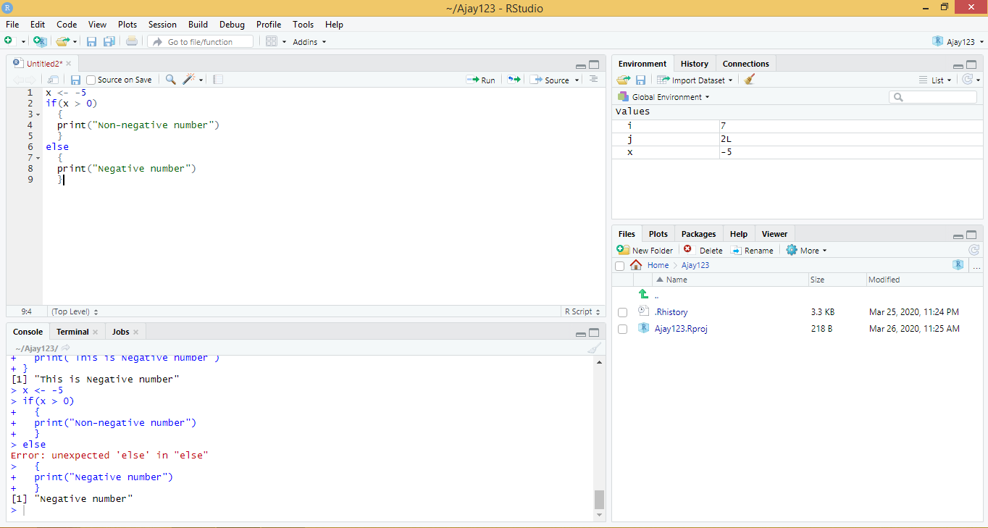

1. Nested If Else Loop

x <- 5

if( x < 0)

{

print(“This is Negative Number”)

}

else if ( x >0 )

{

print(“This is Positive Number”)

}

else

print(“This is zero”)

**OUTPUT :-**

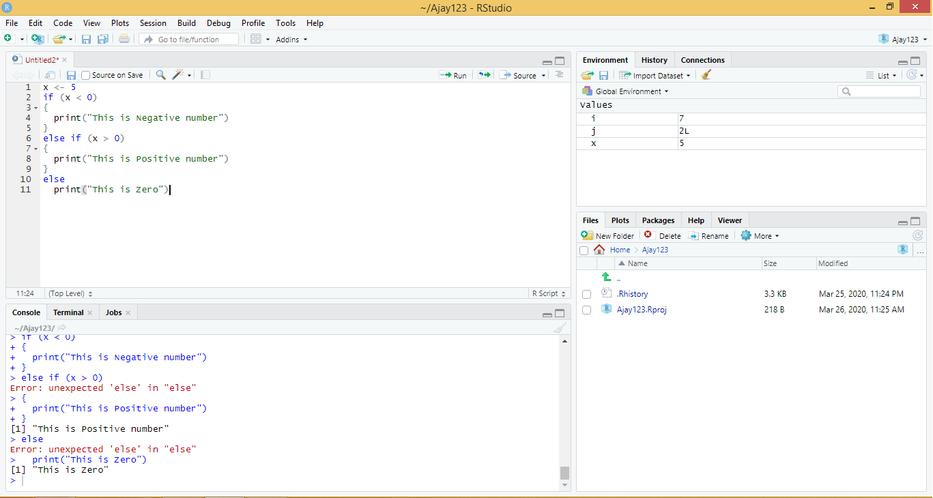

1. Repeat Loop

Code:-

sum <- 0

repeat

sum = sum + 1

print( sum )

If (sum == 6 ) {

print(“Repeat loop end”);

Break

}

}

**OUTPUT :-**

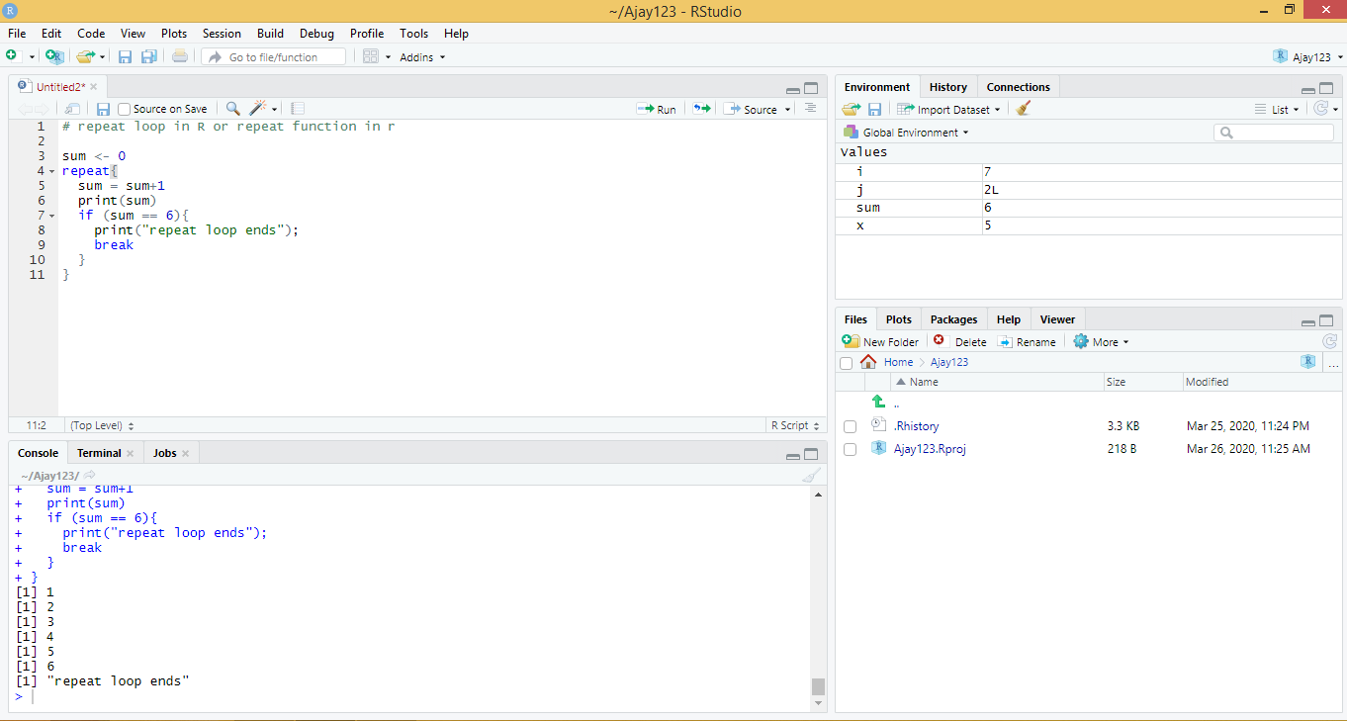

**EXPERIMENT NO. 5**

**AIM :-** Tables with labels in R- Multiple response Variables Excel function translation.

**Theory :-**

expss computes and displays tables with support for ‘SPSS’-style labels, multiple / nested banners, weights, multiple-response variables and significance testing. There are facilities for nice output of tables in ‘knitr’, R notebooks, ‘Shiny’ and ‘Jupyter’ notebooks. Proper methods for labelled variables add value labels support to base R functions and to some functions from other packages. Additionally, the package offers useful functions for data processing in marketing research / social surveys - popular data transformation functions from ‘SPSS’ Statistics (‘RECODE’, ‘COUNT’, ‘COMPUTE’, ‘DO IF’, etc.) and ‘Excel’ (‘COUNTIF’, ‘VLOOKUP’, etc.). Package is intended to help people to move data processing from ‘Excel’/‘SPSS’ to R. See examples below. You can get help about any function by typing ?function_name in the R console.

## **Cross- tabulation**

**CODE :-**

library(expss)

data(mtcars)

mtcars = apply_labels(mtcars,

mpg = "Miles/(US) gallon",

cyl = "Number of cylinders",

disp = "Displacement (cu.in.)",

hp = "Gross horsepower",

drat = "Rear axle ratio",

wt = "Weight (1000 lbs)",

qsec = "1/4 mile time",

vs = "Engine",

vs = c("V-engine" = 0,

"Straight engine" = 1),

am = "Transmission",

am = c("Automatic" = 0,

"Manual"=1),

gear = "Number of forward gears",

carb = "Number of carburetors"

)

cro(mtcars$am, mtcars$vs)

cro_cpct(mtcars$cyl, list(total(), mtcars$am, mtcars$vs))

**OUTPUT :-**

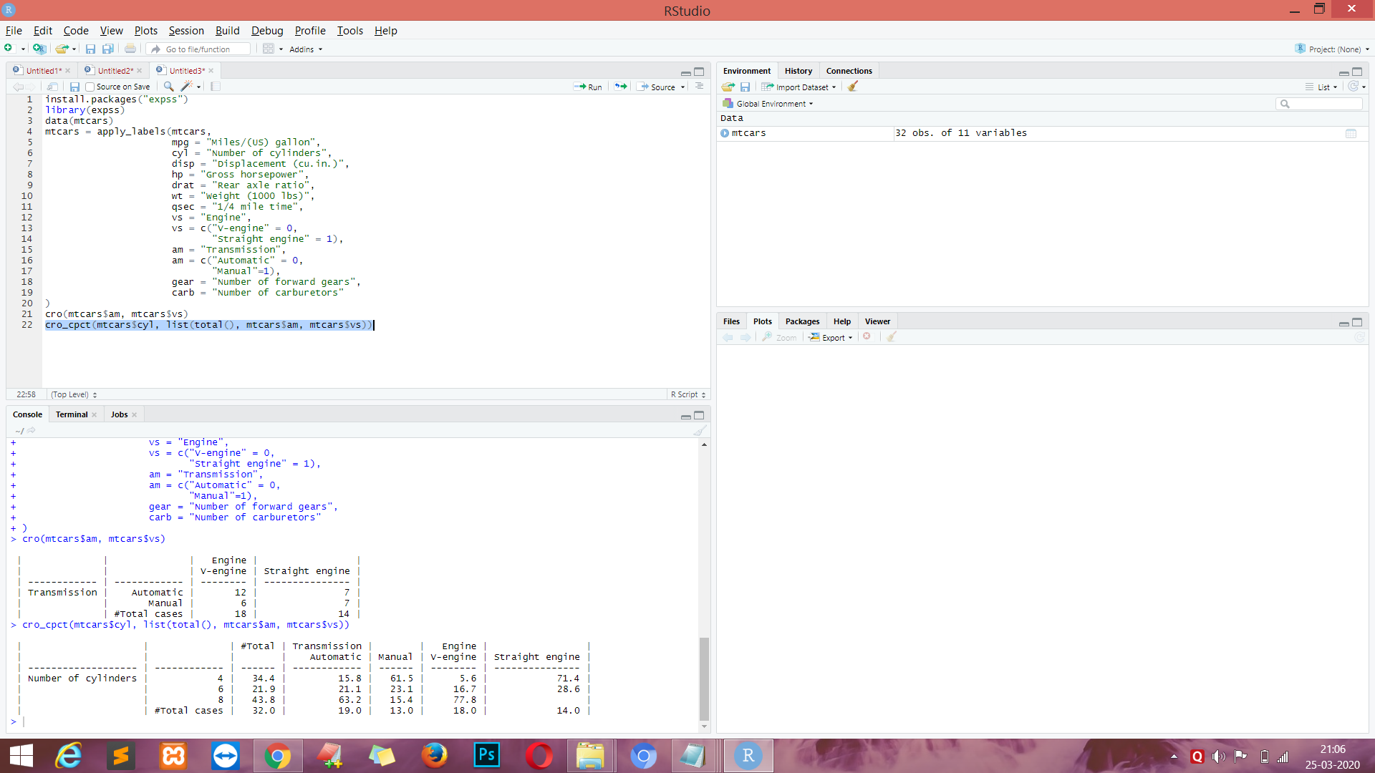

mtcars %>% calc_cro_cpct(cyl, list(total(), am, vs))

mtcars %>%

calc_cro_cpct(cyl, list(total(), am %nest% vs))

mtcars %>%

tab_cells(cyl) %>%

tab_cols(total(), am) %>%

tab_stat_cpct() %>%

tab_pivot()

mtcars %>%

tab_cells(mpg, disp, hp, wt, qsec) %>%

tab_cols(total(), am) %>%

tab_stat_mean_sd_n()

%>%

tab_last_sig_means(subtable_marks

= "both") %>%

tab_pivot() %>%

set_caption("Table with summary statistics

and significance marks.")

**OUTPUT :-**

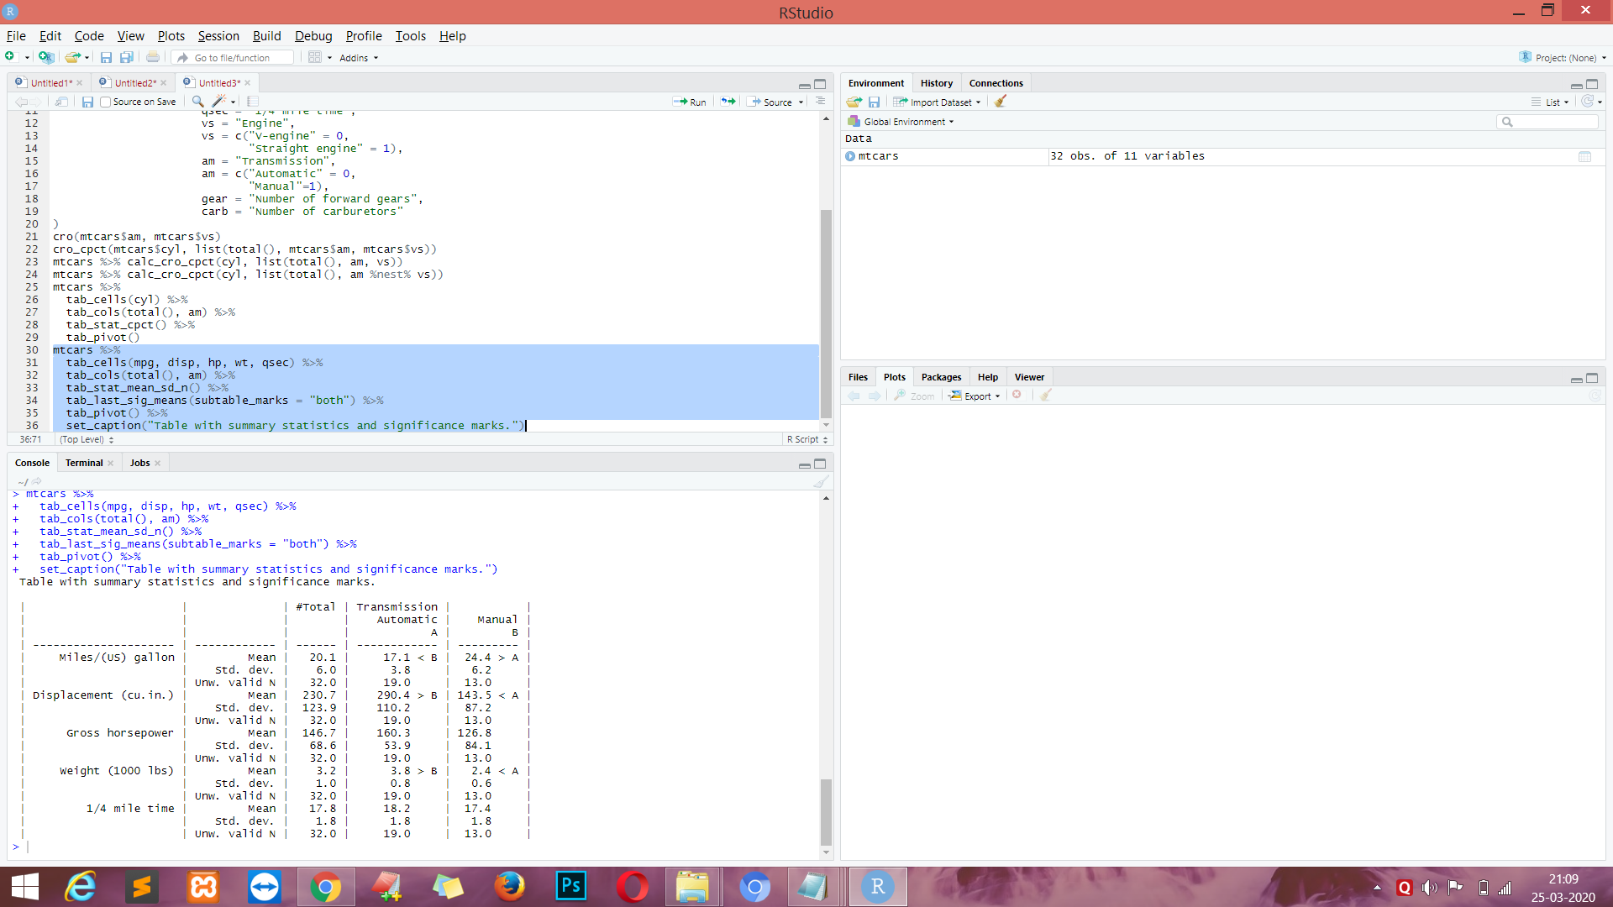

**CODE :-**

mtcars %>%

tab_cells(mpg, disp, hp, wt, qsec) %>%

tab_cols(total(label = "#Total| |"), am) %>%

tab_stat_fun(Mean = w_mean, "Std. dev." = w_sd, "Valid N" = w_n, method = list) %>%

tab_pivot()

**OUTPUT :-**

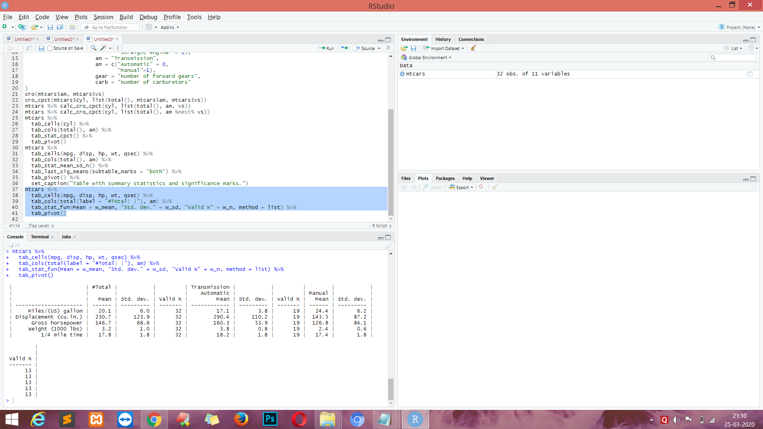

**CODE :-**

mtcars %>%

tab_cols(total(), vs) %>%

tab_cells(mpg) %>%

tab_stat_mean() %>%

tab_stat_valid_n() %>%

tab_cells(am) %>%

tab_stat_cpct(total_row_position = "none", label = "col %") %>%

tab_stat_rpct(total_row_position = "none", label = "row %") %>%

tab_stat_tpct(total_row_position = "none", label = "table %") %>%

tab_pivot(stat_position = "inside_rows")

OUTPUT :-

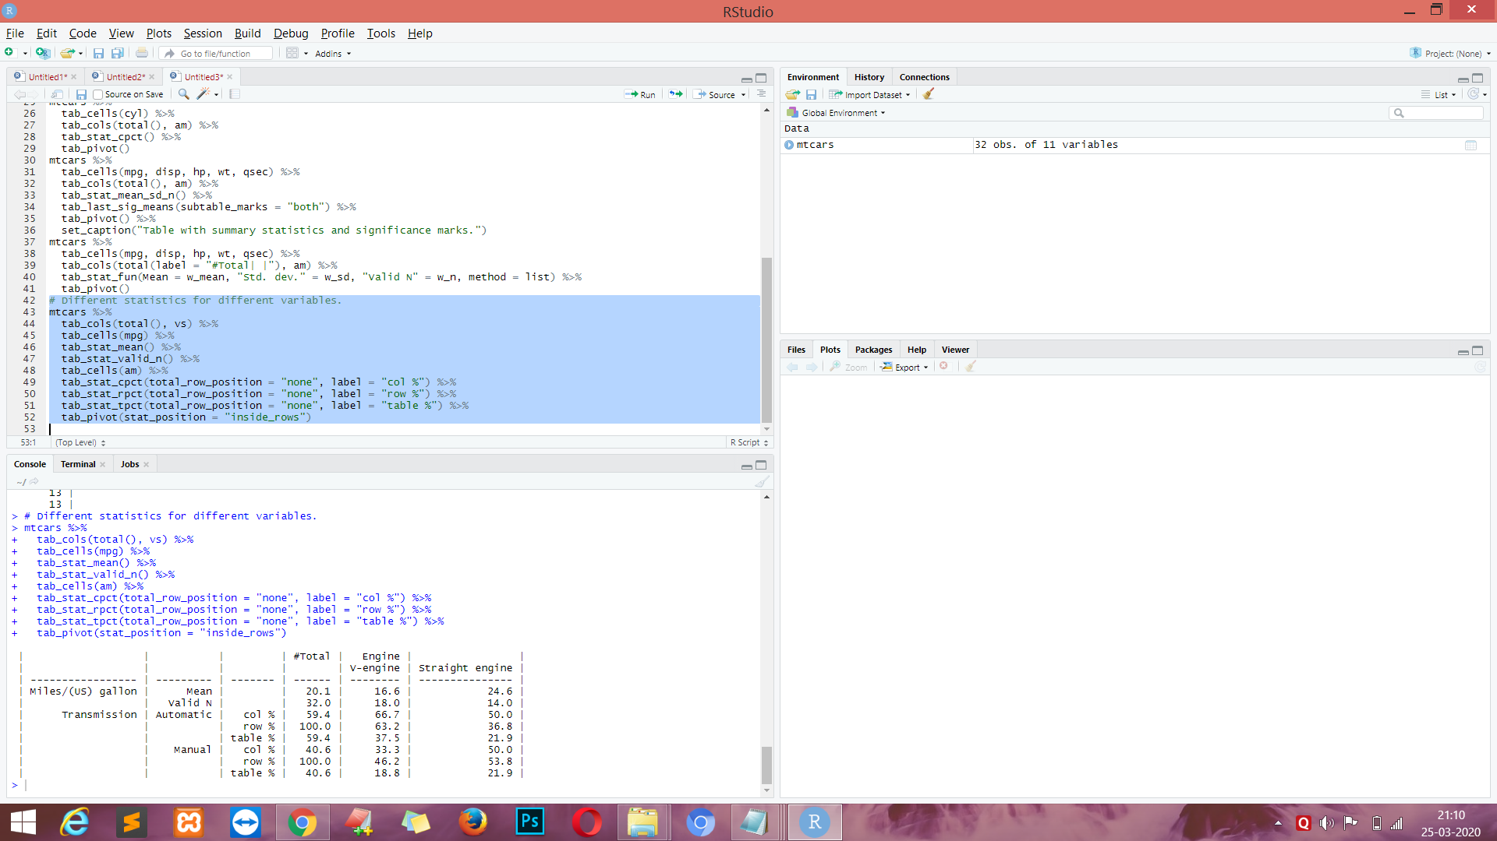

**CODE :-**

# Table with split by rows and with custom totals.

mtcars %>%

tab_cells(cyl) %>%

tab_cols(total(), vs) %>%

tab_rows(am) %>%

tab_stat_cpct(total_row_position = "above",

total_label = c("number of cases", "row %"),

total_statistic = c("u_cases", "u_rpct")) %>%

tab_pivot()

**OUTPUT :-**

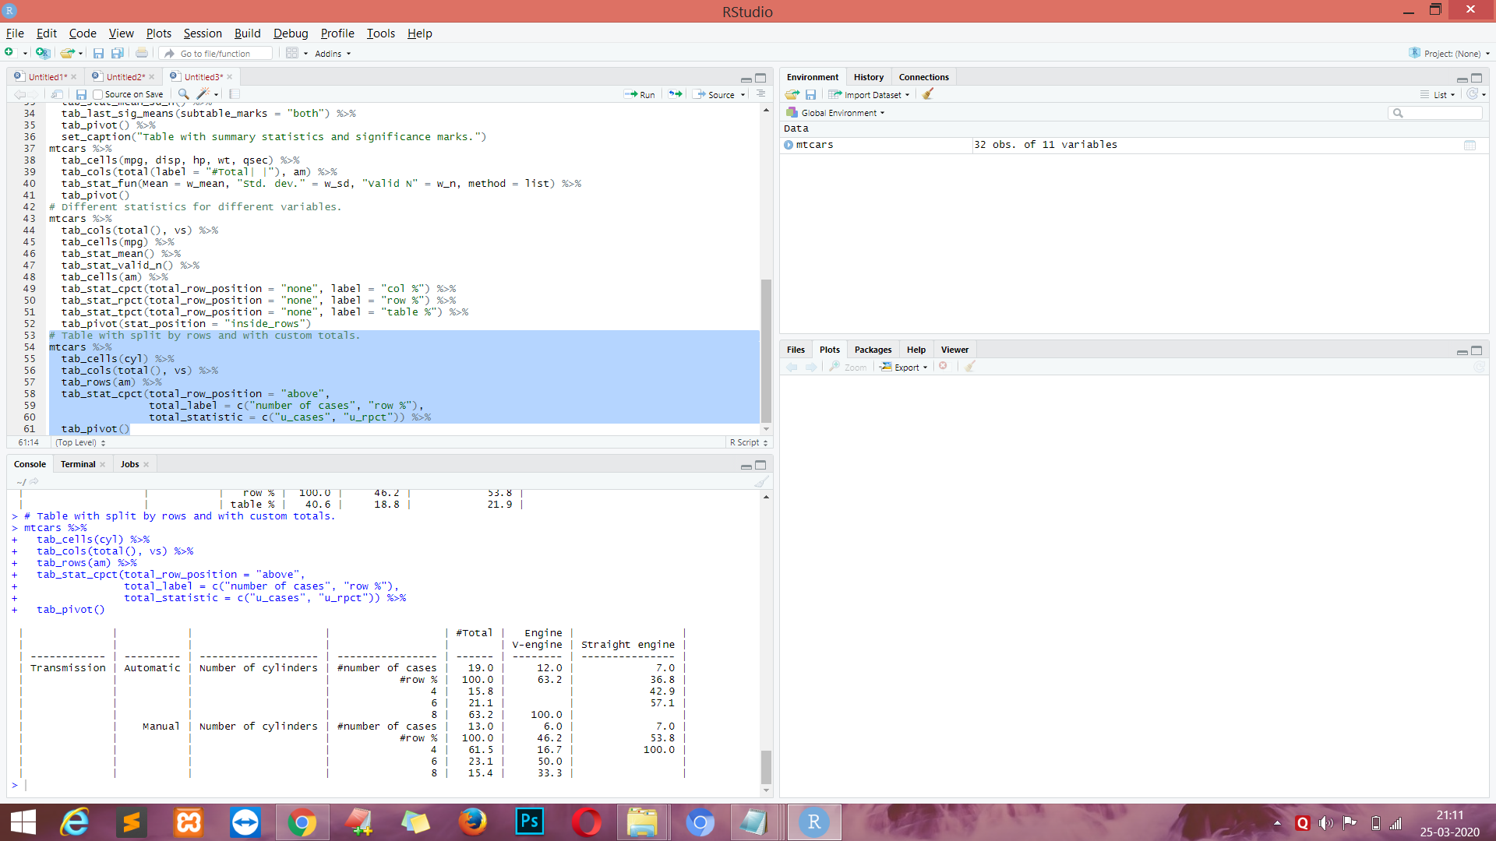

**CODE :-**

# Linear regression by groups.

mtcars %>%

tab_cells(sheet(mpg, disp, hp, wt, qsec)) %>%

tab_cols(total(label = "#Total| |"), am) %>%

tab_stat_fun_df(

function(x){

frm = reformulate(".", response = as.name(names(x)[1]))

model = lm(frm, data = x)

sheet('Coef.' = coef(model),

confint(model)

)}

) %>%

tab_pivot()

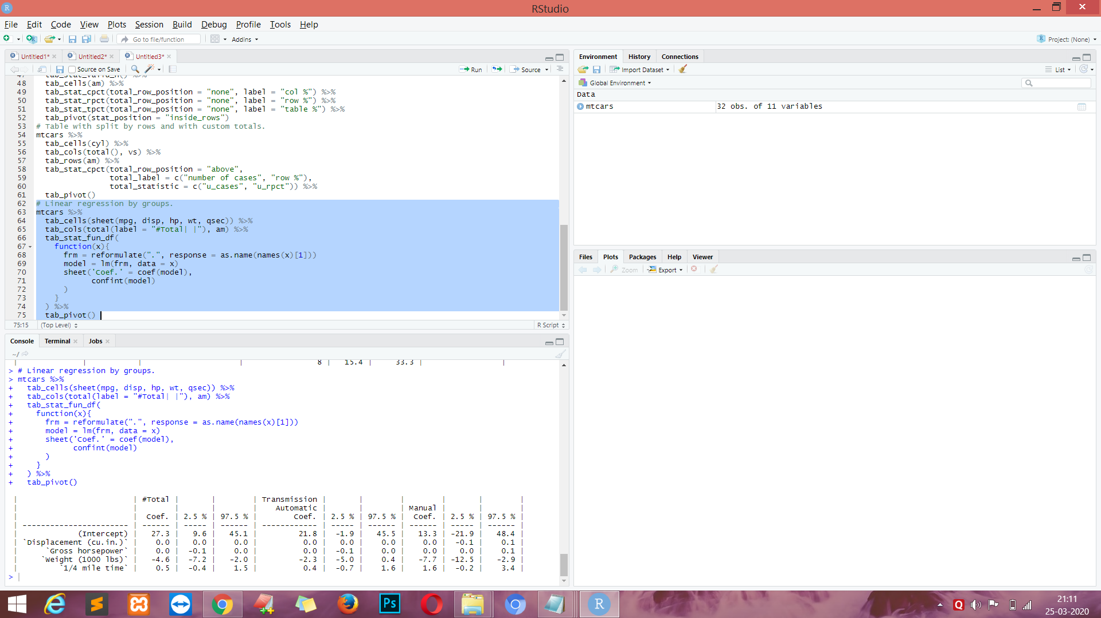

**CODE :-**

data(product_test)

w = product_test # shorter name to save some keystrokes

# here we recode variables from first/second tested product to separate variables for each product according to their cells

# 'h' variables - VSX123 sample, 'p' variables - 'SDF456' sample

# also we recode preferences from first/second product to true names

# for first cell there are no changes, for second cell we should exchange 1 and 2.

w = w %>%

do_if(cell == 1, {

recode(a1_1 %to% a1_6, other ~ copy) %into% (h1_1 %to% h1_6)

recode(b1_1 %to% b1_6, other ~ copy) %into% (p1_1 %to% p1_6)

recode(a22, other ~ copy) %into% h22

recode(b22, other ~ copy) %into% p22

c1r = c1

}) %>%

do_if(cell == 2, {

recode(a1_1 %to% a1_6, other ~ copy) %into% (p1_1 %to% p1_6)

recode(b1_1 %to% b1_6, other ~ copy) %into% (h1_1 %to% h1_6)

recode(a22, other ~ copy) %into% p22

recode(b22, other ~ copy) %into% h22

recode(c1, 1 ~ 2, 2 ~ 1, other ~ copy) %into% c1r

}) %>%

compute({

# recode age by groups

age_cat = recode(s2a, lo %thru% 25 ~ 1, lo %thru% hi ~ 2)

# count number of likes

# codes 2 and 99 are ignored.

h_likes = count_row_if(1 | 3 %thru% 98, h1_1 %to% h1_6)

p_likes = count_row_if(1 | 3 %thru% 98, p1_1 %to% p1_6)

})

# here we prepare labels for future usage

codeframe_likes = num_lab("

1 Liked everything

2 Disliked everything

3 Chocolate

4 Appearance

5 Taste

6 Stuffing

7 Nuts

8 Consistency

98 Other

99 Hard to answer

")

overall_liking_scale = num_lab("

1 Extremely poor

2 Very poor

3 Quite poor

4 Neither good, nor poor

5 Quite good

6 Very good

7 Excellent

")

w = apply_labels(w,

c1r = "Preferences",

c1r = num_lab("

1 VSX123

2 SDF456

3 Hard to say

"),

age_cat = "Age",

age_cat = c("18 - 25" = 1, "26 - 35" = 2),

h1_1 = "Likes. VSX123",

p1_1 = "Likes. SDF456",

h1_1 = codeframe_likes,

p1_1 = codeframe_likes,

h_likes = "Number of likes. VSX123",

p_likes = "Number of likes. SDF456",

h22 = "Overall quality. VSX123",

p22 = "Overall quality. SDF456",

h22 = overall_liking_scale,

p22 = overall_liking_scale

)

**OUTPUT :-**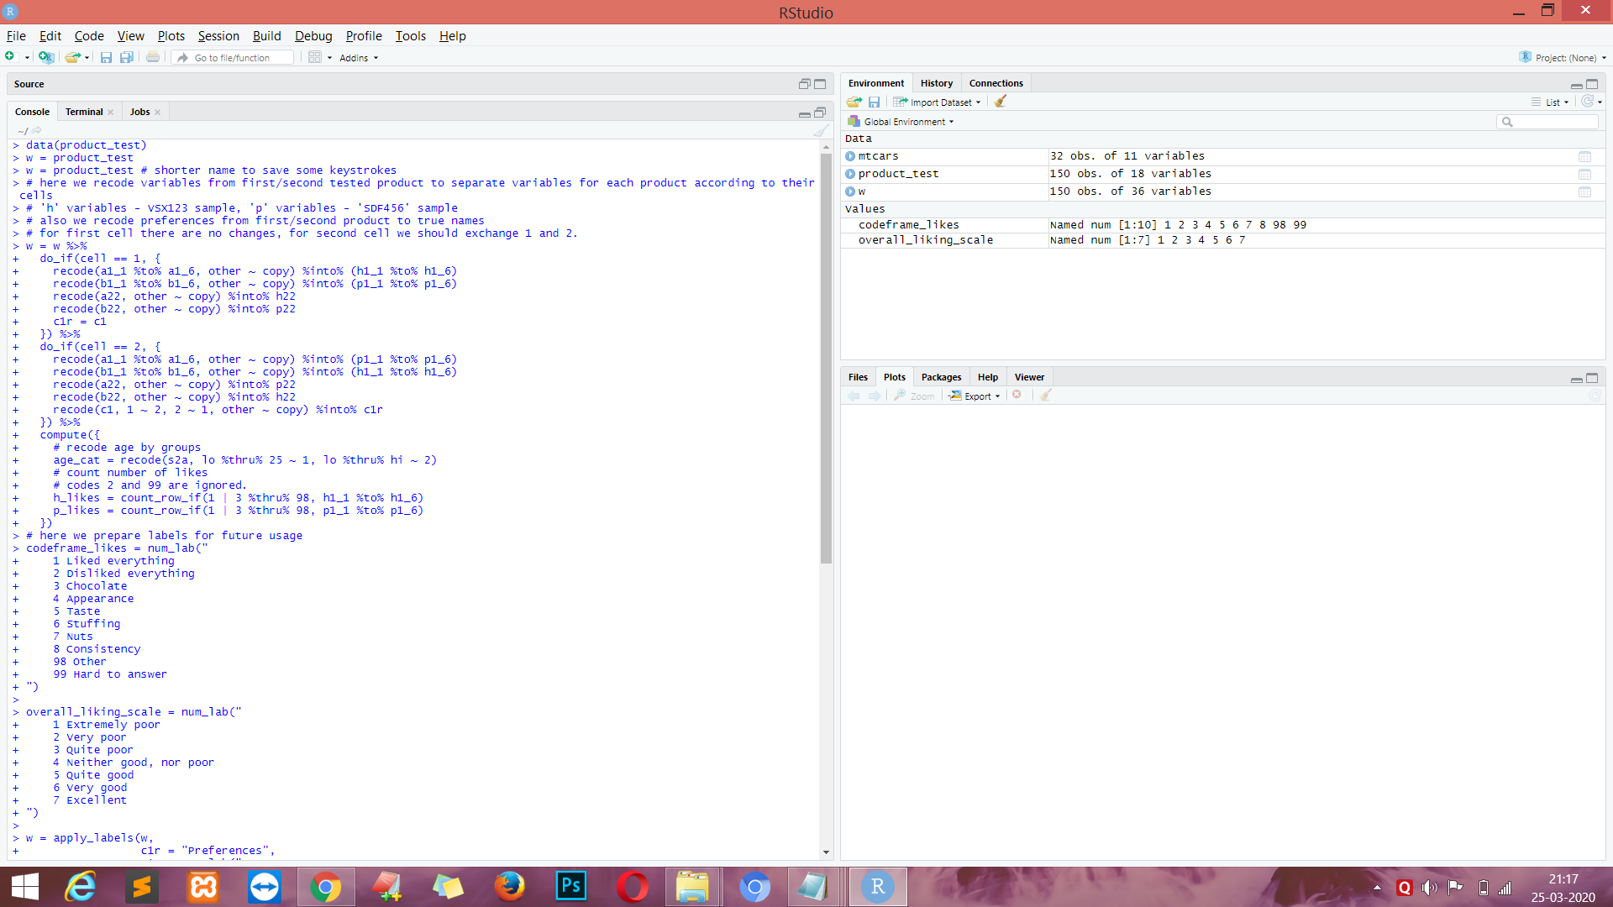

**CODE :-**

w %>% tab_cols(total(), age_cat) %>%

tab_cells(c1r) %>%

tab_mis_val(3) %>%

tab_stat_cases() %>%

tab_last_sig_cases() %>%

tab_pivot()

**OUTPUT :-**

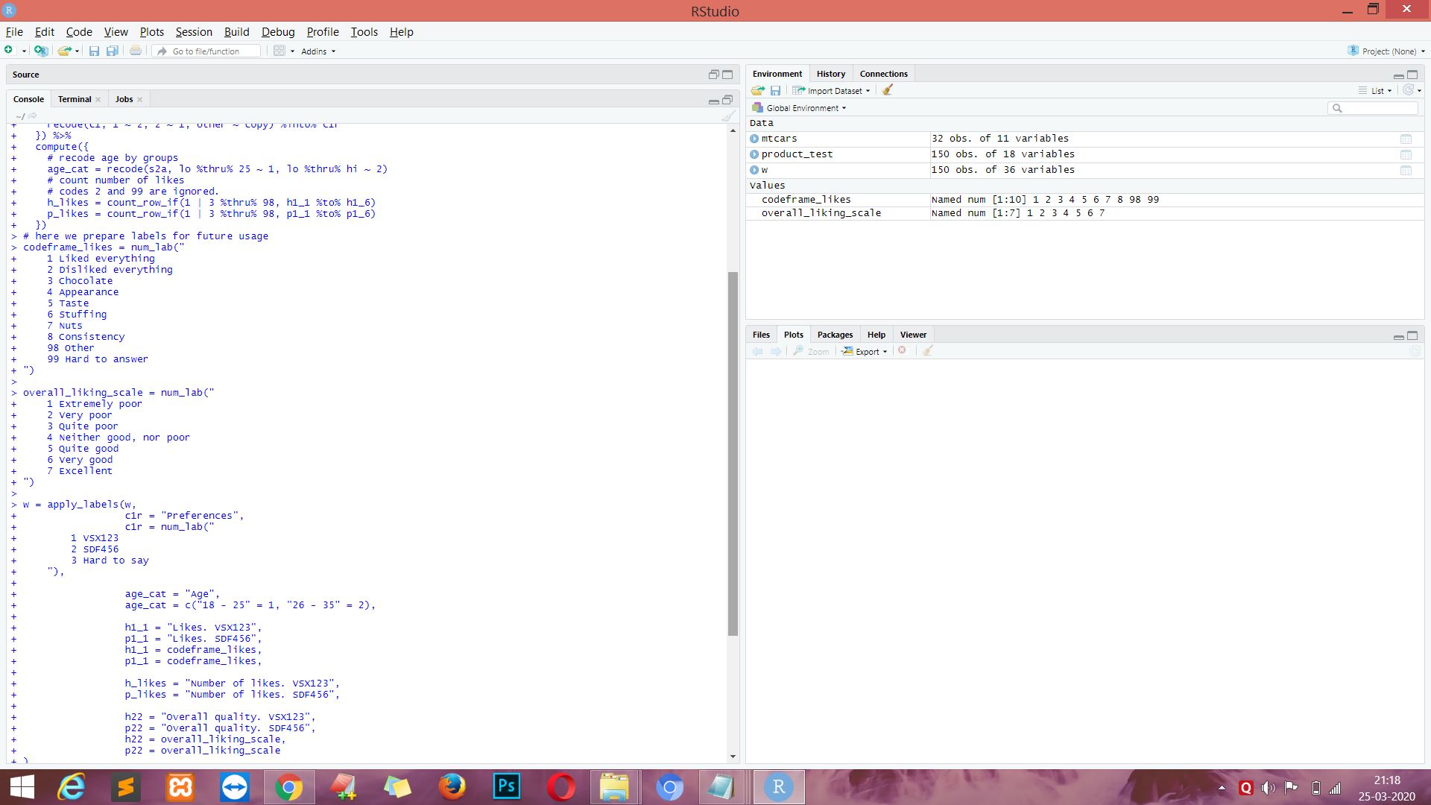

**CODE :-**

# lets specify repeated parts of table creation chains

banner = w %>% tab_cols(total(), age_cat, c1r)

# column percent with significance

tab_cpct_sig = . %>% tab_stat_cpct() %>%

tab_last_sig_cpct(sig_labels = paste0("<b>",LETTERS, "</b>"))

# means with siginifcance

tab_means_sig = . %>% tab_stat_mean_sd_n(labels = c("<b><u>Mean</u></b>", "sd", "N")) %>%

tab_last_sig_means(

sig_labels = paste0("<b>",LETTERS, "</b>"),

keep = "means")

# Preferences

banner %>%

tab_cells(c1r) %>%

tab_cpct_sig() %>%

tab_pivot()

banner %>%

tab_cells(h22) %>%

tab_means_sig() %>%

tab_cpct_sig() %>%

tab_cells(p22) %>%

tab_means_sig() %>%

tab_cpct_sig() %>%

tab_pivot()

**OUTPUT :-**

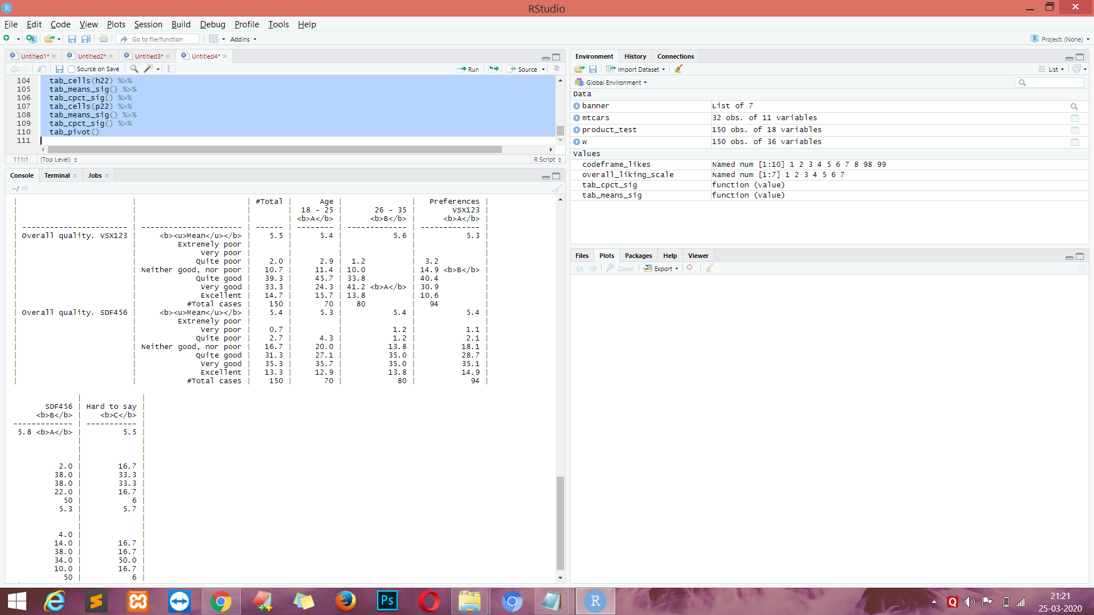

**CODE :-**

# Likes

banner %>%

tab_cells(h_likes) %>%

tab_means_sig() %>%

tab_cells(mrset(h1_1 %to% h1_6)) %>%

tab_cpct_sig() %>%

tab_cells(p_likes) %>%

tab_means_sig() %>%

tab_cells(mrset(p1_1 %to% p1_6)) %>%

tab_cpct_sig() %>%

tab_pivot()

**OUTPUT :-**

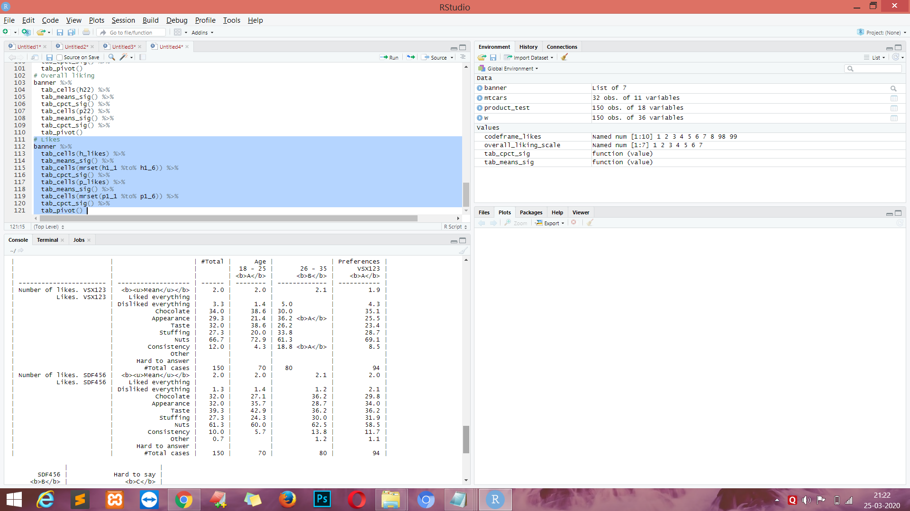

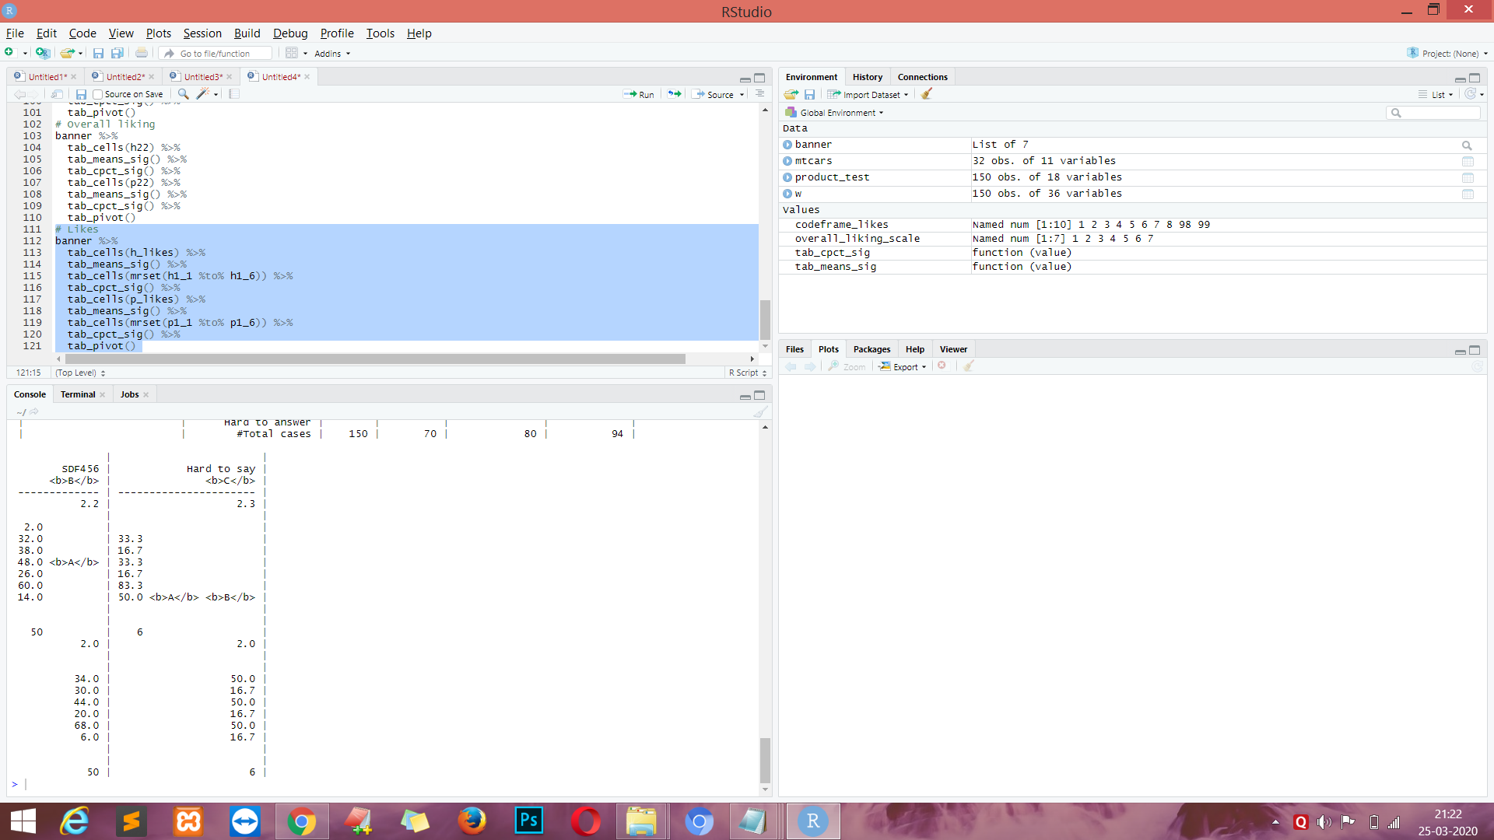

**CODE :-**

# below more complicated table where we compare likes side by side

# Likes - side by side comparison

w %>%

tab_cols(total(label = "#Total| |"), c1r) %>%

tab_cells(list(unvr(mrset(h1_1 %to% h1_6)))) %>%

tab_stat_cpct(label = var_lab(h1_1)) %>%

tab_cells(list(unvr(mrset(p1_1 %to% p1_6)))) %>%

tab_stat_cpct(label = var_lab(p1_1)) %>%

tab_pivot(stat_position = "inside_columns")

**OUTPUT :-**

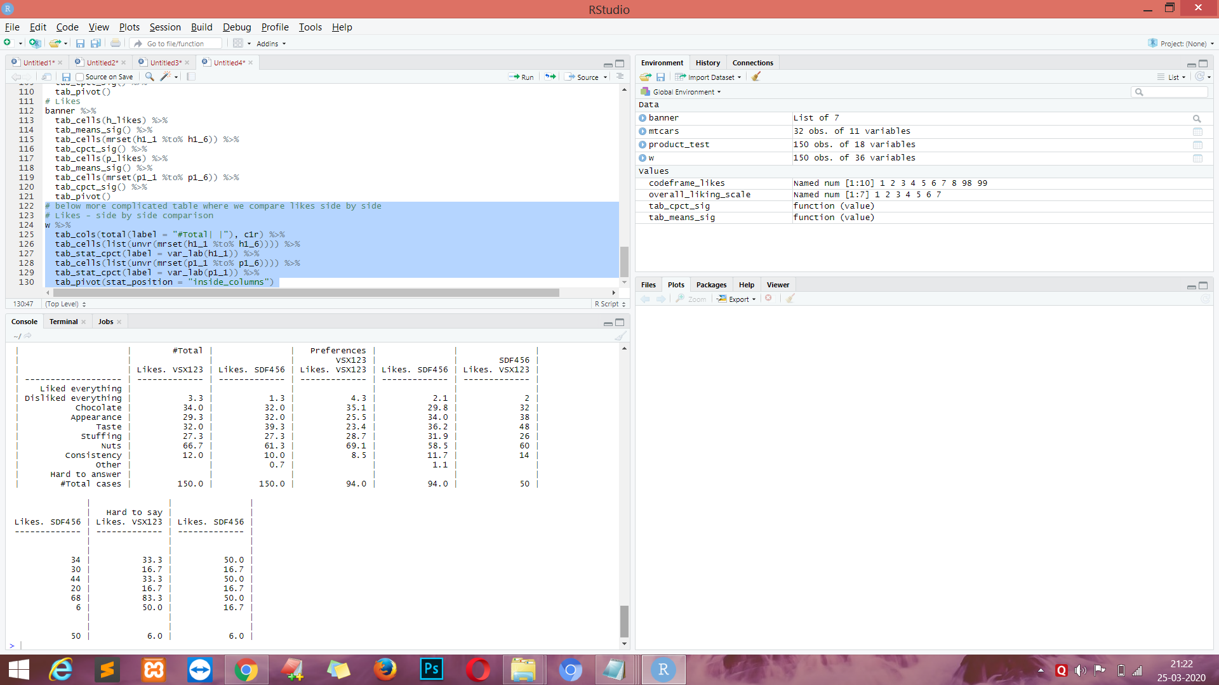

**EXPERIMENT NO. 6**

**AIM :-** Working with Large Dataset with dplyr & data table

**Theory :-**

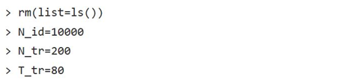

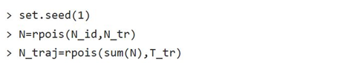

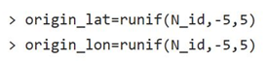

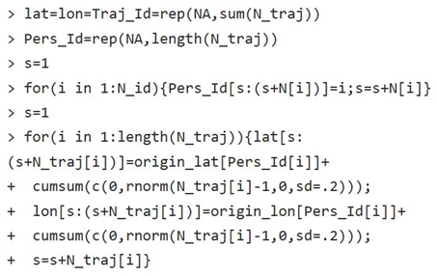

**OUTPUT :-**

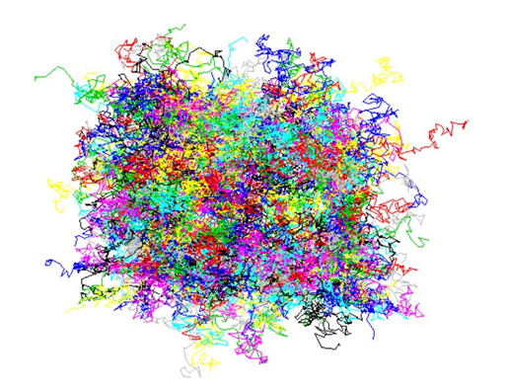

**CODE :-**

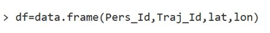

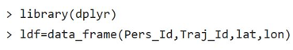

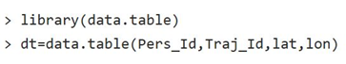

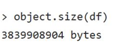

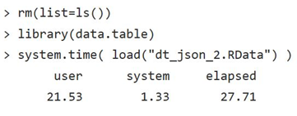

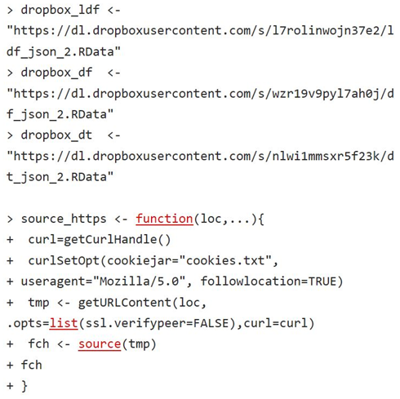

**OUTPUT :-**

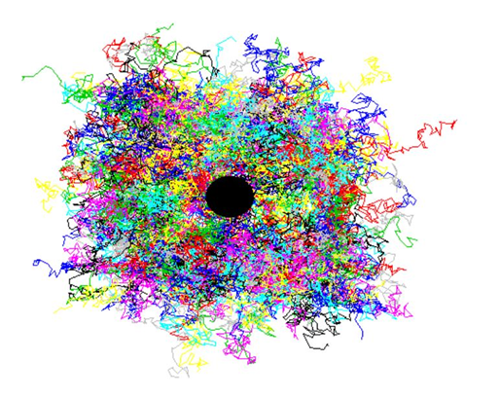

**CODE :-**

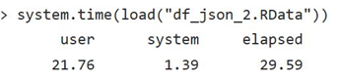

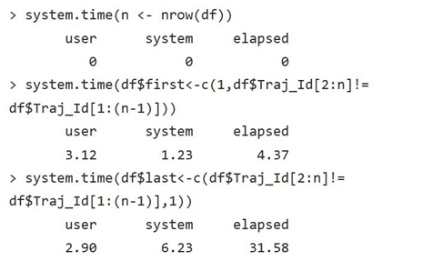

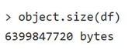

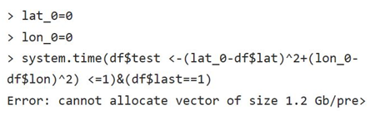

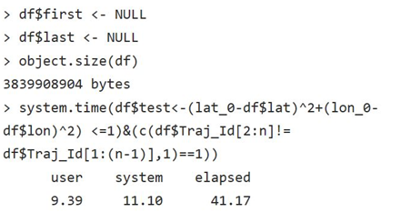

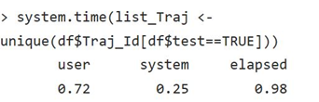

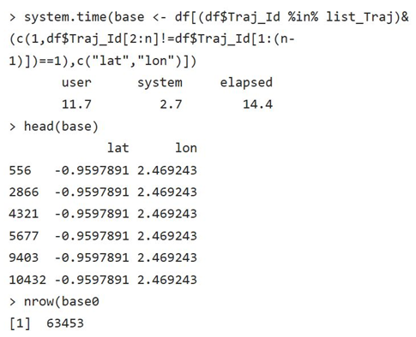



**OUTPUT :-**

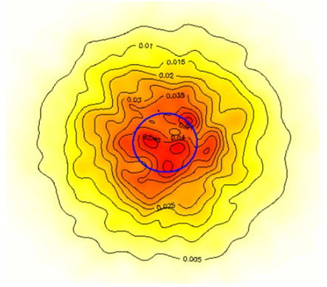

**CODE :-**

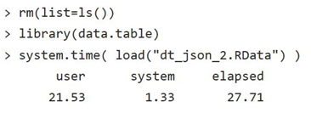

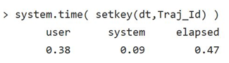

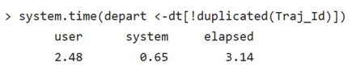

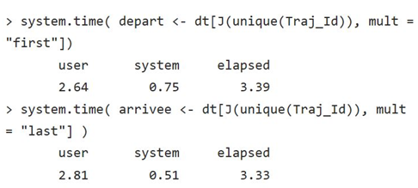

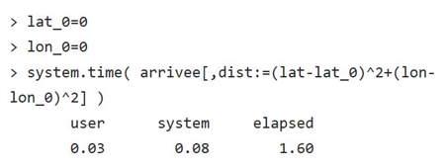

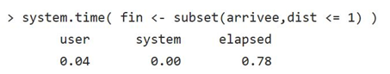

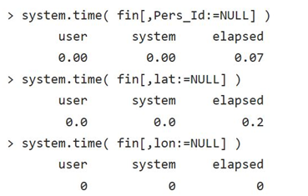

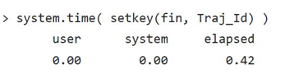

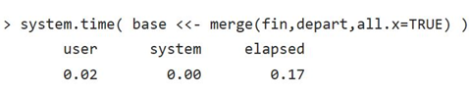

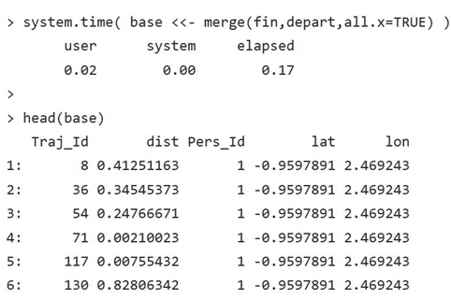

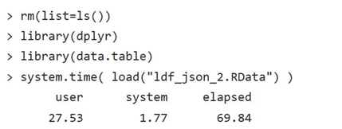

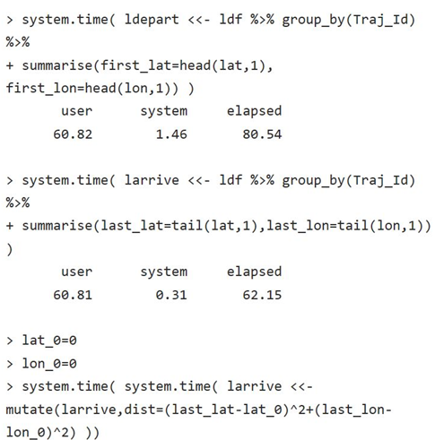

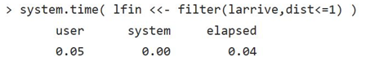

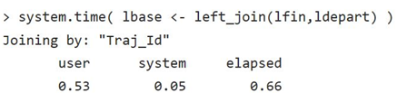

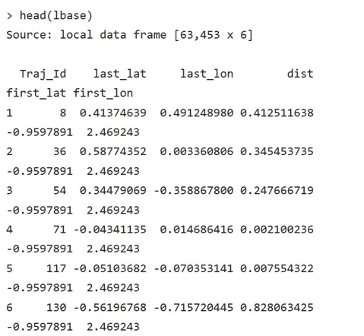

**EXPERIMENT NO. 7**

**AIM:-** EDA with R - Range, Summary , Mean Variance, median, Std. Deviation , Histogram,

Box plot, Scatter plot

**Theory :-**

**CODE :-**

install.packages("aqp")

install.packages("soilDB")

# Load from the the loakercreek dataset

data("loafercreek")

# Construct generalized horizon designations

n <- c("A",

"BAt",

"Bt1",

"Bt2",

"Cr",

"R")

# REGEX rules

p <- c("A",

"BA|AB",

"Bt|Bw",

"Bt3|Bt4|2B|C",

"Cr",

"R")

# Compute genhz labels and add to loafercreek dataset

loafercreek$genhz <- generalize.hz(loafercreek$hzname, n, p)

# Extract the horizon table

h <- horizons(loafercreek)

# Examine the matching of pairing of the genhz label to the hznames

table(h$genhz, h$hzname)

**OUTPUT :-**

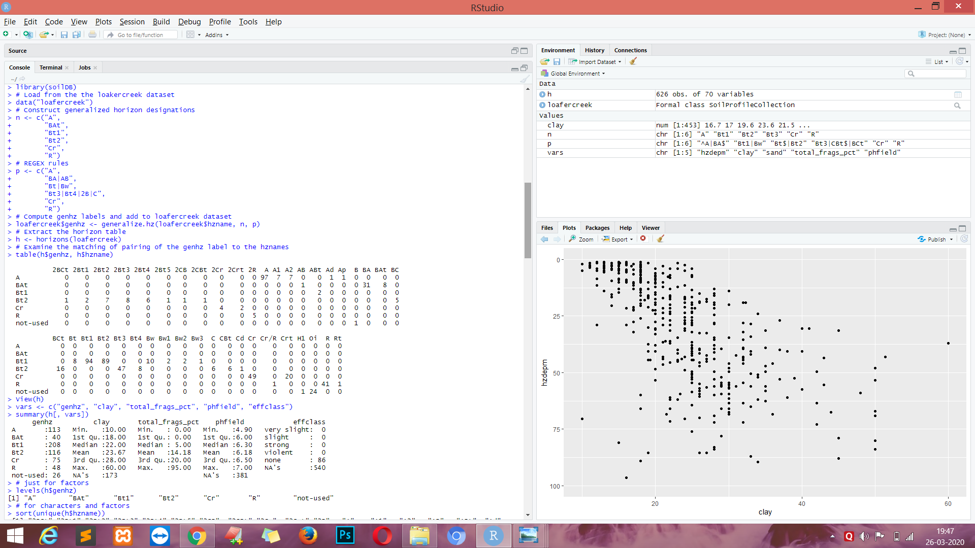

**CODE :-**

View(h)

vars <- c("genhz", "clay", "total_frags_pct", "phfield", "effclass")

summary(h[, vars])

# just for factors

levels(h$genhz)

# for characters and factors

sort(unique(h$hzname))

h$hzname <- ifelse(h$hzname == "BT", "Bt", h$hzname)

edit(h)

**OUTPUT :-**

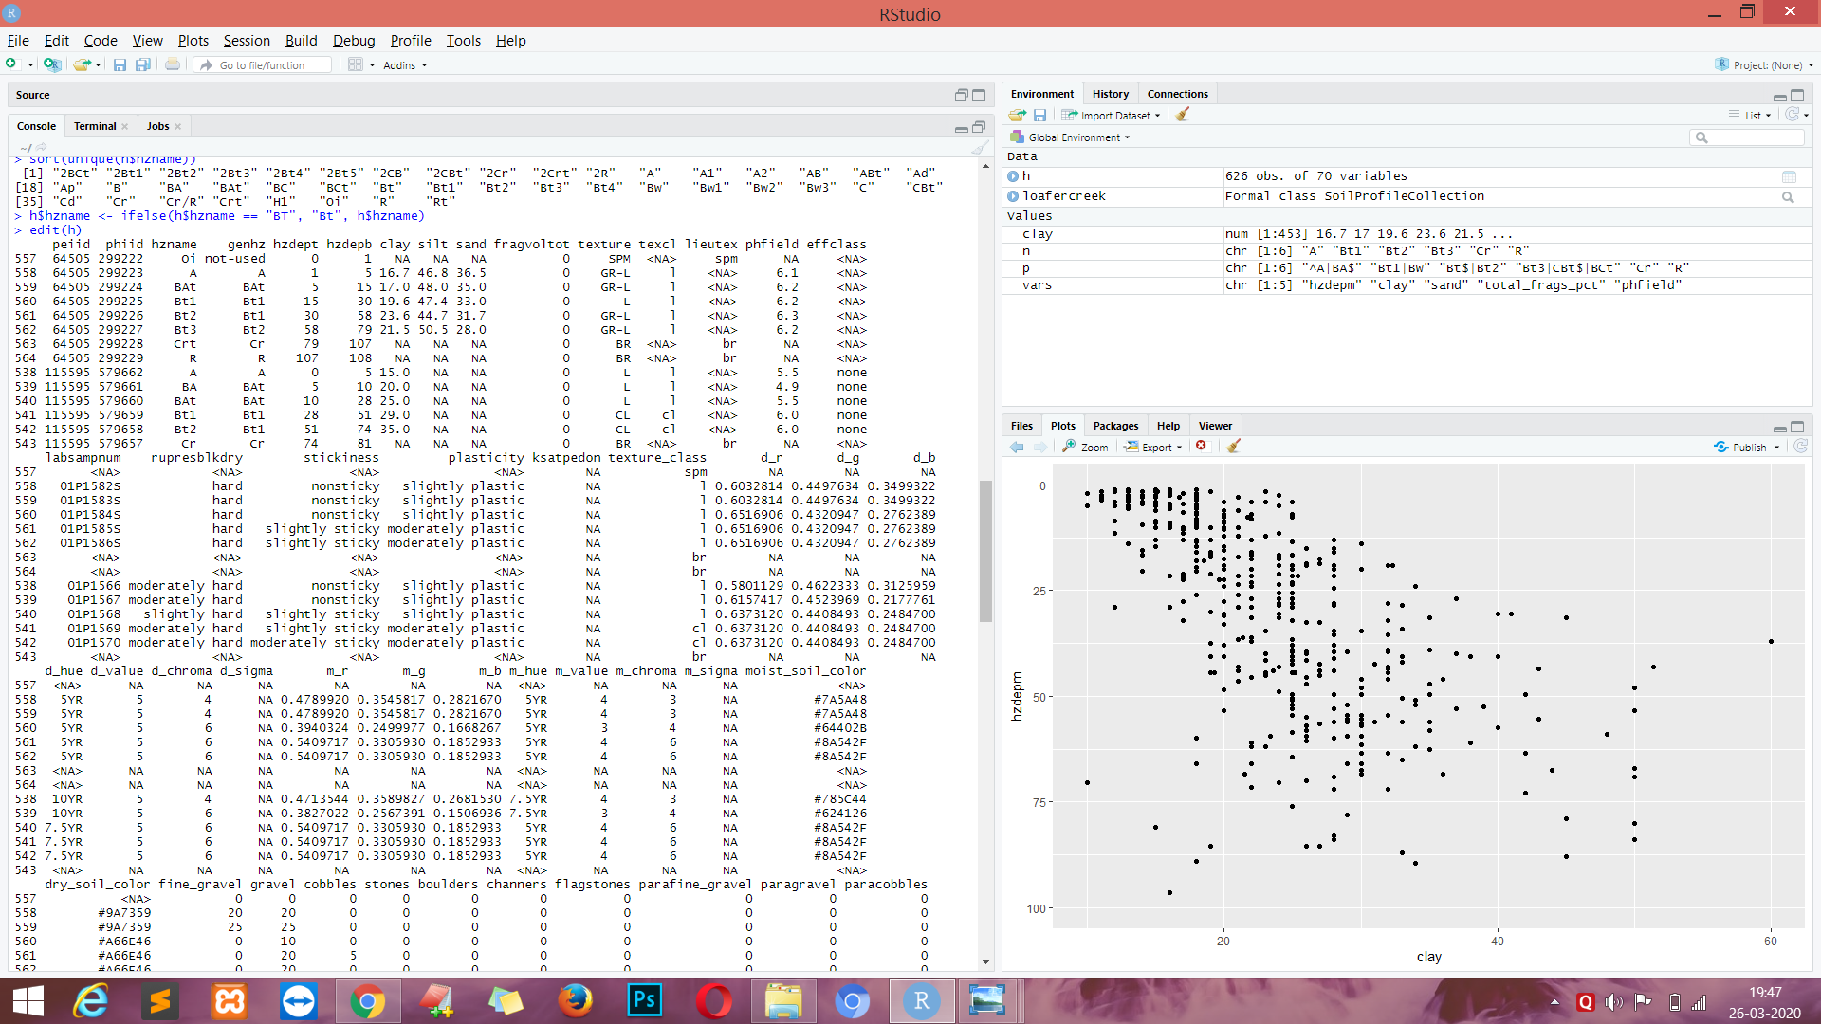

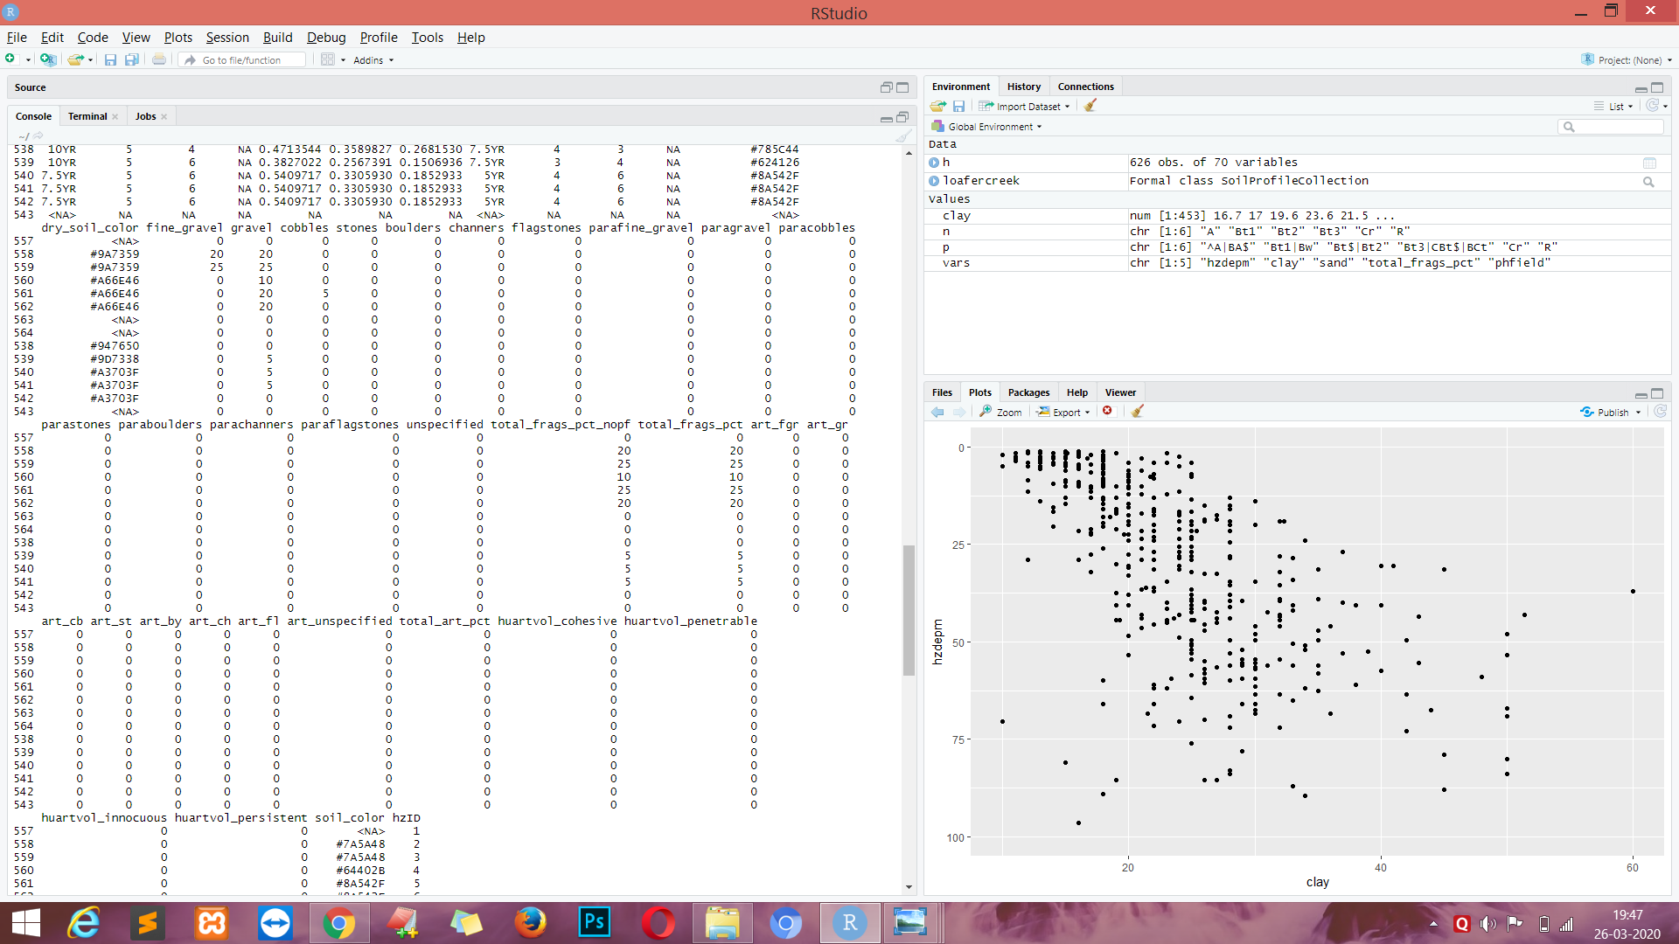

**CODE :-**

# gopheridge rules

n <- c('A', 'Bt1', 'Bt2', 'Bt3','Cr','R')

p <- c('^A|BA$', 'Bt1|Bw','Bt$|Bt2', 'Bt3|CBt$|BCt','Cr','R')

# first remove missing values and create a new vector

clay <- na.exclude(h$clay)

mean(clay)

median(clay)

sort(table(round(h$clay)), decreasing = TRUE)[1] # sort and select the 1st value, which will be the mode

range(clay)

diff(range(clay))

IQR(clay)

**OUTPUT :-**

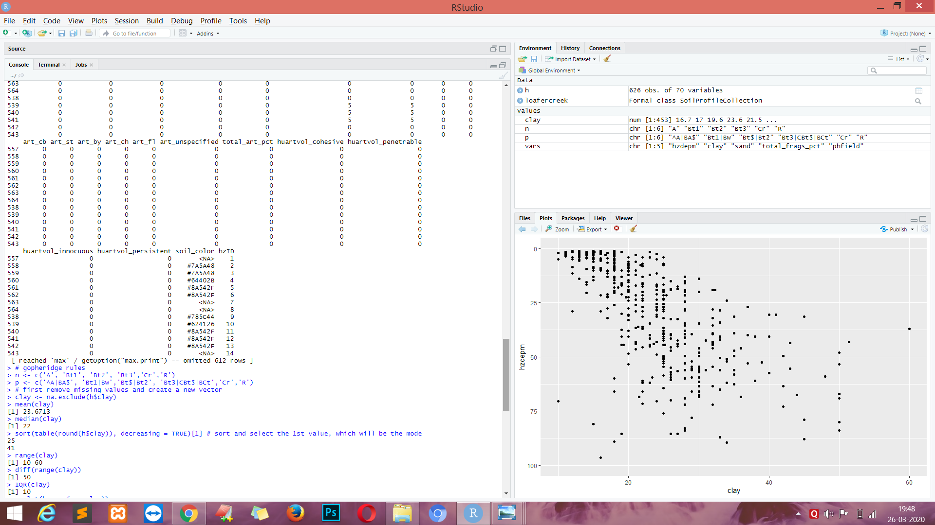

**CODE :-**

ggplot(h, aes(x = clay)) +

geom_histogram(bins = nclass.Sturges(h$clay))

ggplot(h, (aes(x = genhz, y = clay))) +

geom_boxplot()

h$hzdepm <- (h$hzdepb + h$hzdept) / 2 # Compute the middle horizon depth

vars <- c("hzdepm", "clay", "sand", "total_frags_pct", "phfield")

round(cor(h[, vars], use = "complete.obs"), 2)

# scatter plot

ggplot(h, aes(x = clay, y = hzdepm)) +

geom_point() +

ylim(100, 0)

sd(h$clay, na.rm = TRUE)

**OUTPUT :-**

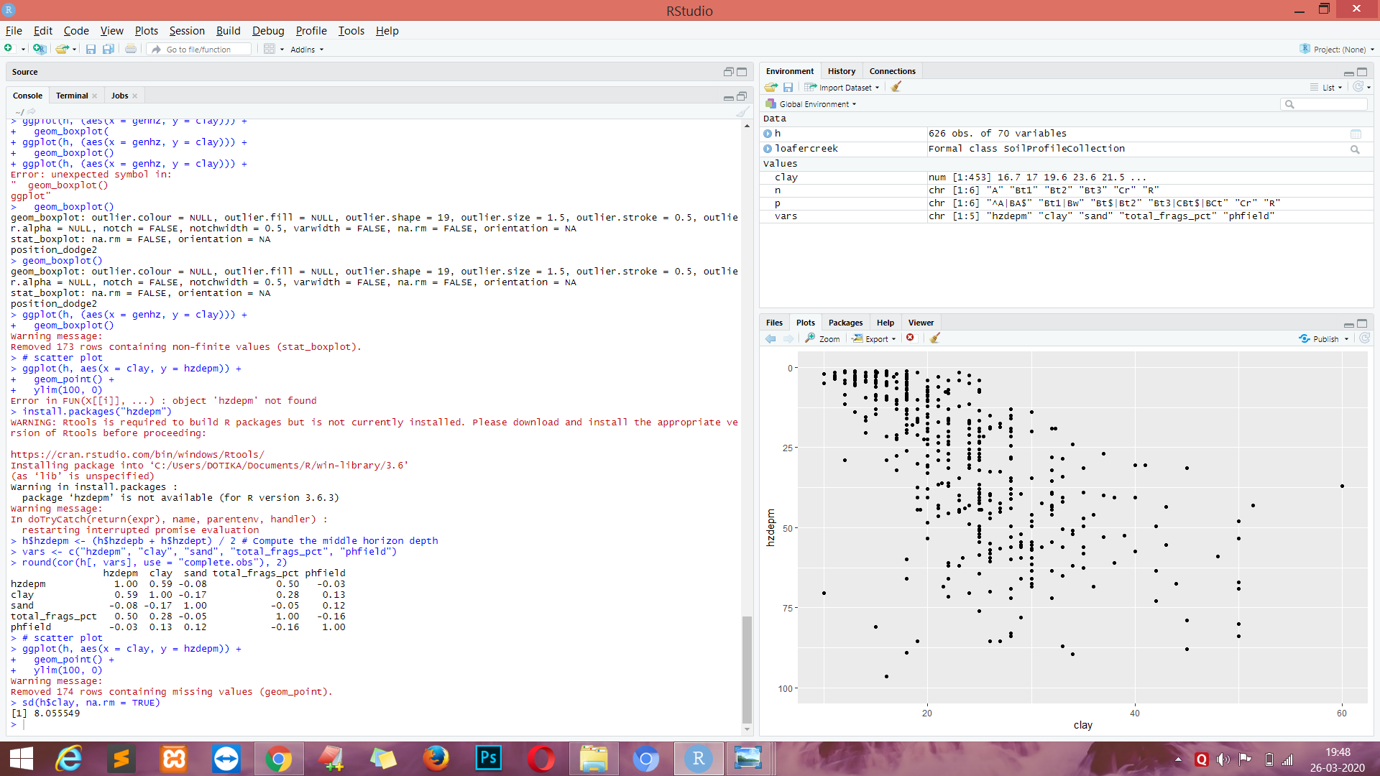

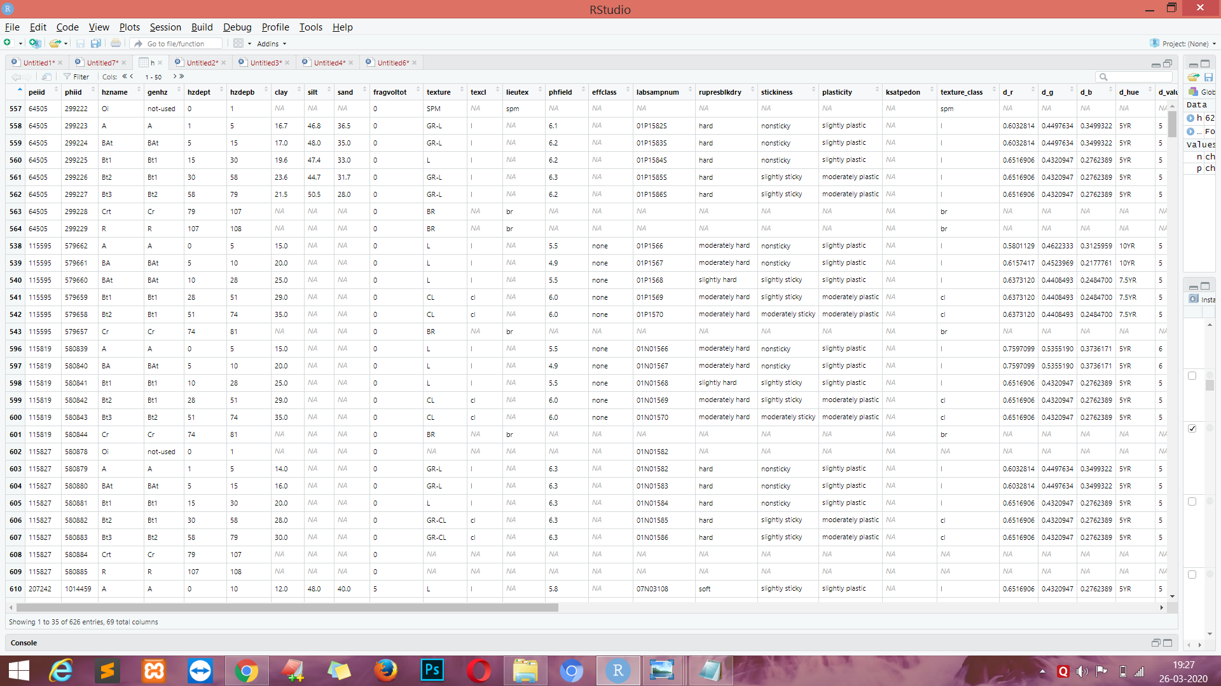

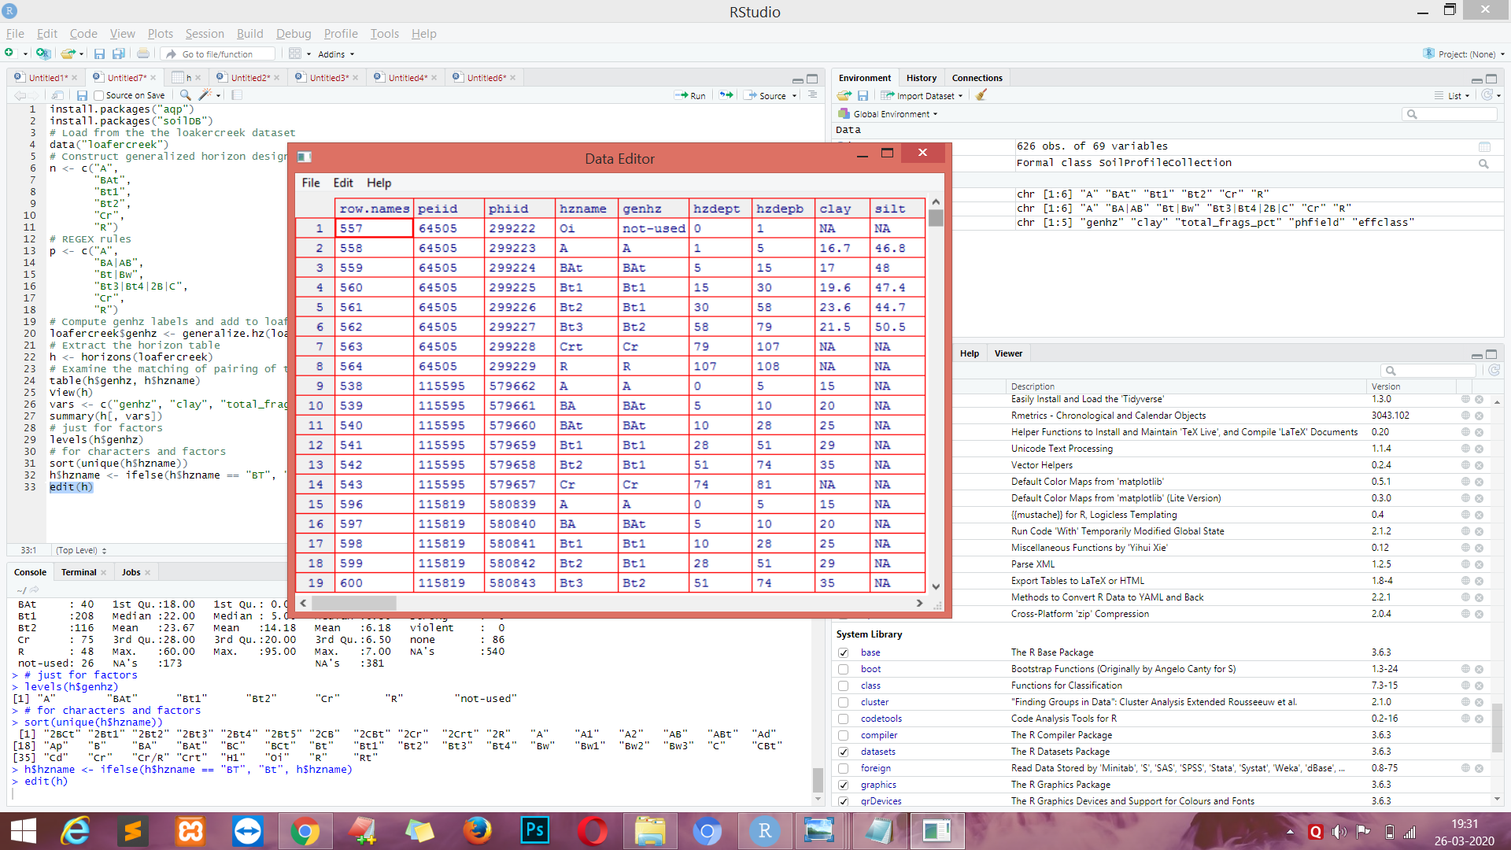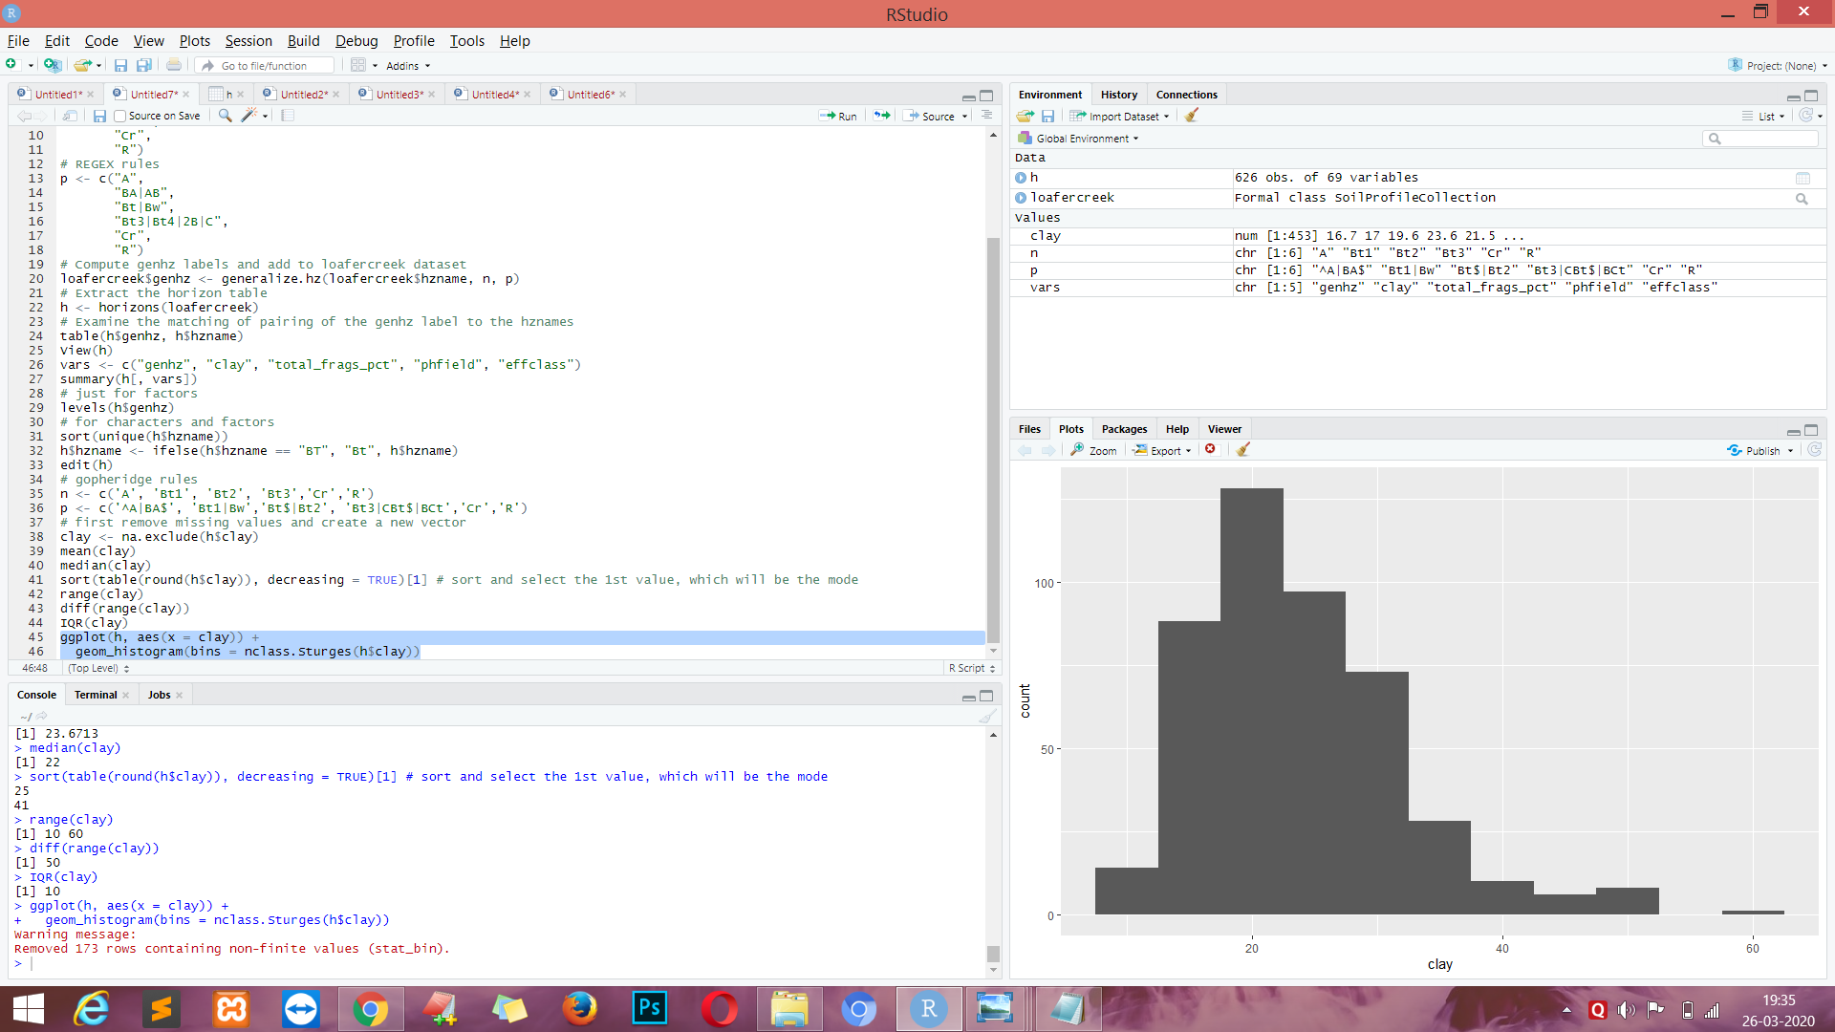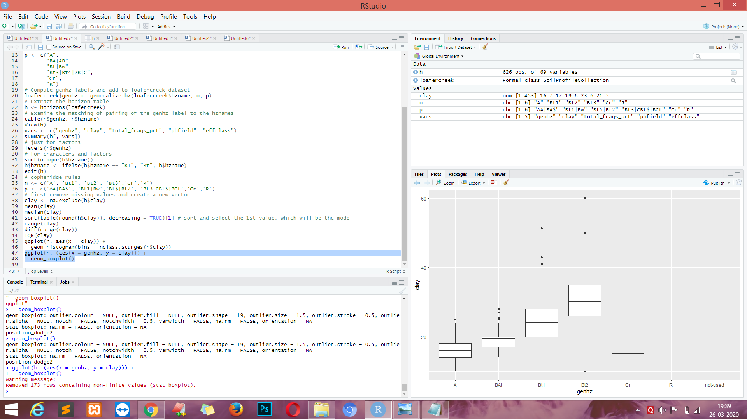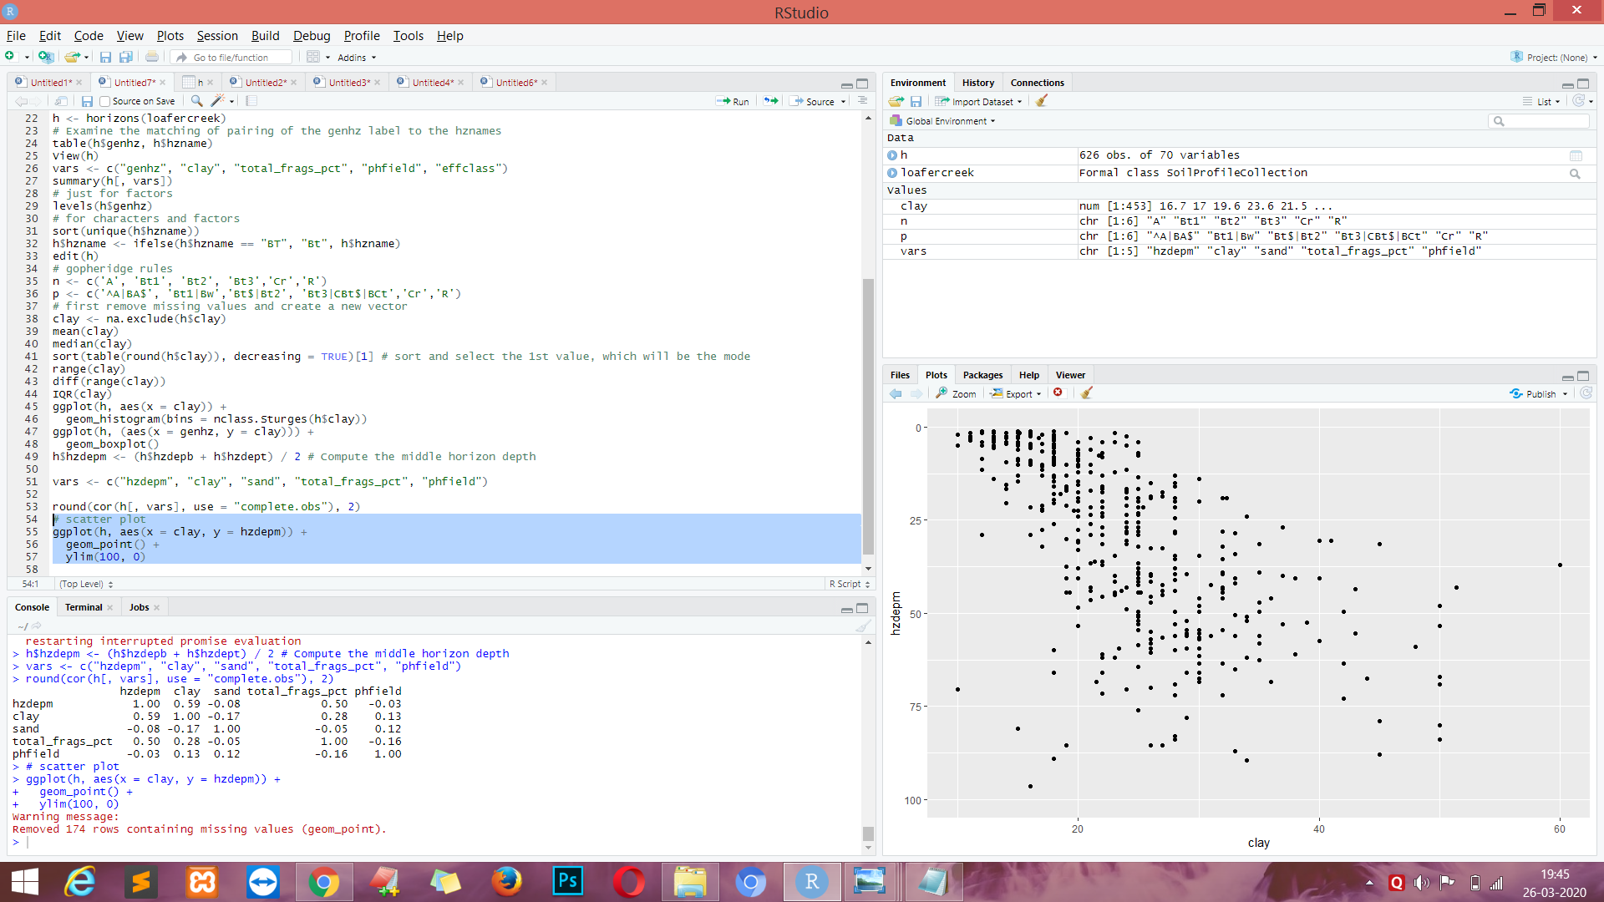

**EXPERIMENT NO. 8**

**Aim:**-Basic and Advanced Graphics in R

**Code:-**

City = read.csv("http://course1.winona.edu/bdeppa/DSCI%20415/Data/City77.csv")

row.names(City) = City$City

City = City[,-1]

names(City)

hist(City$medinc,prob=T,nclass=20,col="blue",main="Histogram of Median Income",xlab="Median Income")

lines(density(City$medinc),lty=2,col="red",lwd=2)

require(ggplot2)

a = ggplot(City,aes(medinc))

a + geom_histogram(binwidth=1000,aes(y=..density..),fill="blue",color="black") +

geom_density(linetype=2) +

xlab("Median Income") +

ggtitle("Median Income for Top 77 Cities")

**OUTPUT :-**

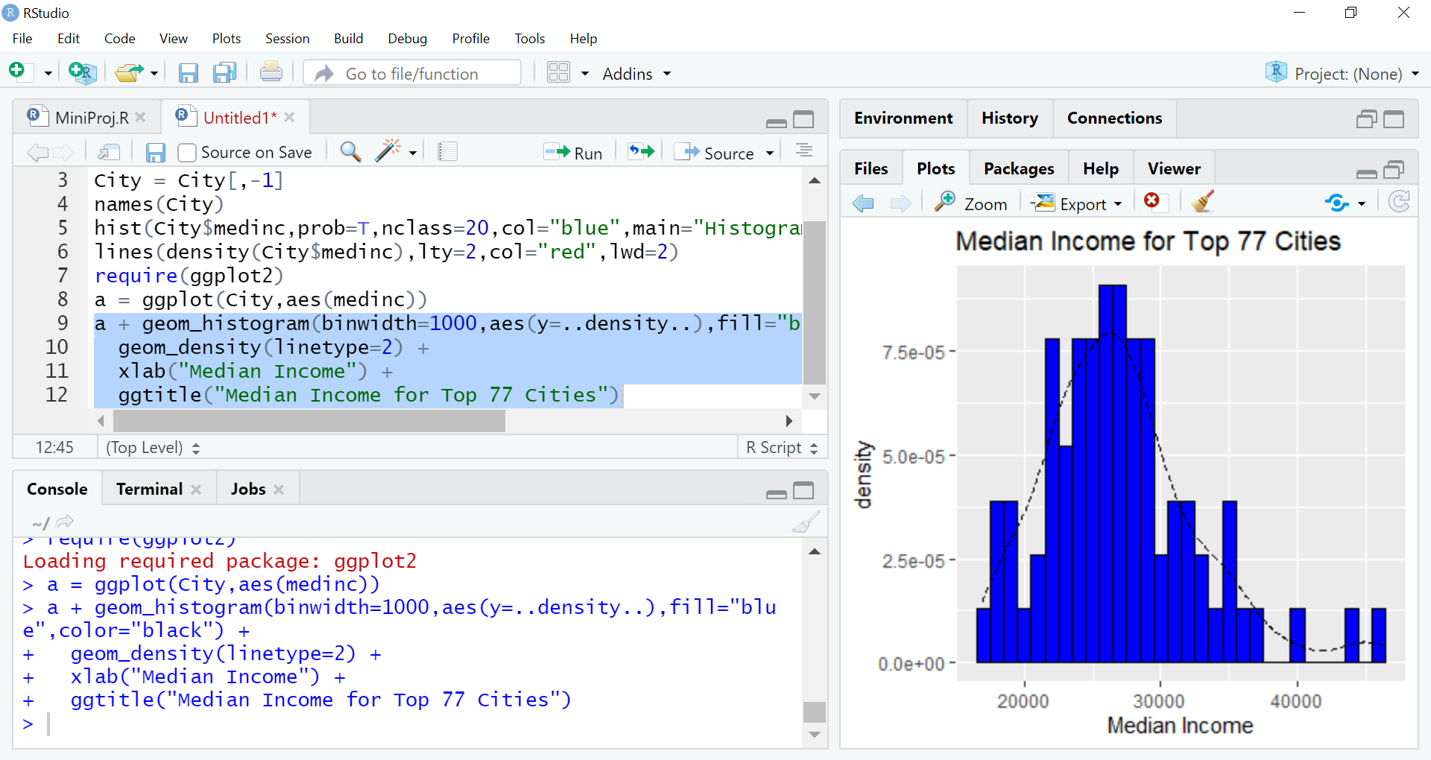

**CODE :-**

lines(lowess(City$poverty,City$infmort),lty=2,col="blue",lwd=2)

abline(lm(infmort~poverty,data=City),lwd=2)

title(main="Infant Morality vs. Poverty Level")

**OUTPUT :-**

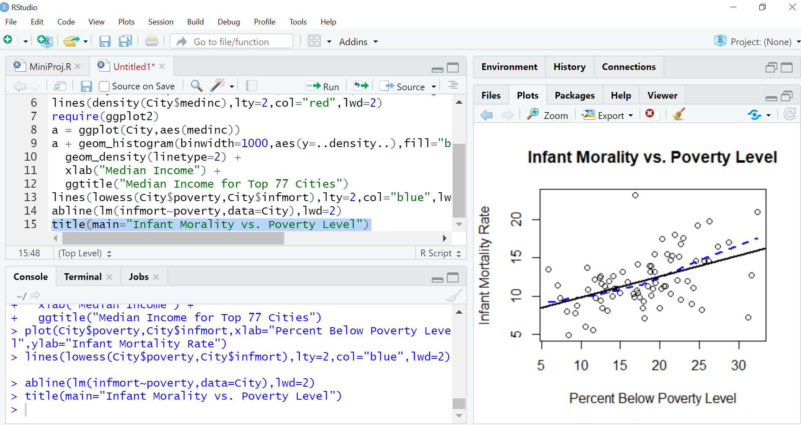

**CODE :-**

a = ggplot(City,aes(poverty,infmort))

a + geom_point() + geom_smooth() +

geom_text(aes(label=row.names(City)),size=2) +

xlab("Poverty") + ylab("Infant Mortality") +

ggtitle("Infant Mortality vs. Poverty Rate")

**OUTPUT :-**

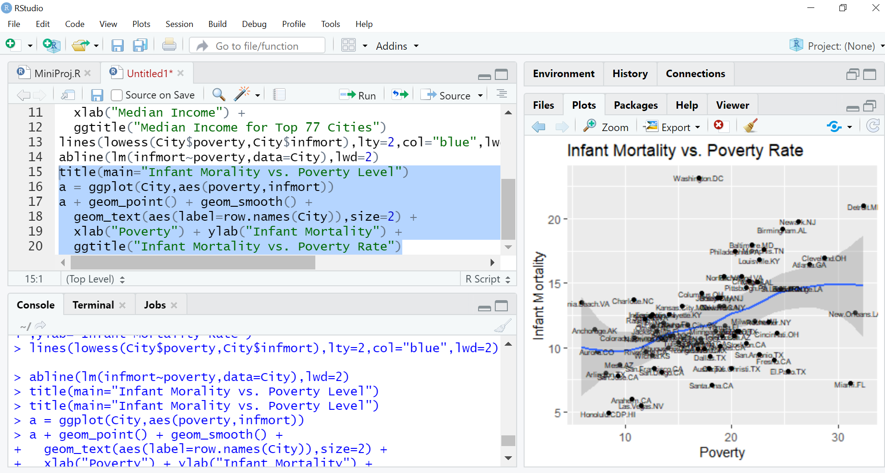

**CODE :-**

Olives = read.csv("http://course1.winona.edu/bdeppa/DSCI%20415/Data/Olives.txt")

names(Olives)

par(mfrow=c(3,2)) # sets a plotting region for with 3 rows and 2 columns

boxplot(split(Olives$Oleic,Olives$Area.Name),xlab="Area",ylab="Oleic Acid")

boxplot(split(Olives$Linoleic,Olives$Area.Name),xlab="Area",ylab="Linoleic Acid")

boxplot(split(Olives$Strearic,Olives$Area.Name),xlab="Area",ylab="Strearic Acid")

boxplot(split(Olives$Linolenic,Olives$Area.Name),xlab="Area",ylab="Linolenic Acid")

boxplot(split(Olives$Eicosanoic,Olives$Area.Name),xlab="Area",ylab="Eicosanoic Acid")

boxplot(split(Olives$Eicosenoic,Olives$Area.Name),xlab="Area",ylab="Eicosenoic Acid")

**OUTPUT :-**

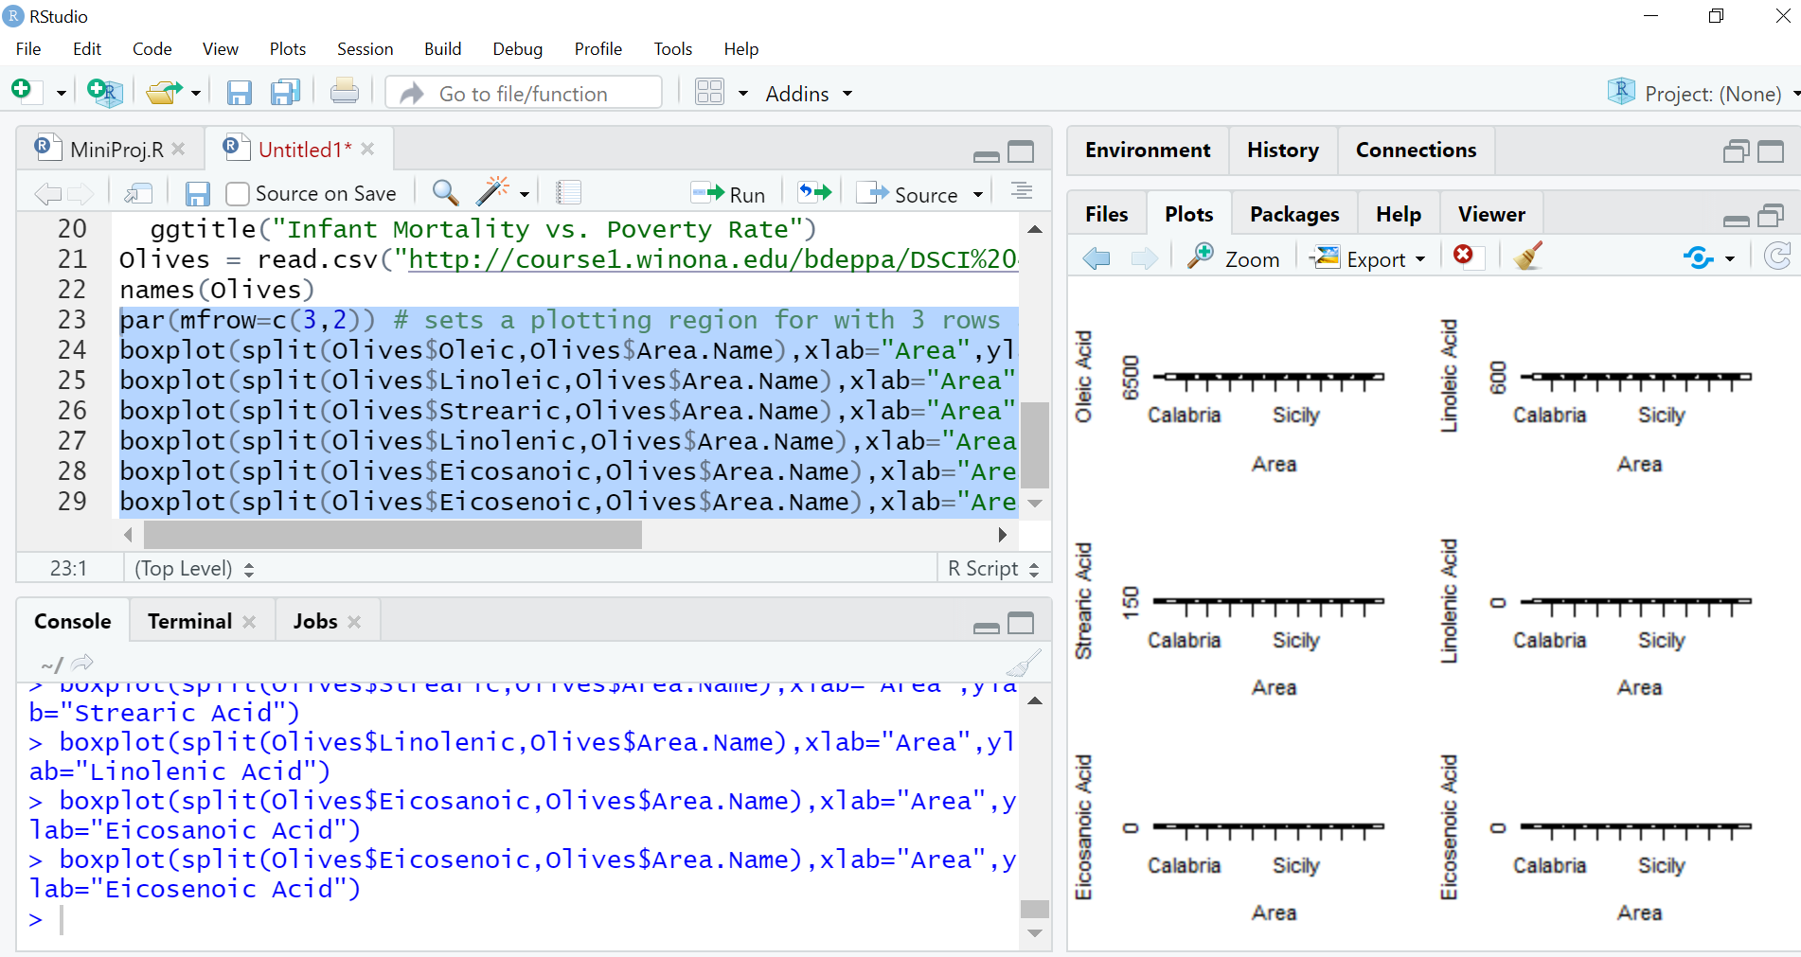

**CODE :-**

install.packages("s20x")

require("s20x")

boxqq(Oleic~Region.Name,data=Olives)

**OUTPUT :-**

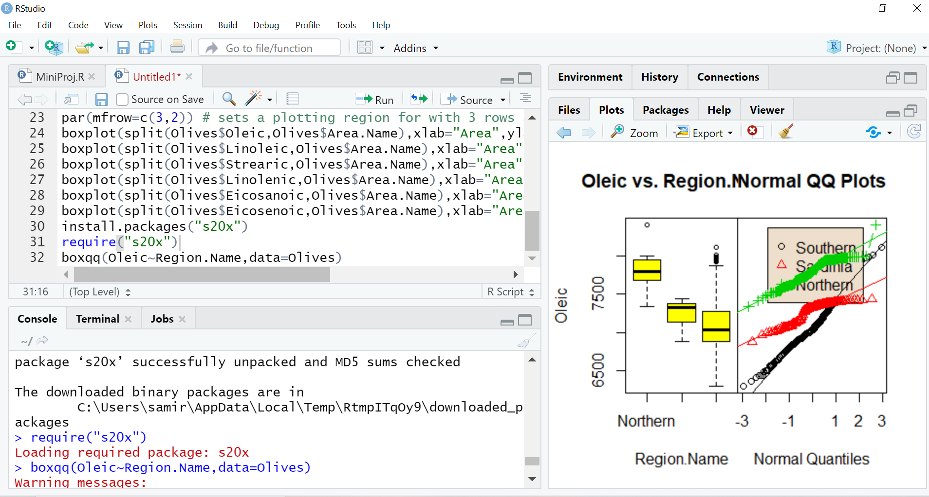

**CODE :-**

a = ggplot(Olives,aes(Area.Name,Oleic))

a + geom_boxplot(fill="lightblue") + xlab("Area Name") +

ylab("Oleic Acid") + ggtitle("Oleic Acid vs. Growing Area")

a = ggplot(Olives,aes(Area.Name,Oleic))

a + geom_violin(fill="lightblue") + xlab("Area Name") +

ylab("Oleic Acid") + ggtitle("Oleic Acid vs. Growing Area")

install.packages("violinmplot")

require(violinmplot)

violinmplot(Area.Name~Oleic,xlab="Oleic Acid",ylab="Area Name",data=Olives,horizontal=T)

Statplot(Olives$Linoleic,xname="Linoleic")

data("UCBAdmissions")

UCBAdmissions

temp = data.frame(UCBAdmissions)

temp

DeptCount = margin.table(UCBAdmissions,3)

DeptCount

par(mfrow=c(1,2))

pie(DeptCount)

barplot(DeptCount,xlab="Department",ylab="Frequency")

**OUTPUT :-**

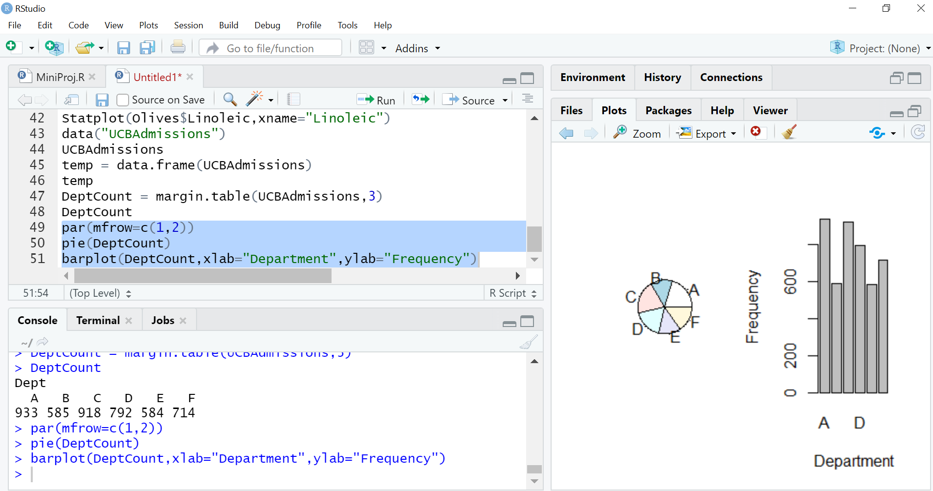

**CODE :-**

names(Olives)

olive.mat = Olives[,c(7,6,5,3)]

pairs(olive.mat)

**OUTPUT :-**

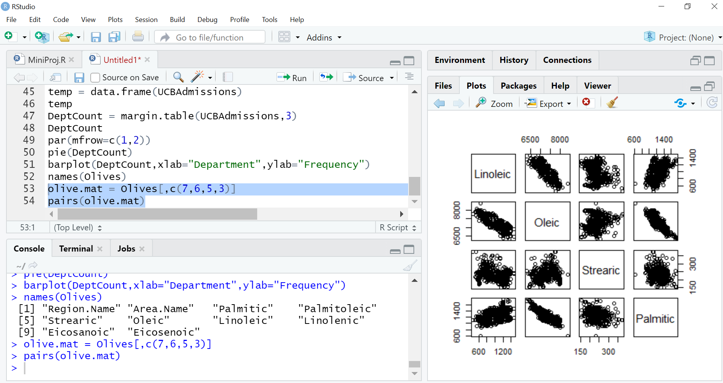

**CODE :-**

panel.cor = function (x, y, digits = 2, prefix = "", cex.cor)

{

usr <- par("usr")

on.exit(par(usr))

par(usr = c(0, 1, 0, 1))

r <- abs(cor(x, y))

txt <- format(c(r, 0.123456789), digits = digits)[1]

txt <- paste(prefix, txt, sep = "")

if (missing(cex.cor))

cex <- 0.8/strwidth(txt)

text(0.5, 0.5, txt, cex = cex * r)

}

panel.trendsd = function (x, y, f = 0.5)

{

par(err = -1)

xs <- sort(x, index = T)

x <- xs$x

ix <- xs$ix

y <- y[ix]

trend <- lowess(x, y, f)

e2 <- (y - trend$y)^2

scatter <- lowess(x, e2)

uplim <- trend$y + sqrt(abs(scatter$y))

lowlim <- trend$y - sqrt(abs(scatter$y))

points(x, y, pch = 1)

lines(trend, col = "Blue")

lines(scatter$x, uplim, lty = 2, col = "Red")

lines(scatter$x, lowlim, lty = 2, col = "Red")

invisible()

}

panel.hist = function (x, ...)

{

usr <- par("usr")

on.exit(par(usr))

par(usr = c(usr[1:2], 0, 1.5))

h <- hist(x, plot = FALSE)

breaks <- h$breaks

nB <- length(breaks)

y <- h$counts

y <- y/max(y)

rect(breaks[-nB], 0, breaks[-1], y, col = "cyan", ...)

}

pairs.trendsd = function(data,...) {

pairs(data,lower.panel=panel.cor,upper.panel=panel.trendsd,

diag.panel=panel.hist,...)}

require(lattice)

pairs.trendsd(olive.mat)

**OUTPUT :-**

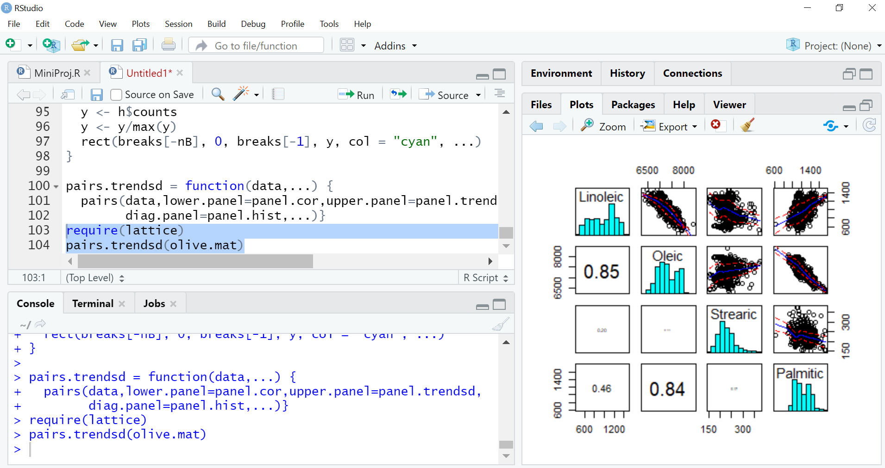

**CODE :-**

data(iris)

names(iris)

library(lattice)

xyplot(Sepal.Length~Petal.Length|Species,data=iris)

**OUTPUT :-**

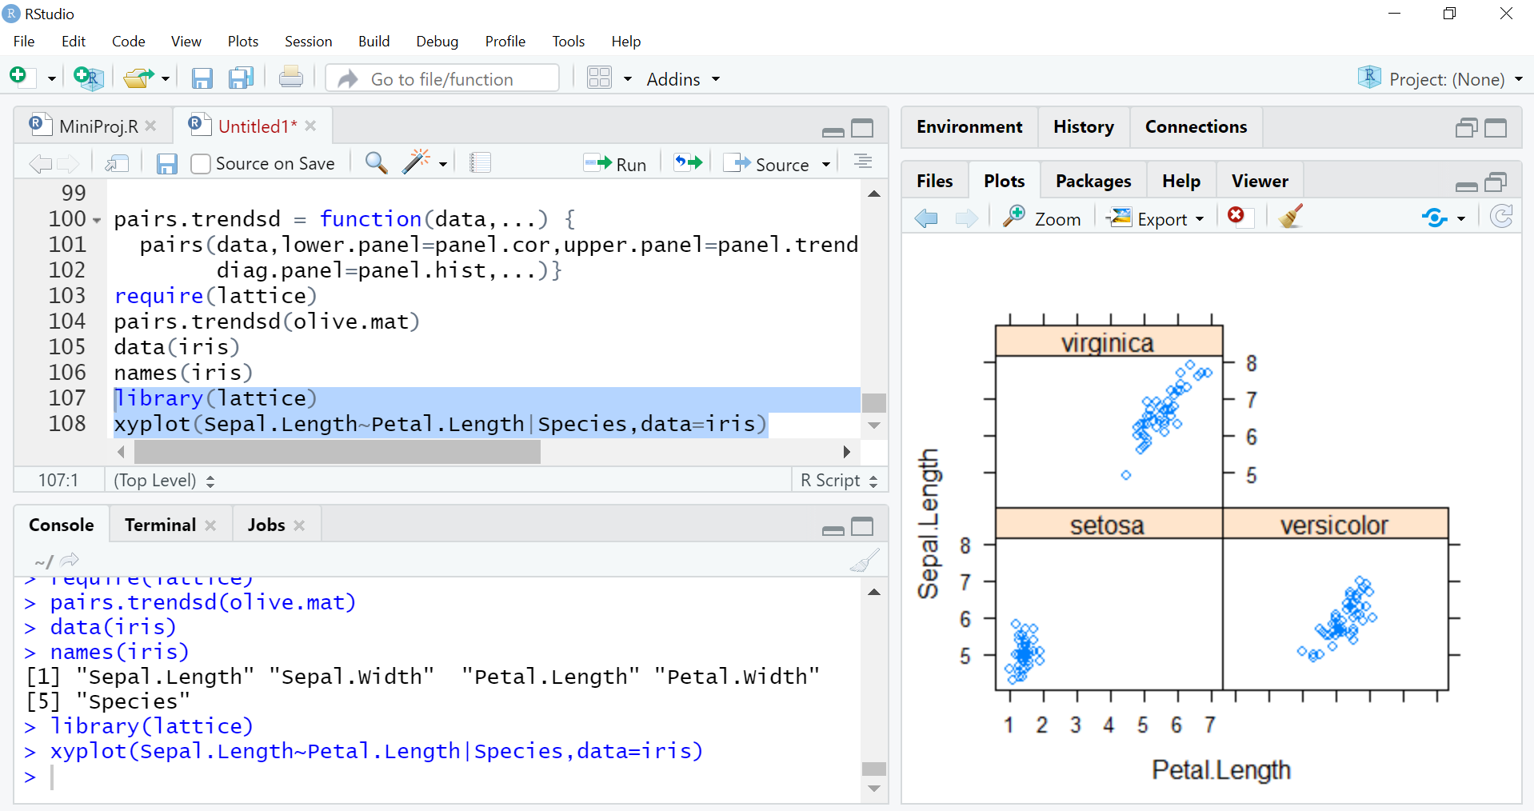

**CODE :-**

SepWid = equal.count(iris$Sepal.Width)

print(SepWid)

xyplot(Sepal.Length~Petal.Length|SepWid,data=iris)

**OUTPUT :-**

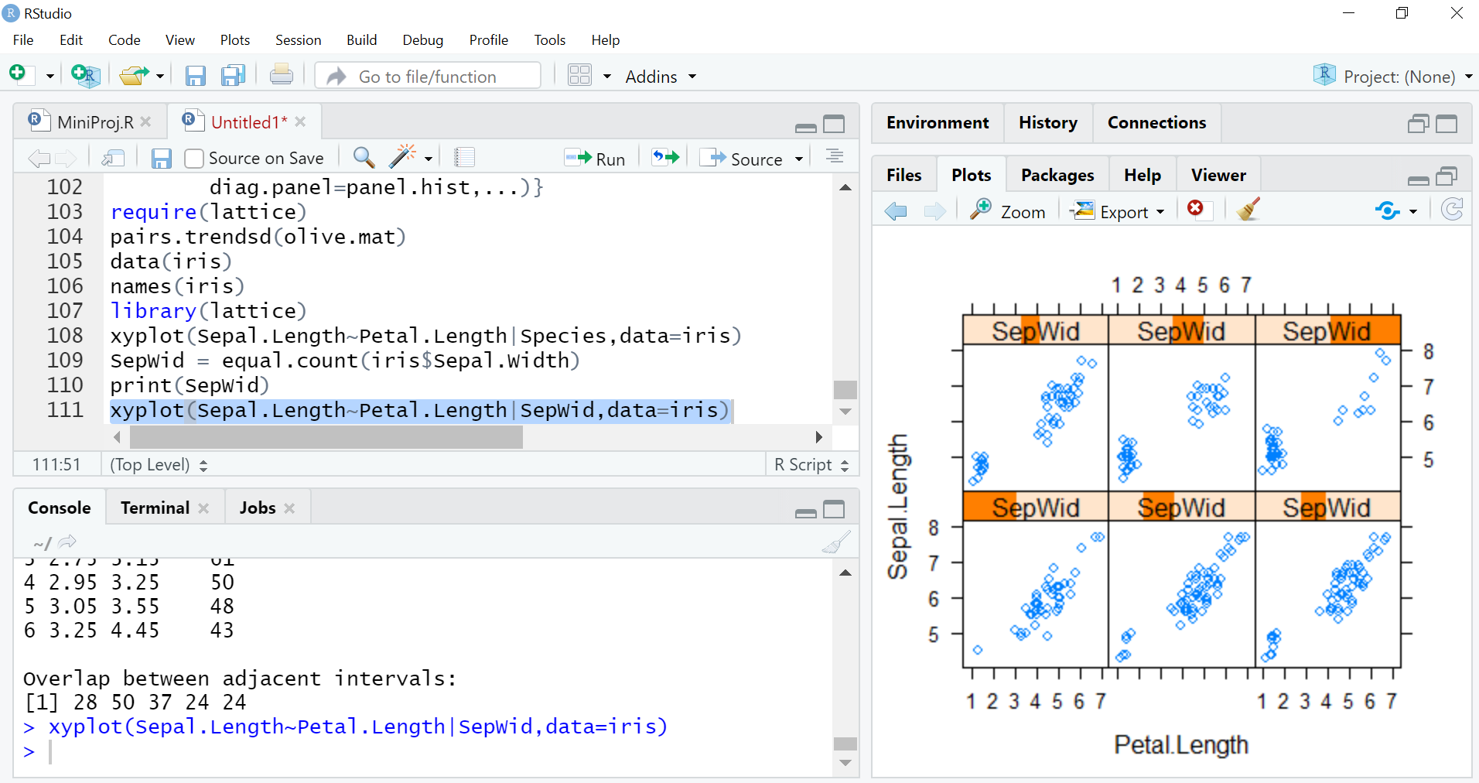

**CODE :-**

xyplot(Sepal.Length~Petal.Length|SepWid,groups=Species,layout=c(3,2),

auto.key=list(columns=3),main="Sepal Length * Petal Length | Sepal

Width",data=iris)

splom(~iris[,1:4],groups=Species,auto.key=list(columns=3),data=iris)

**OUTPUT :-**

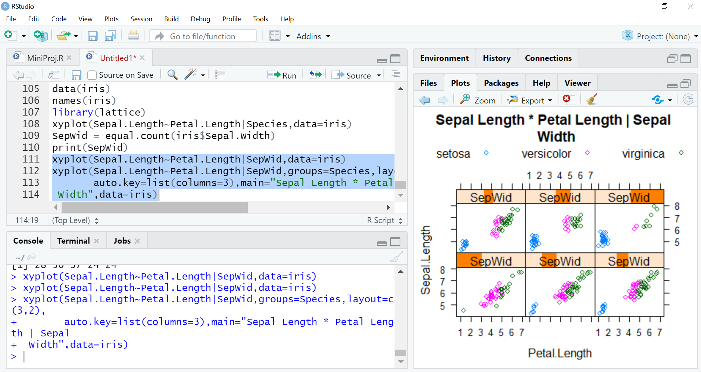

**CODE :-**

bwplot(Species~Sepal.Width,data=iris,xlab="Sepal Width (mm)",main="Boxplots of Iris Sepal Width")

**OUTPUT :-**

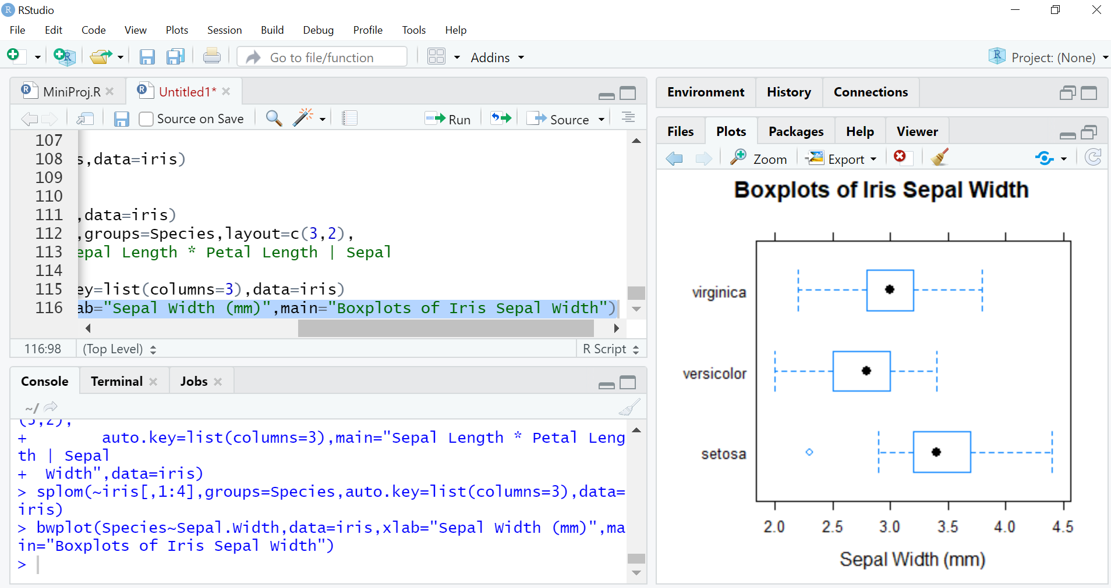

**CODE :-**

stripplot(Species ~ jitter(Sepal.Width), data = iris, xlab="Sepal Width (mm)",main="Sepal Width Across Species")

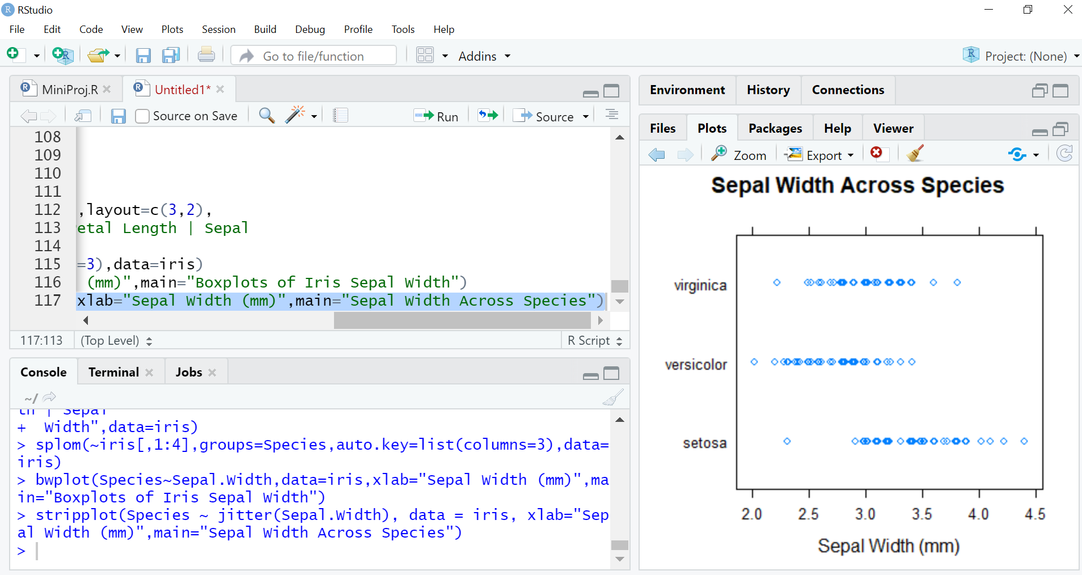

coplot(Sepal.Width~Sepal.Length|Species,data=iris)

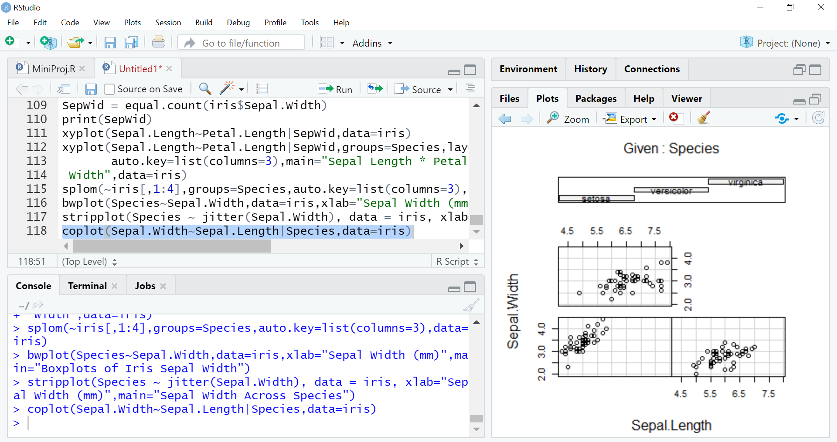

**CODE :-**

coplot(Sepal.Width~Sepal.Length|Petal.Width*Petal.Length,number=c(3,3),

overlap=.5,col=as.numeric(iris$Species),pch=as.numeric(iris$Species)+1,data=iris)

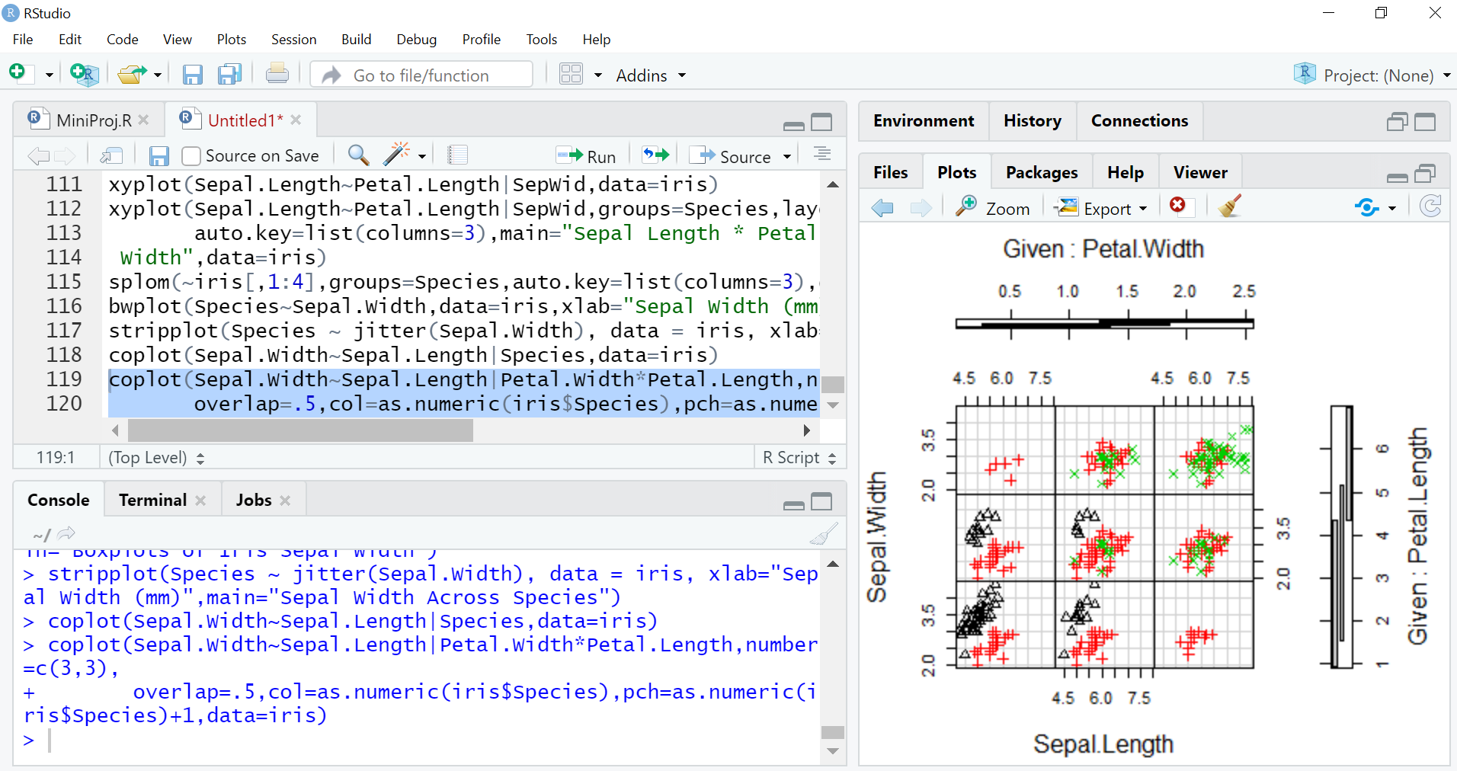

**CODE :-**

install.packages("ash")

library(ash)

Swiss = read.csv("http://course1.winona.edu/bdeppa/DSCI%20415/Data/Swiss.csv")

names(Swiss)

d1 = ash1(bin1(Swiss$diagon,nbin=50),3)

hist(Swiss$diagon,nclass=20,prob=T,col="blue",main="Histogram of Bill Diagonal (mm)")

lines(d1)

**OUTPUT :-**

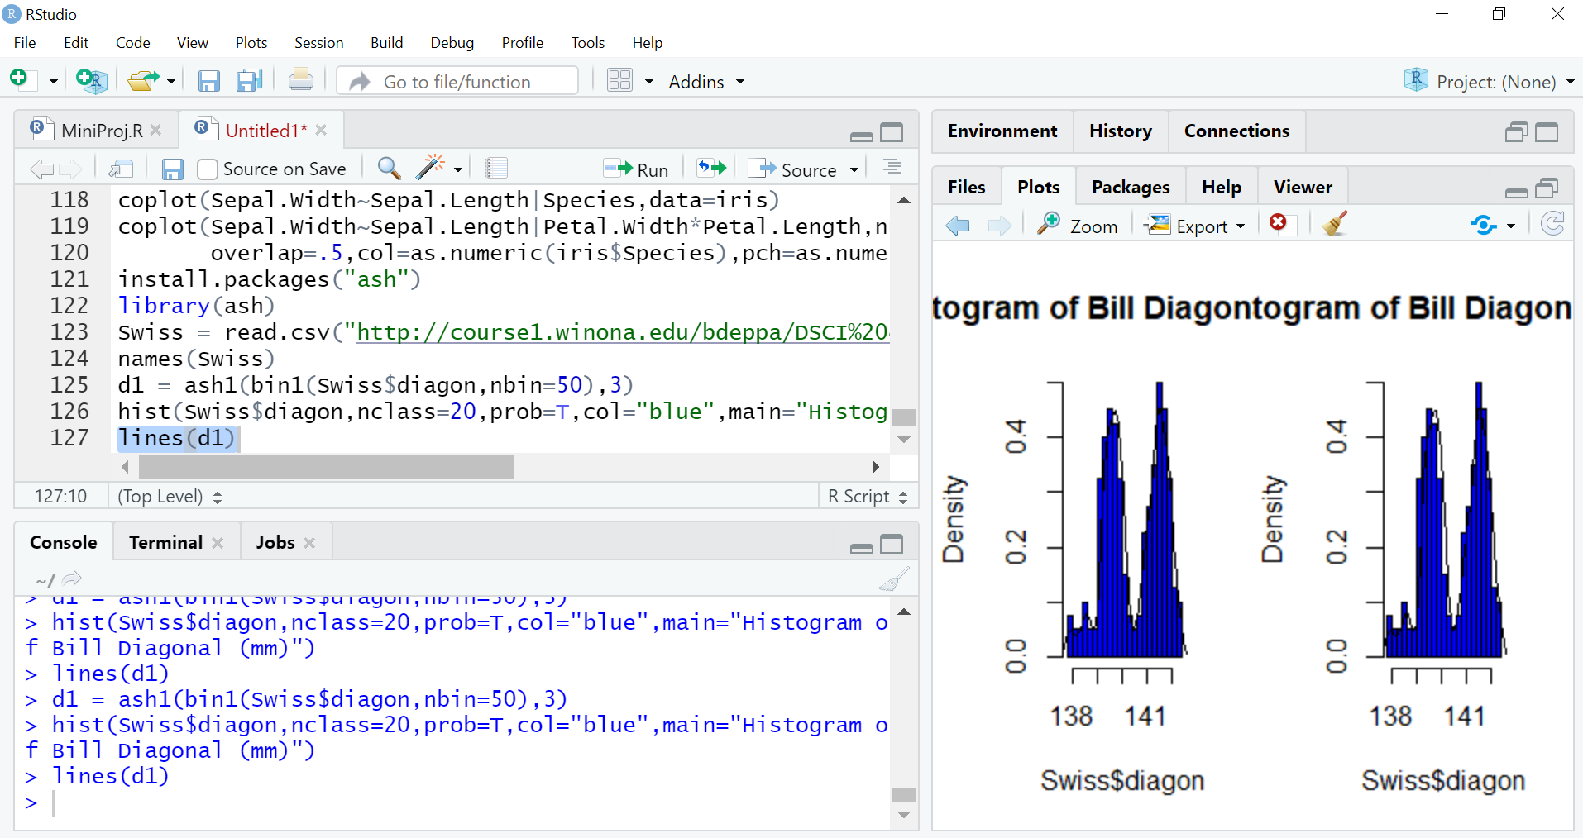

**CODE :-**

Statplot(Swiss$diagon)

diagrt.bin <- bin2(cbind(Swiss$diagon,Swiss$right),nbin=c(50,50))

diagrt.1 <- ash2(diagrt.bin,m=c(5,5))

persp(diagrt.1,xlab="Diagonal Length",ylab="Right Height",zlab="",cex=.5,theta=-45,phi=30,shade=1,col="royal blue")

image(diagrt.1,xlab="Bill Diagonal",ylab="Right Height")

contour(diagrt.1,xlab="Bill Diagonal",ylab="Right Height",add=T)

points(Swiss$diagon,Swiss$right,pch=as.character(Swiss$genu),cex=.4)

**OUTPUT :-**

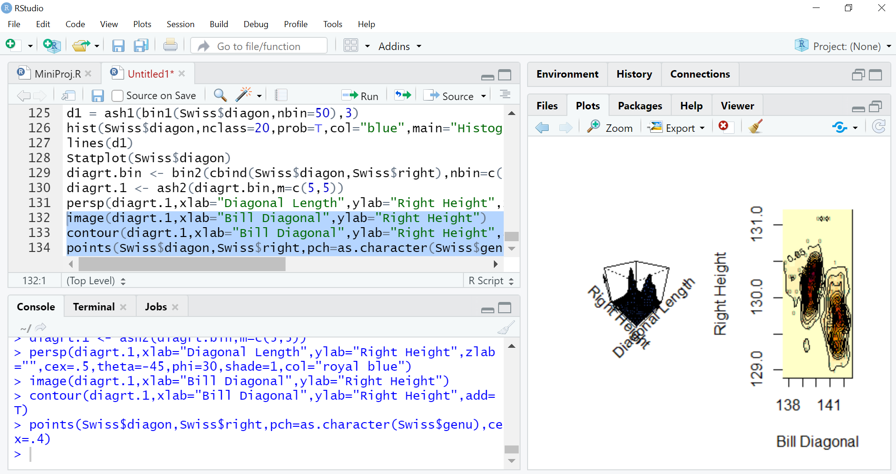

**CODE :-**

Genuine <- Swiss$genu

Genuine[Genuine==0] <- "Forged"

Genuine[Genuine==1] <- "Real"

xyplot(Swiss$diagon~Swiss$bottom|Genuine,groups=Genuine)

**OUTPUT :-**

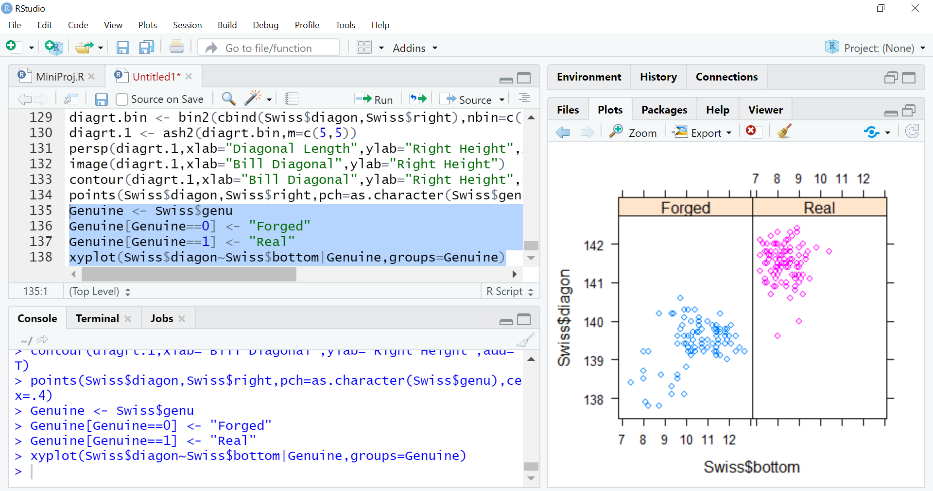

splom(~Swiss[,1:6],groups=Genuine,auto.key=list(columns=2))

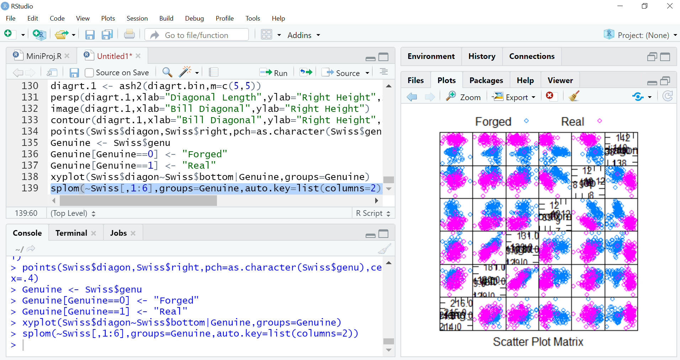

**CODE :-**

pairs.image <- function(x) {

pairs(x,panel=function(x,y) {

foo <- bin2(cbind(x,y),nbin=c(75,75))

foo <- ash2(foo,m=c(6,6))

image(foo,add=T,xlab="",ylab="",col=topo.colors(1000))

points(x,y,pch=".")

})

}

pairs.image(Swiss[,1:6])

**OUTPUT :-**

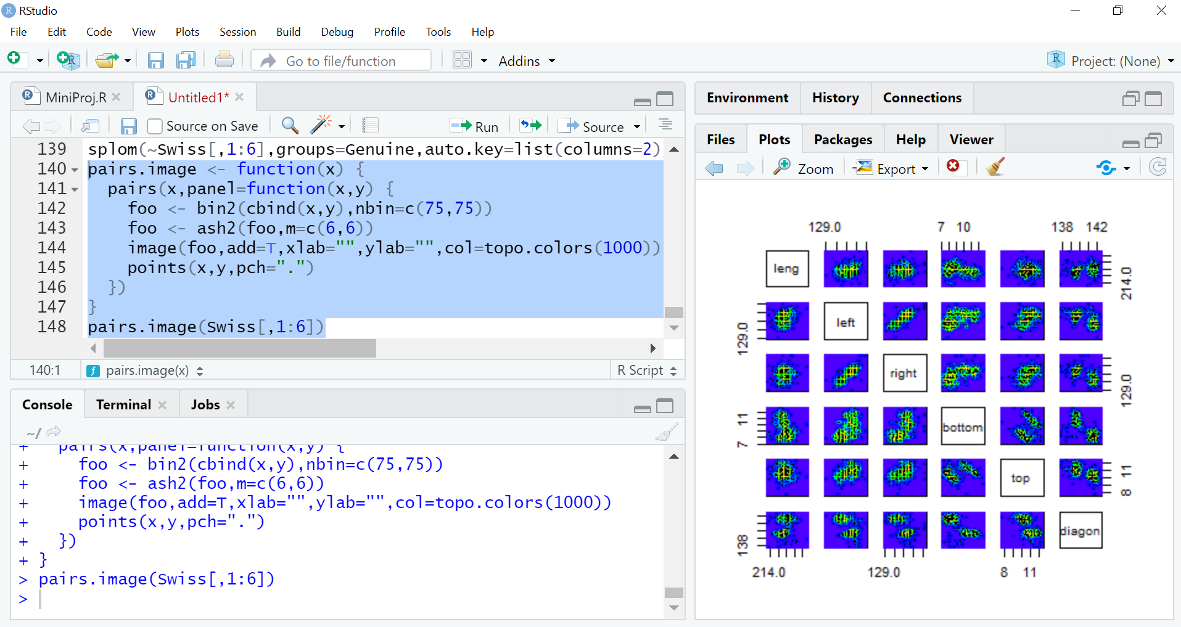

**CODE :-**

pairs.persp <- function(x) {

par(bg="sky blue")

pairs(x,panel=function(x,y) {

foo <- bin2(cbind(x,y),nbin=c(75,75))

foo <- ash2(foo,m=c(8,8))

par(new=T)

persp(foo,xlab="",ylab="",theta=-45,phi=35,col="royal blue",

shade=.75,box=F,scale=F,border=NA,expand=.9)

})

par(new=F,bg="white")

}

pairs.persp(Swiss[,1:3])

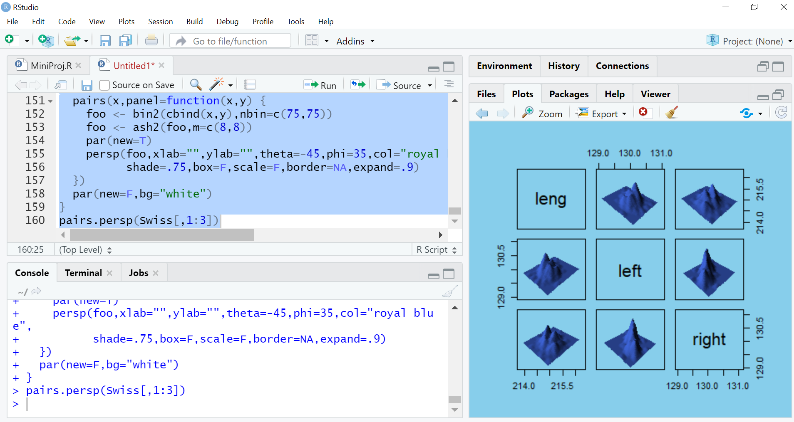

**EXPERIMENT NO. 9**

**AIM :-** Basic of correlation - Simple & Multiple Regression in R

**THEORY :-**

install.packages("magrittr")

install.packages("ggplot2")

to_correlate <- mtcars %>% dplyr::select(qsec, cyl, disp, hp)

cor(to_correlate)

cor.test(mtcars$qsec, mtcars$cyl)

cor.test(mtcars$qsec, mtcars$cyl, conf.level = 0.9)

ggplot(to_correlate, aes(x=cyl, y=qsec)) + geom_jitter(width=0.1) + stat_smooth(method="lm", se=FALSE)

**OUTPUT :-**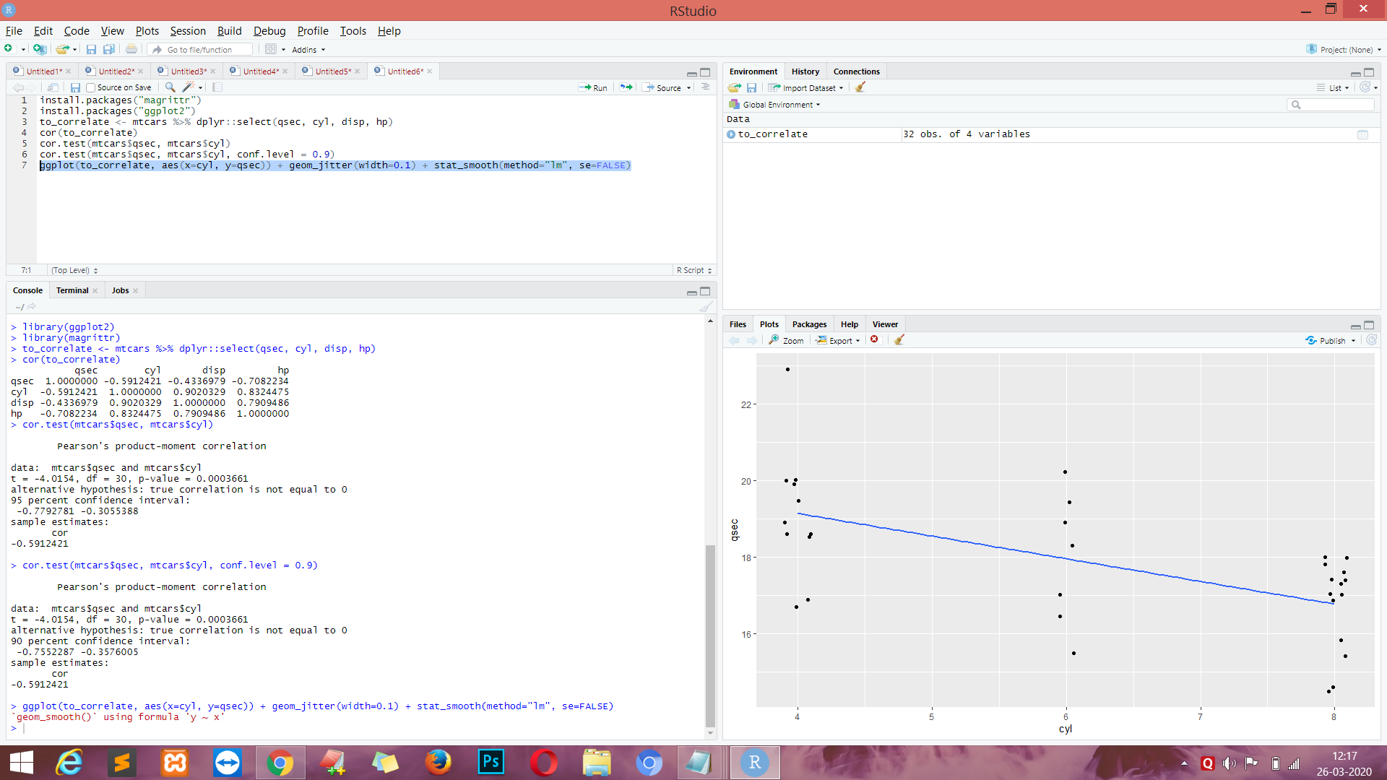

**CODE :-**

install.packages("Hmisc")

Hmisc::rcorr(to_correlate %>% as.matrix())

stargazer(cor(to_correlate), type = "html")

install.packages("stargazer")

stargazer(cor(to_correlate), type = "html")

apaTables::apa.cor.table(to_correlate)

install.packages("apaTables")

apaTables::apa.cor.table(to_correlate)

ctest <- cor.test(mtcars$qsec, mtcars$cyl)

str(ctest)

ctest$p.value

ctest$estimate

broom::glance(ctest)

cor.test(mtcars$qsec, mtcars$cyl, method = "spearman")

cor(to_correlate, method = "spearman")

to_correlate_miss <- to_correlate

to_correlate_miss$qsec[c(1, 5)] <- NA

cor(to_correlate_miss) #implicitly use="everything"

cor(to_correlate_miss, use="pairwise.complete.obs")

ggplot(cars, aes(x=speed, y=dist)) +

geom_point(color='darkblue', size = 3) +

geom_smooth(method=lm, se=FALSE, fullrange=TRUE, color='black', size=1.2) +

labs(x="Speed (mph)", y="Stopping distance (ft)")

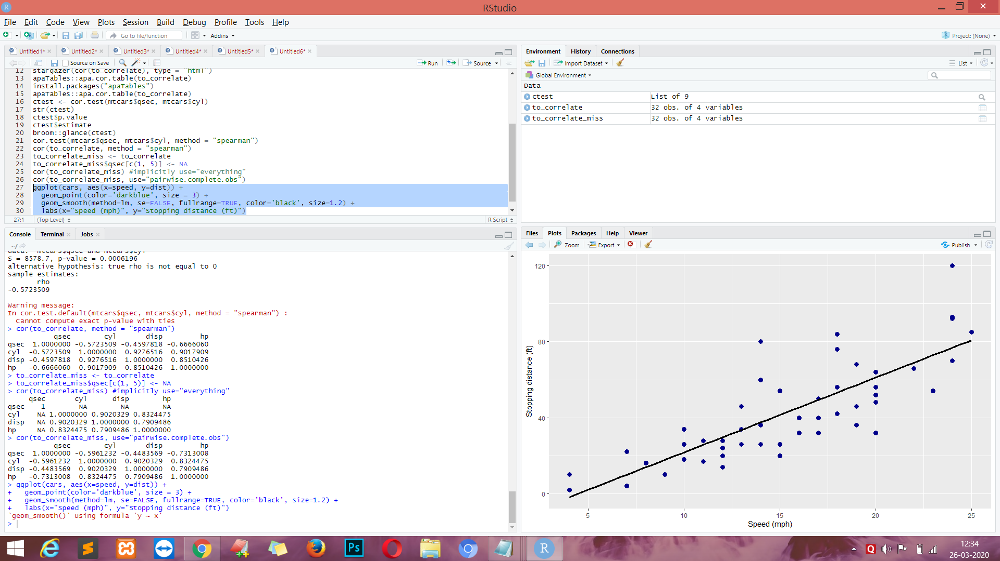

lm_cars <- lm(dist ~ speed, data=cars)

summary(lm_cars)

plot(lm_cars)

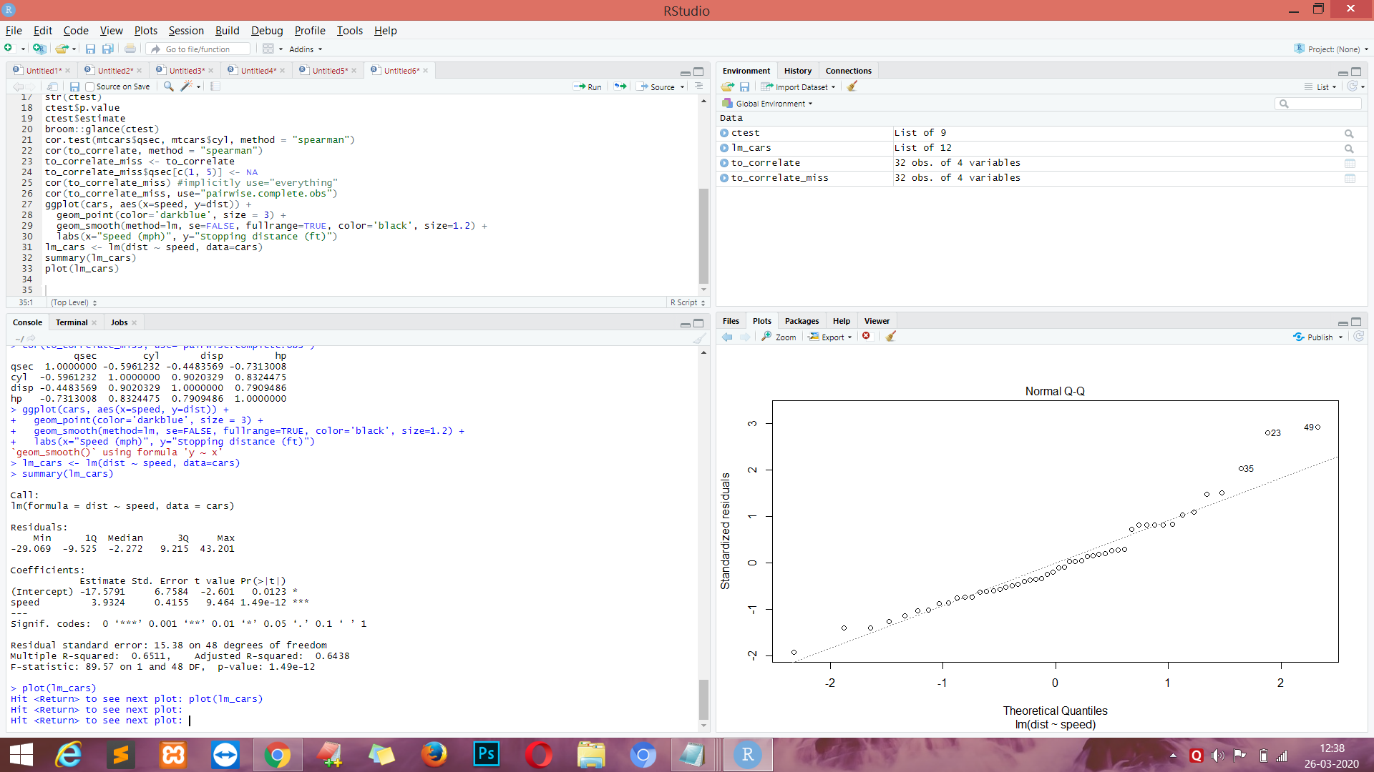

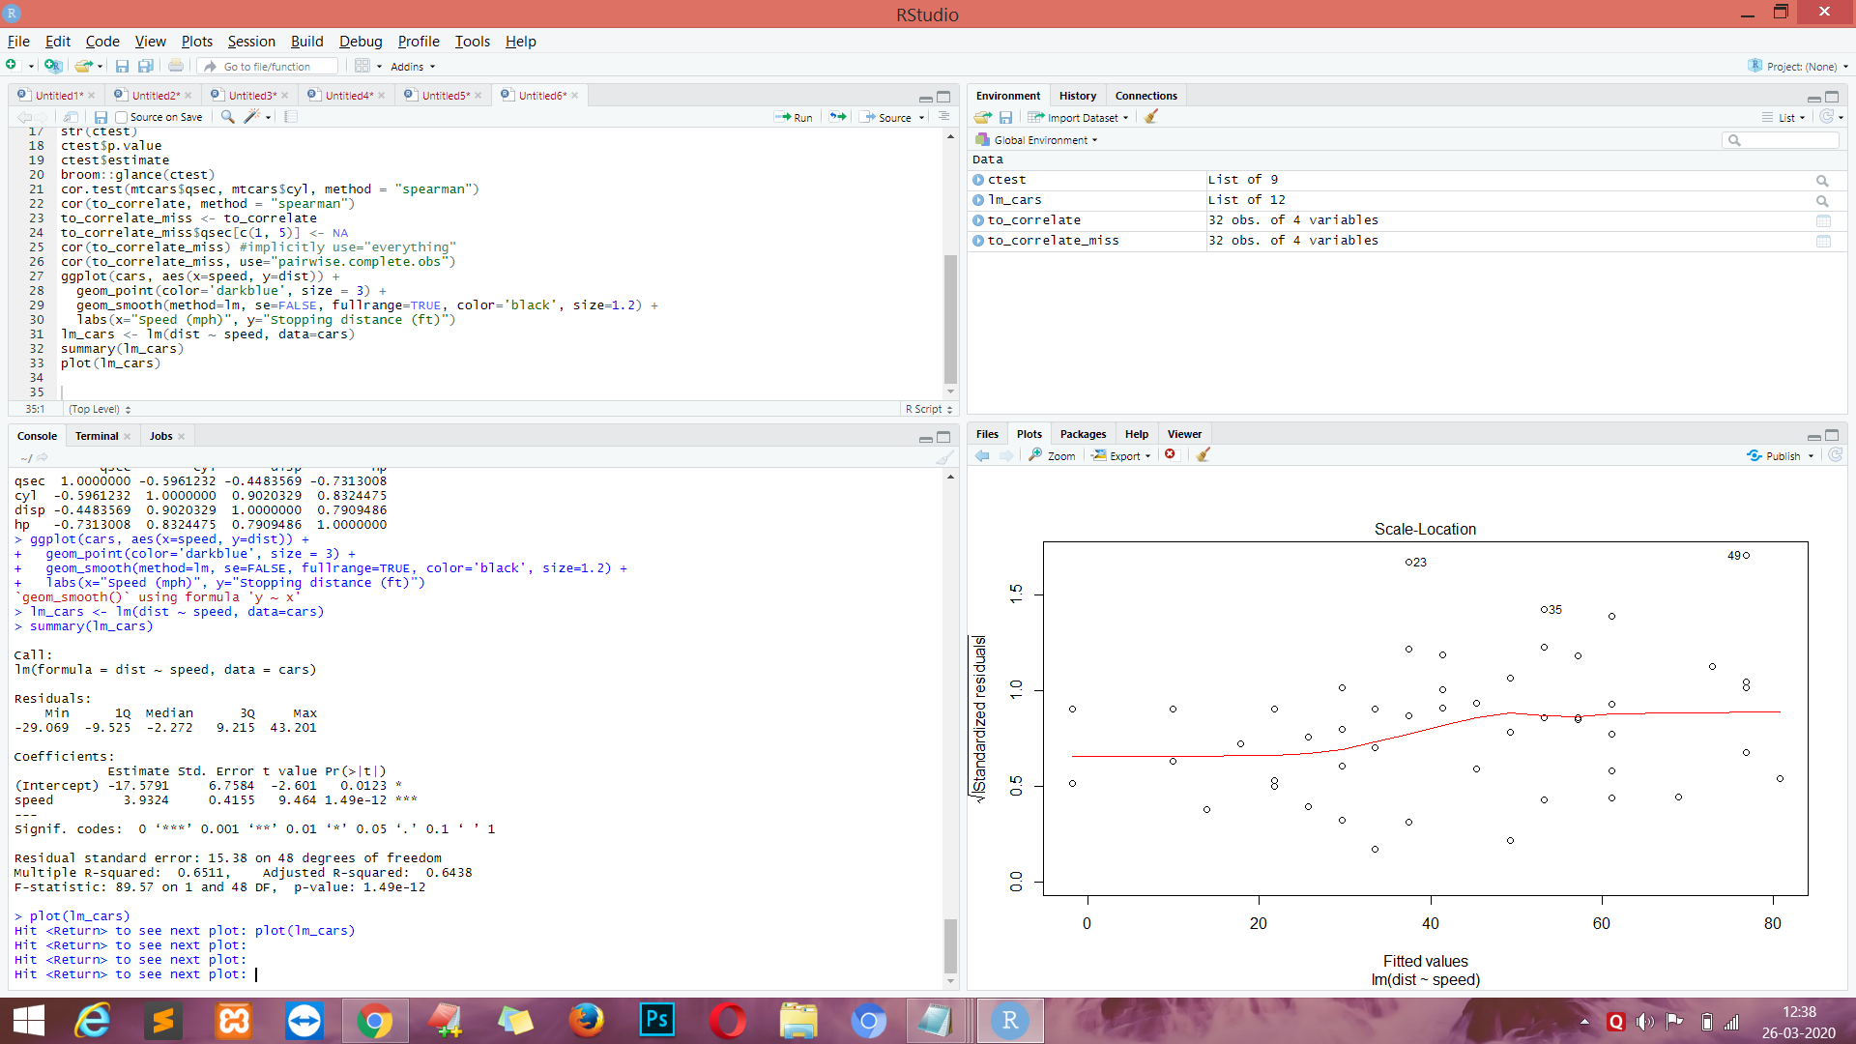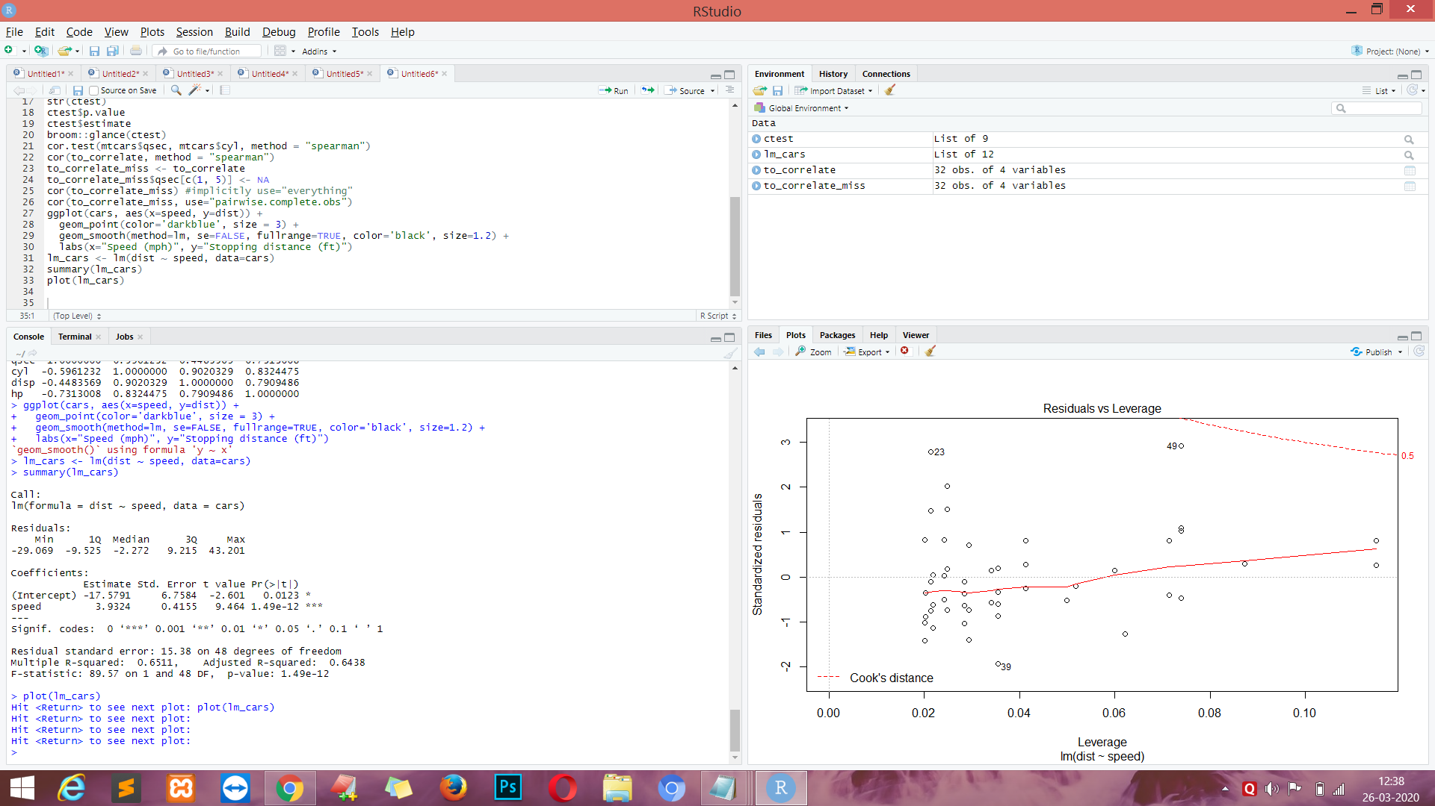

**CODE :-**

autoplot(lm_cars)

system.time(lm_cars.boot <- Boot(lm_cars, R=2000))

install.packages("boot")

summary(lm_cars.boot, high.moments=TRUE)

confint(lm_cars.boot, level=.95, type="bca")

hist(lm_cars.boot, legend="separate")

**OUTPUT :-**

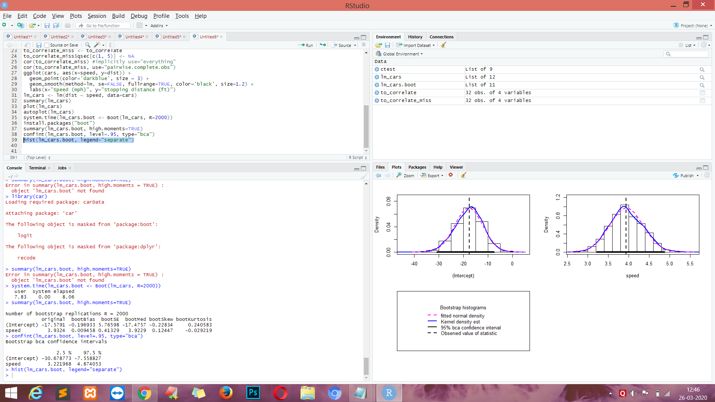

**CODE :-**

mpg_model <- lm(mpg ~ hp + am, mtcars)

summary(mpg_model)

ggplot(mtcars, aes(x=hp, y=mpg, color=factor(am))) + geom_point() + stat_smooth(method=lm, se=FALSE)

**OUTPUT :-**

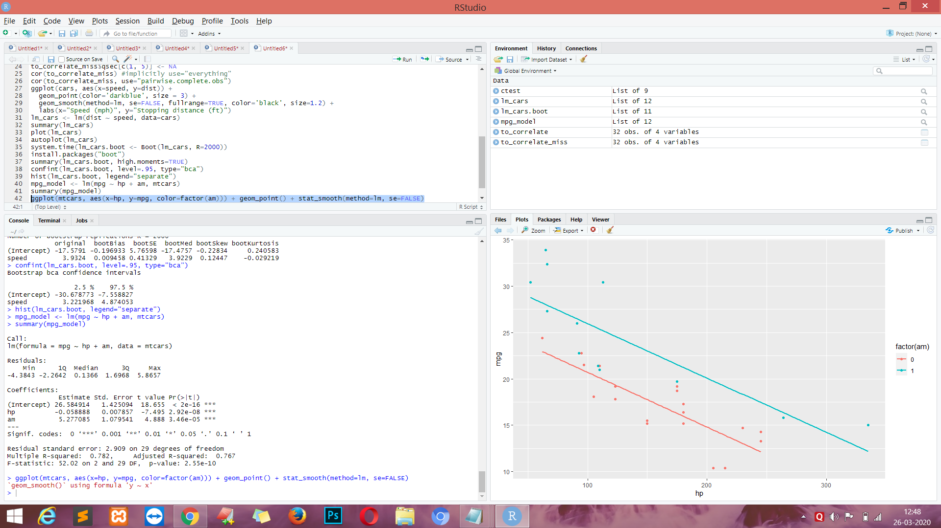

**CODE :-**

broom::glance(mpg_model)

broom::tidy(mpg_model)

int_model <- lm(mpg ~ hp*wt + am, mtcars)

summary(int_model)

#handy 2-way interaction plotting function from jtools.

interact_plot(int_model, pred = "hp", modx = "wt")

data(pigs, package="emmeans")

pigs <- pigs %>% mutate(log_conc=log(conc), percent_fac=factor(percent))

pigs.lm <- lm(log_conc ~ source + percent_fac, data = pigs)

summary(pigs.lm)

pigs.emm.s <- emmeans(pigs.lm, "source")

print(pigs.emm.s)

pigs.emm.p <- emmeans(pigs.lm, "percent_fac")

print(pigs.emm.p)

print(emmeans(pigs.lm, ~source*percent_fac))

pig_pairs <- pairs(pigs.emm.s)

print(pig_pairs)

pigs.emm.s@linfct

pig_pairs@linfct

plot(pigs.emm.s, comparisons = TRUE)

**OUTPUT :-**

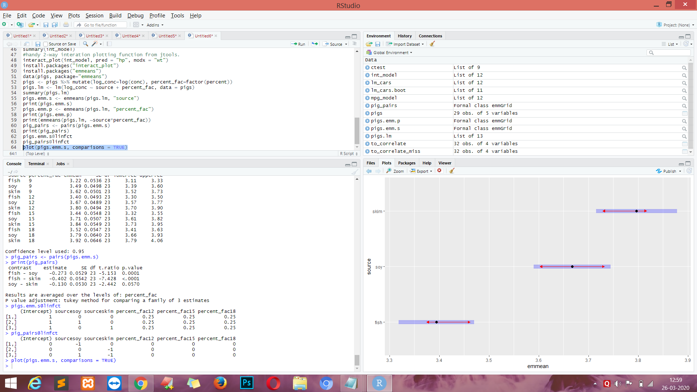

**CODE :-**

fitiris <- lm(Petal.Length ~ Petal.Width * Species, data = iris)

summary(fitiris)

car::Anova(fitiris, type="III") #overall effects of predictors in the model

plot(fitiris, pred = "Petal.Width", modx = "Species")

emmeans(fitiris, ~Species)

pairs(emmeans(fitiris, ~Species))

summary(emtrends(model = fitiris, ~Species, var="Petal.Width"), infer=TRUE)

pairs(emtrends(model = fitiris, ~Species, var="Petal.Width"))

pigs.emm.p <- emmeans(pigs.lm, "percent_fac")

ply <- contrast(pigs.emm.p, "poly")

ply

coef(ply) #show the contrast coefficients

org.int <- lm(cbind(sales1, sales2) ~ price1 * price2 + day + store, data = oranges)

summary(org.int)

emtrends(org.int, pairwise ~ variety, var = "price1", mult.name = "variety")

**OUTPUT :-**

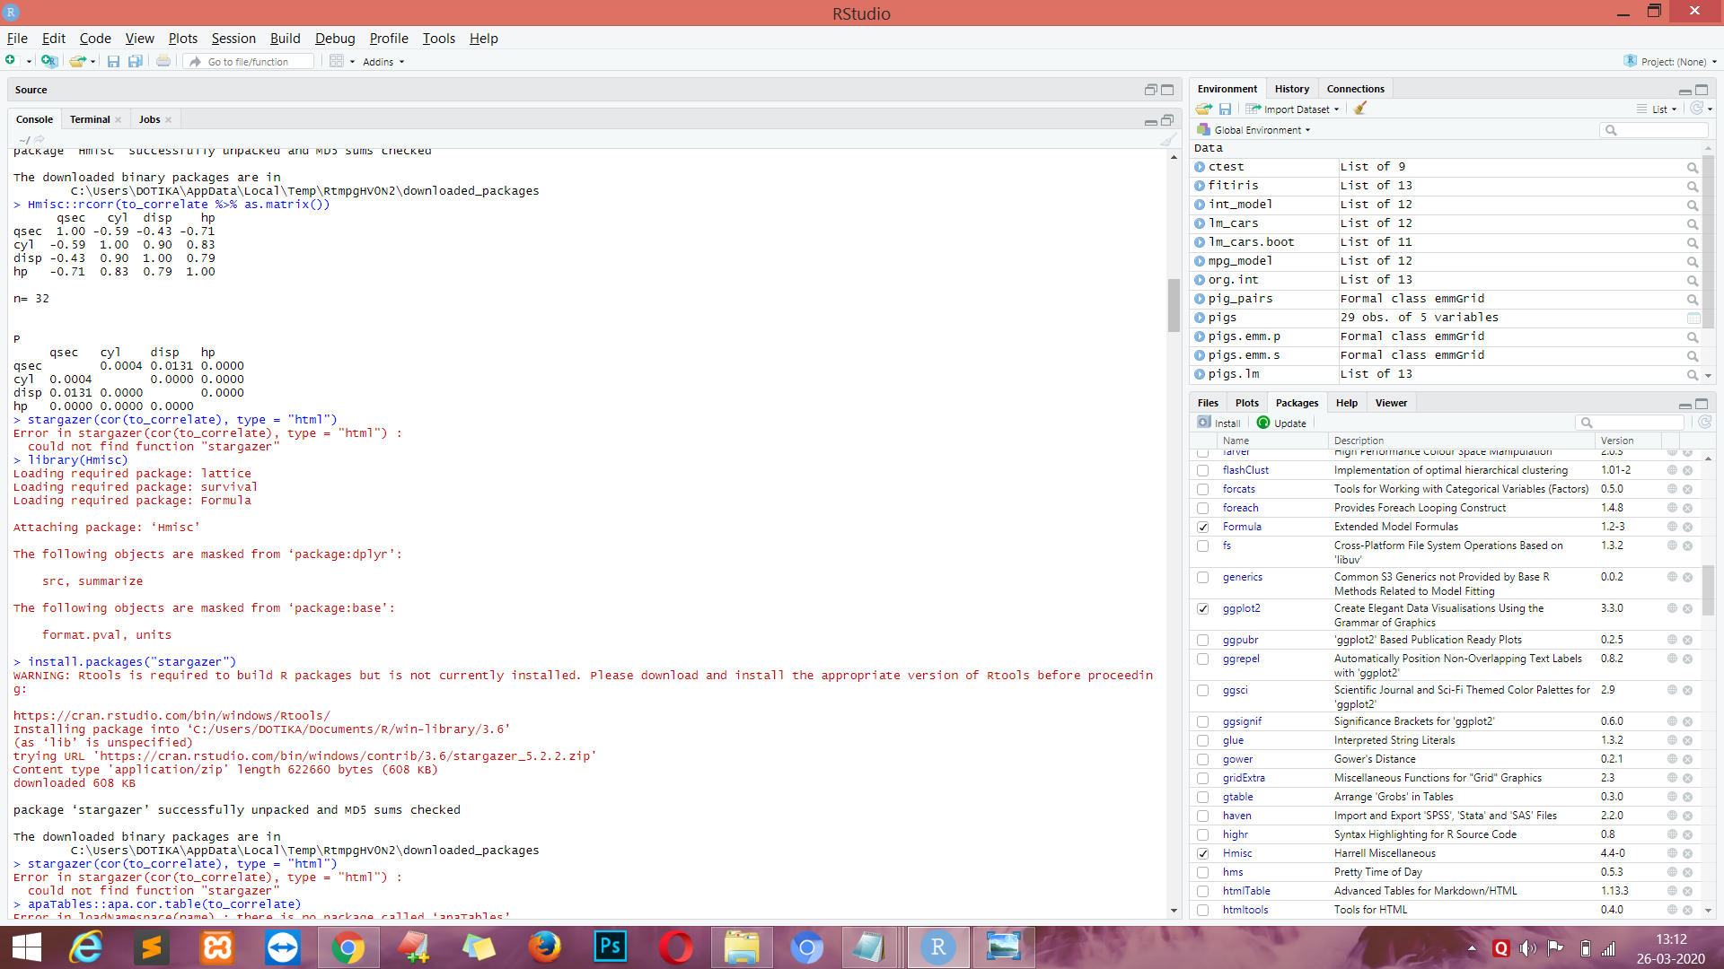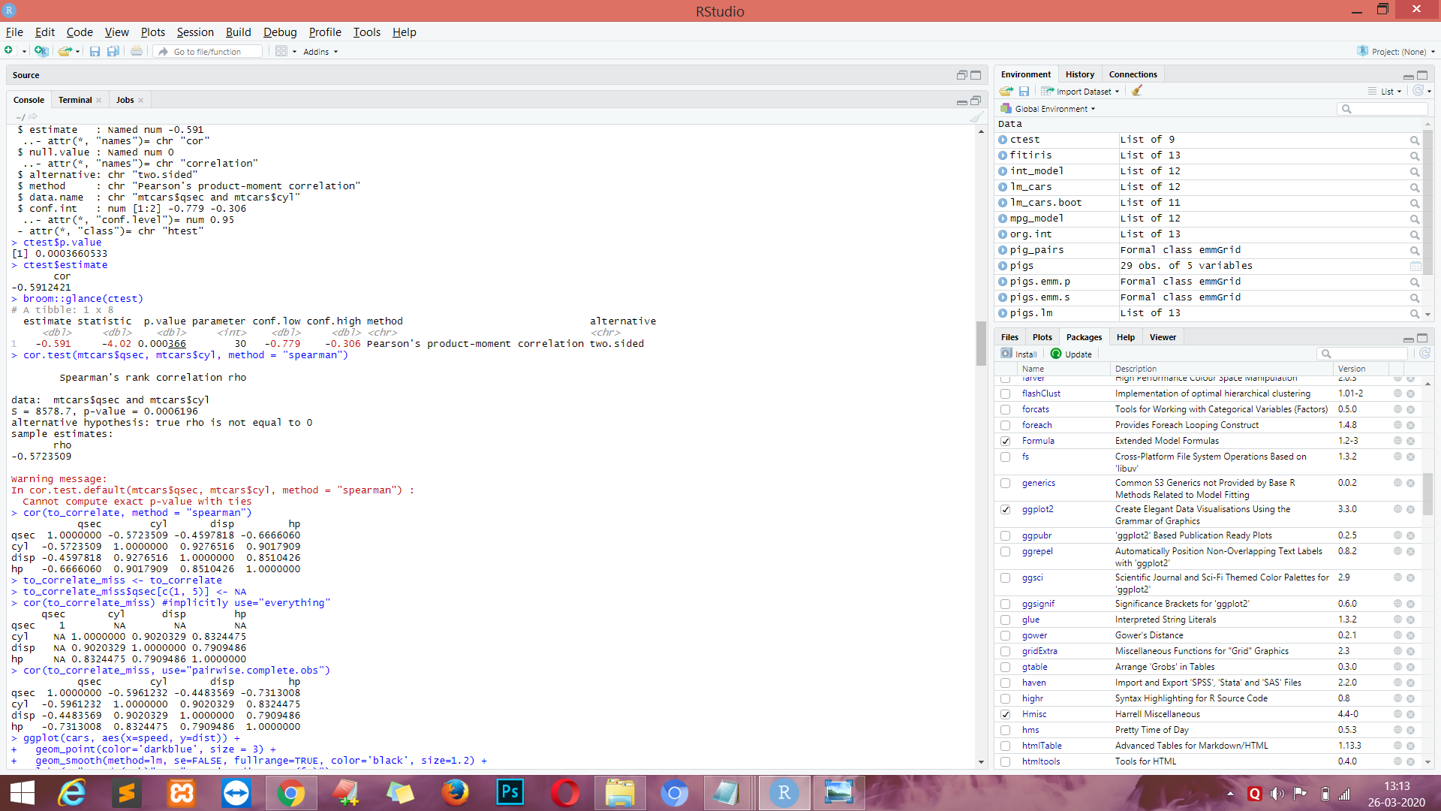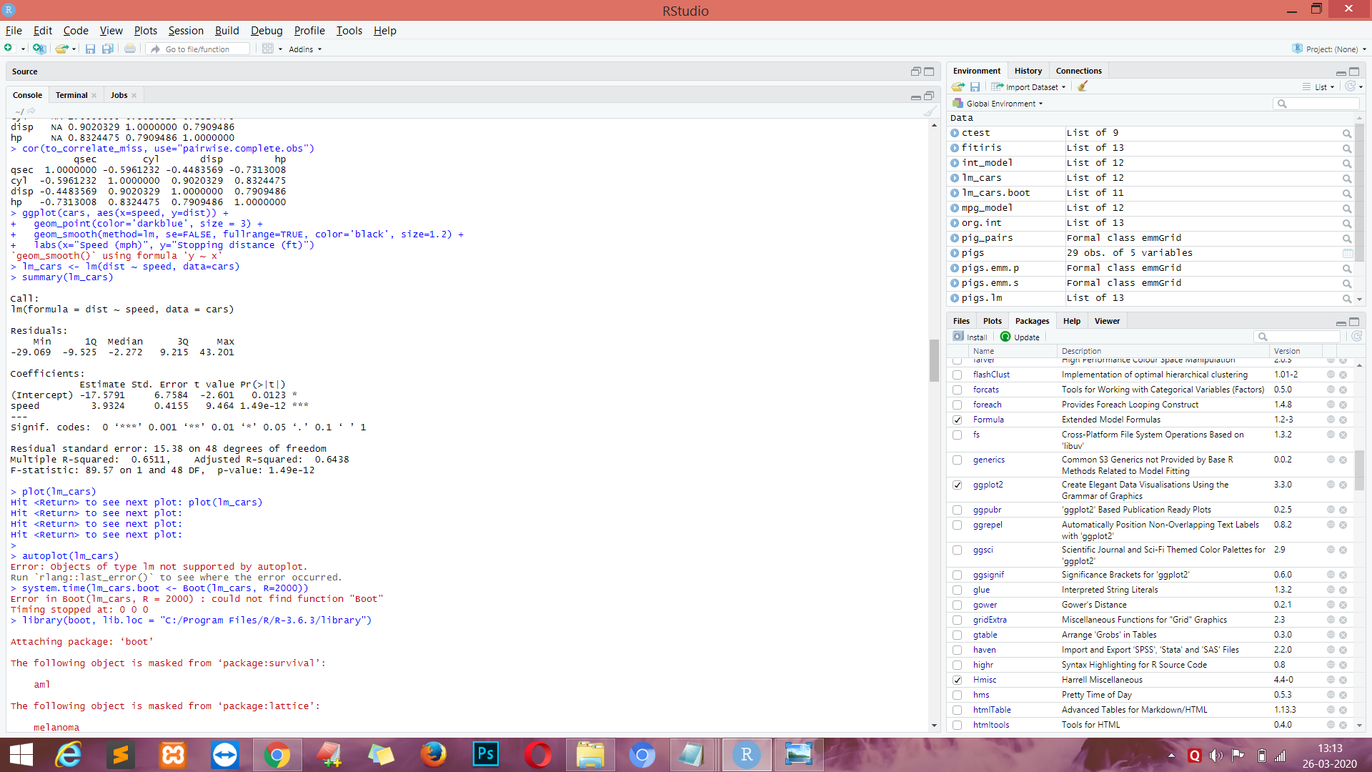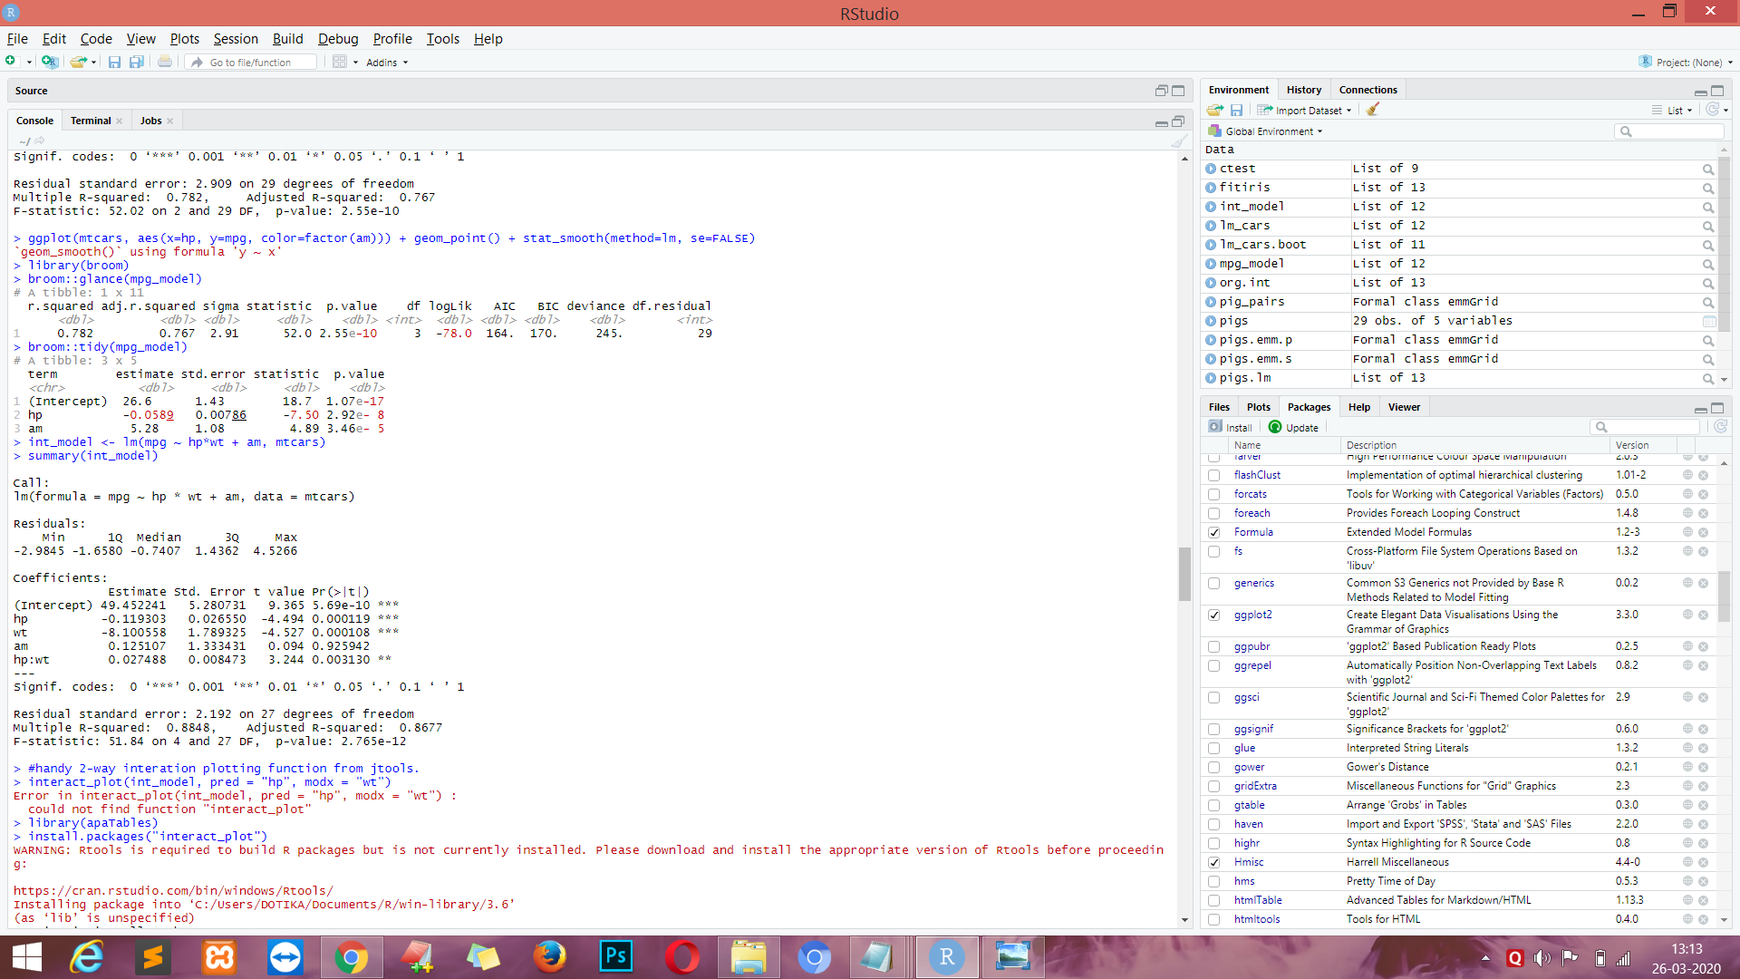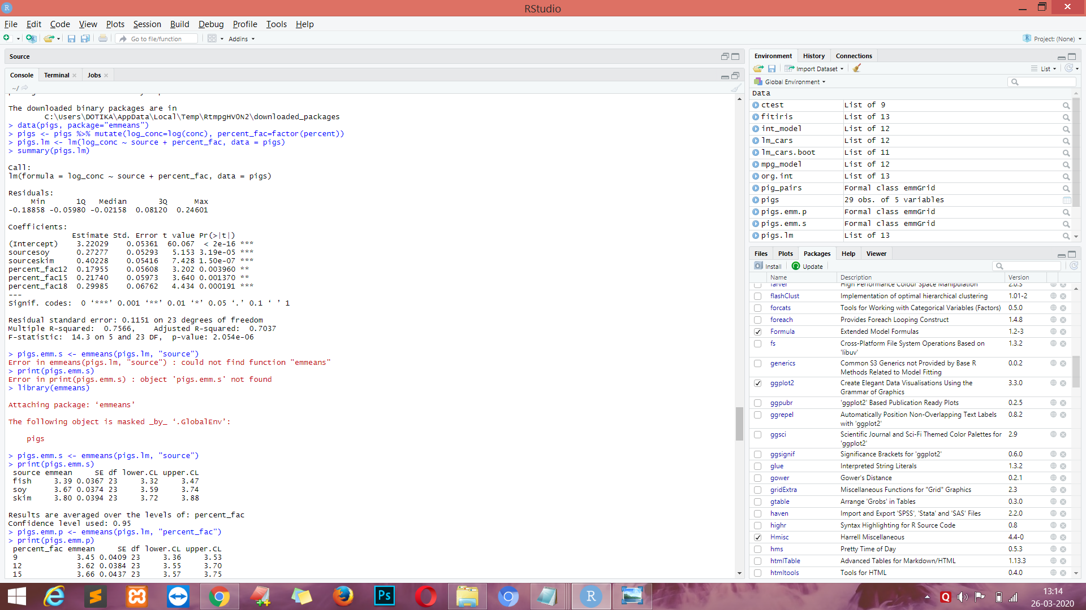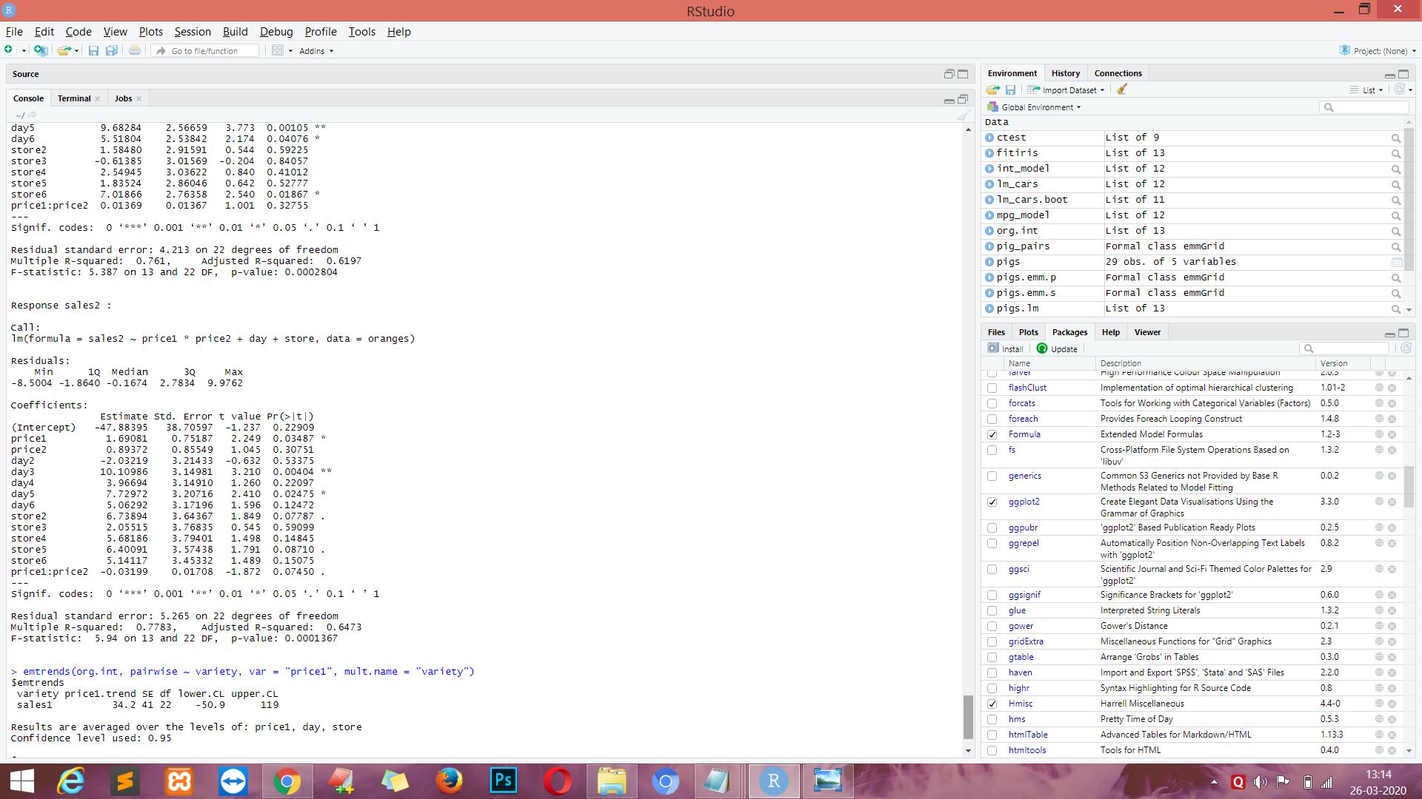

**EXPERIMENT NO. 10**

**AIM :-** Clustering in R- K mean

**Theory :-**

Clustering is a technique of data segmentation that partitions the data into several groups based on their similarity.

Basically, we group the data through a statistical operation. These smaller groups that are formed from the bigger data are known as clusters. These cluster exhibit the following properties:

* They are discovered while carrying out the operation and the knowledge of their number is not known in advance.
* Clusters are the aggregation of similar objects that share common characteristics.

Clustering is the most widespread and popular method of Data Analysis and Data Mining. It is used in cases where the underlying input data has a colossal volume and we are tasked with finding similar subsets that can be analysed in several ways.

**CODE :-**

install.packages("tidyverse")

install.packages("cluster")

install.packages("factoextra")

install.packages("gridExtra")

#Author DataFlair

library(tidyverse)

library(cluster)

library(factoextra)

library(gridExtra)

data('USArrests')

d_frame <- USArrests

d_frame <- na.omit(d_frame) #Removing the missing values

d_frame <- scale(d_frame)

**OUTPUT :-**

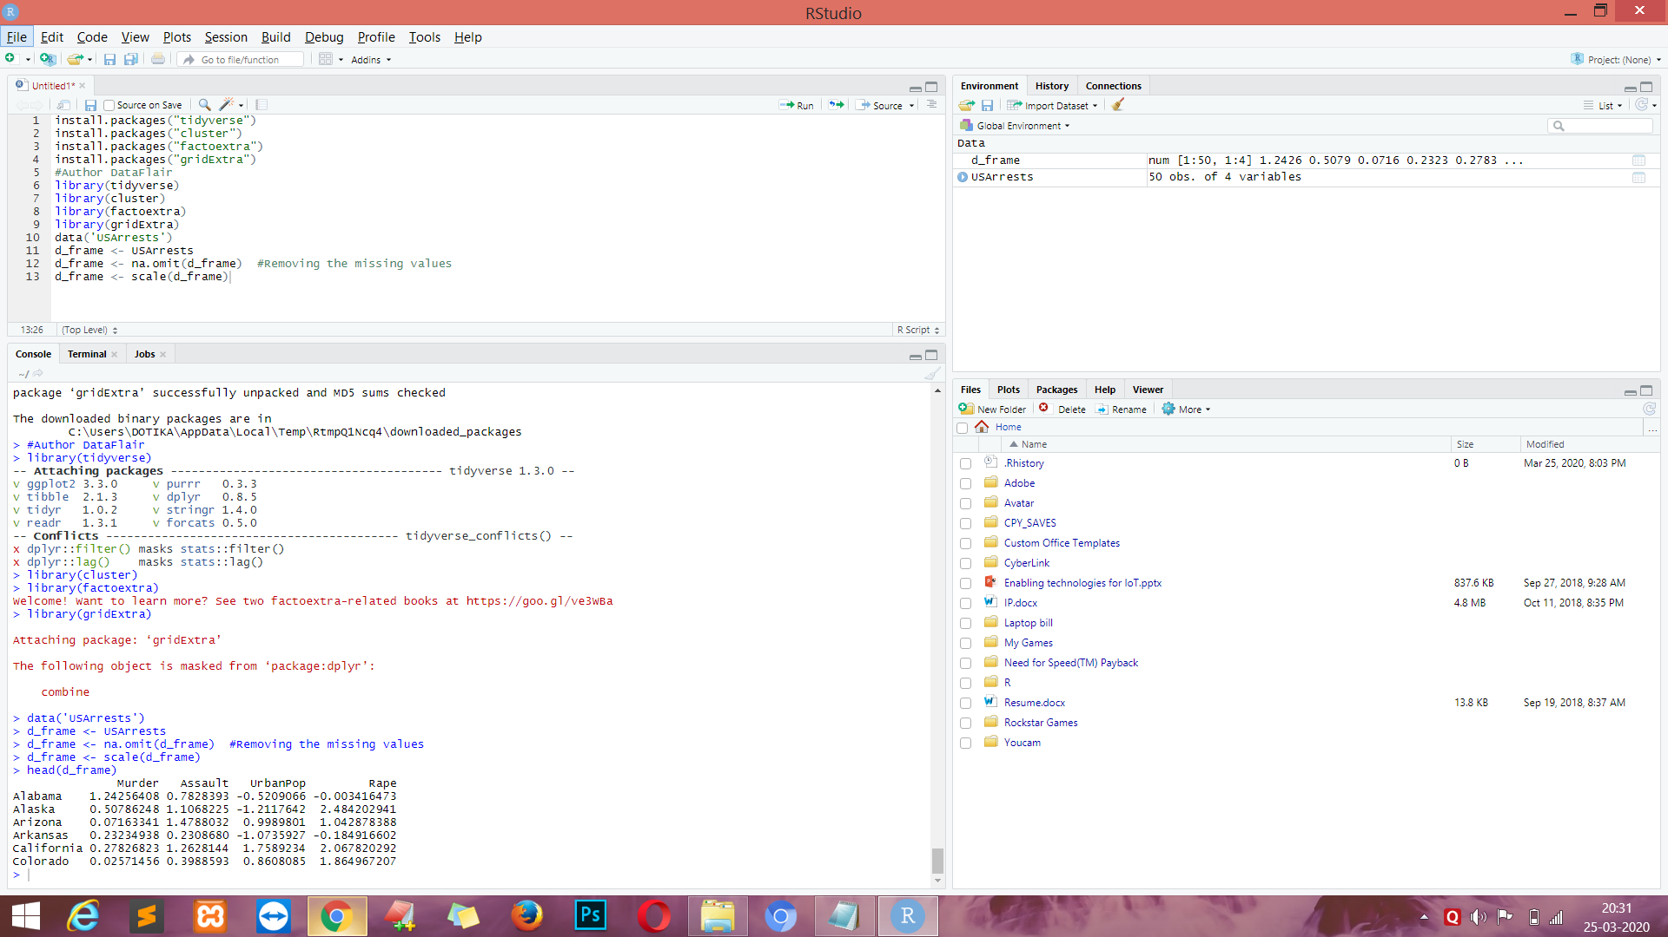

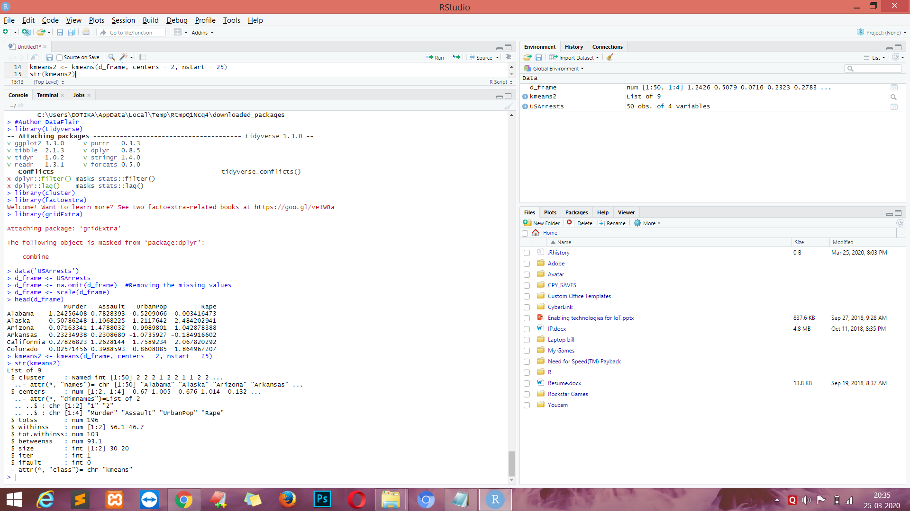

**CODE :-**

kmeans2 <- kmeans(d_frame, centers = 2, nstart = 25)

str(kmeans2)

fviz_cluster(kmeans2, data = d_frame)

**OUTPUT :-**

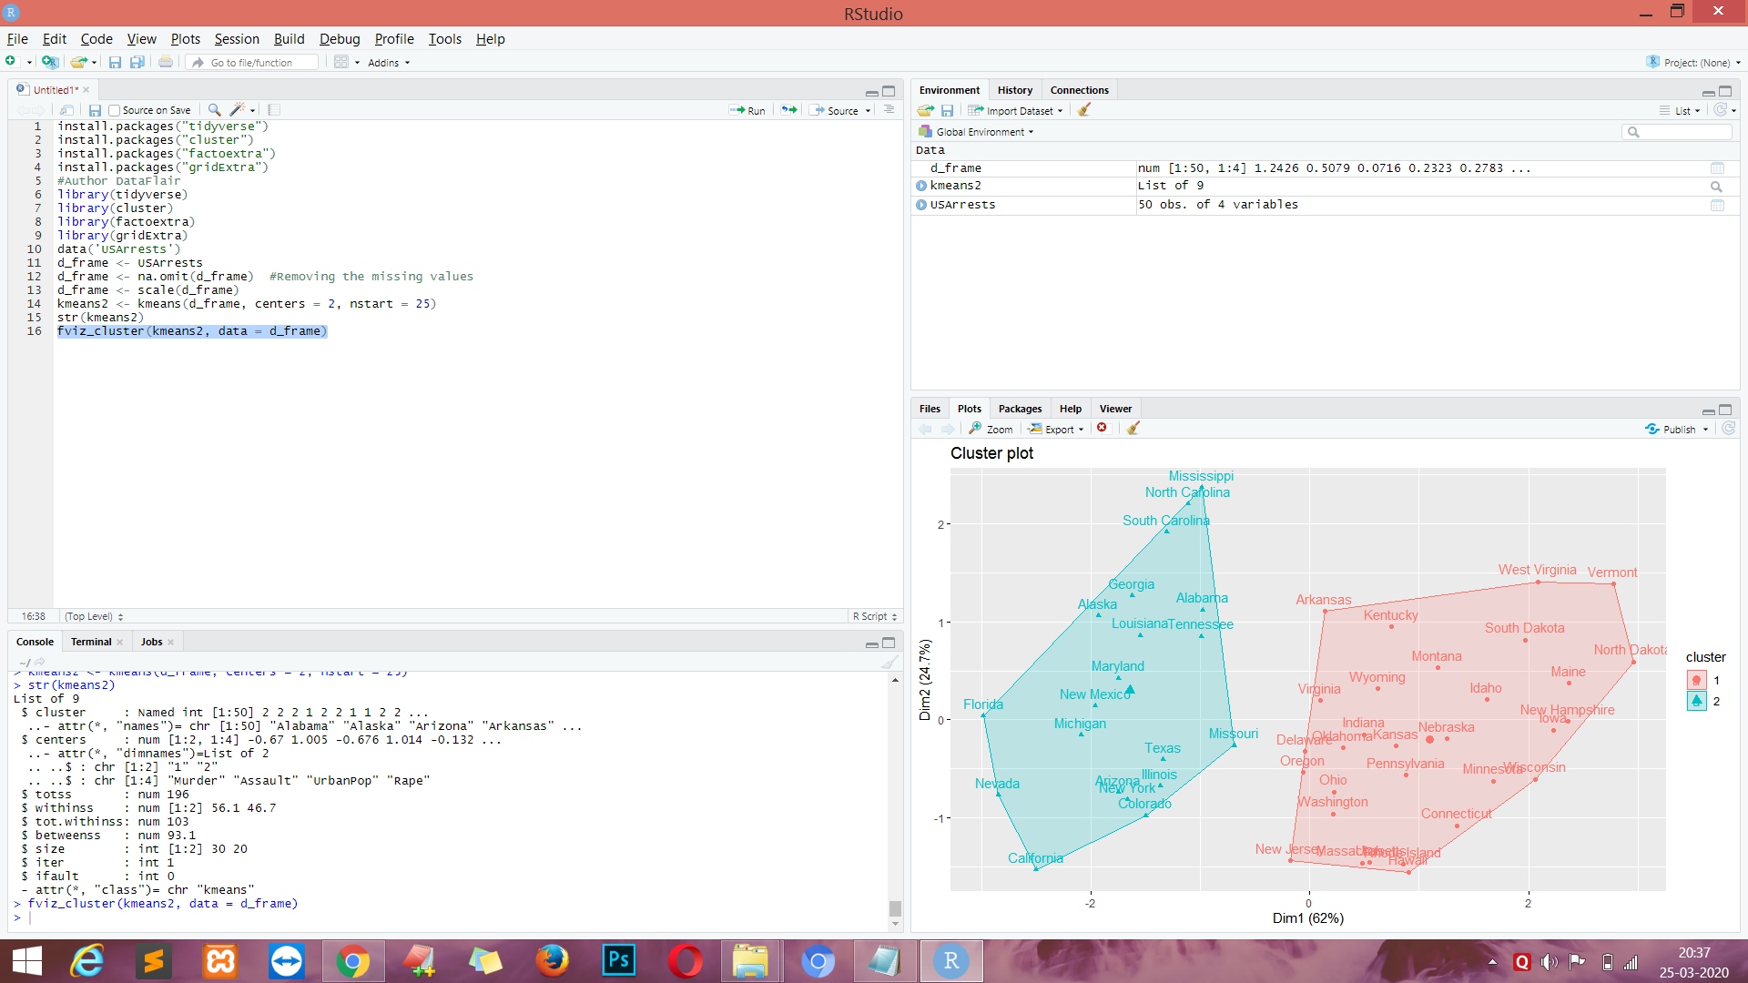

**CODE :-**

kmeans3 <- kmeans(d_frame, centers = 3, nstart = 25) #DataFlair

kmeans4 <- kmeans(d_frame, centers = 4, nstart = 25)

kmeans5 <- kmeans(d_frame, centers = 5, nstart = 25)

#Comparing the Plots

plot1 <- fviz_cluster(kmeans2, geom = "point", data = d_frame) + ggtitle("k = 2")

plot2 <- fviz_cluster(kmeans3, geom = "point", data = d_frame) + ggtitle("k = 3")

plot3 <- fviz_cluster(kmeans4, geom = "point", data = d_frame) + ggtitle("k = 4")

plot4 <- fviz_cluster(kmeans5, geom = "point", data = d_frame) + ggtitle("k = 5")

grid.arrange(plot1, plot2, plot3, plot4, nrow = 2)

**OUTPUT :-**

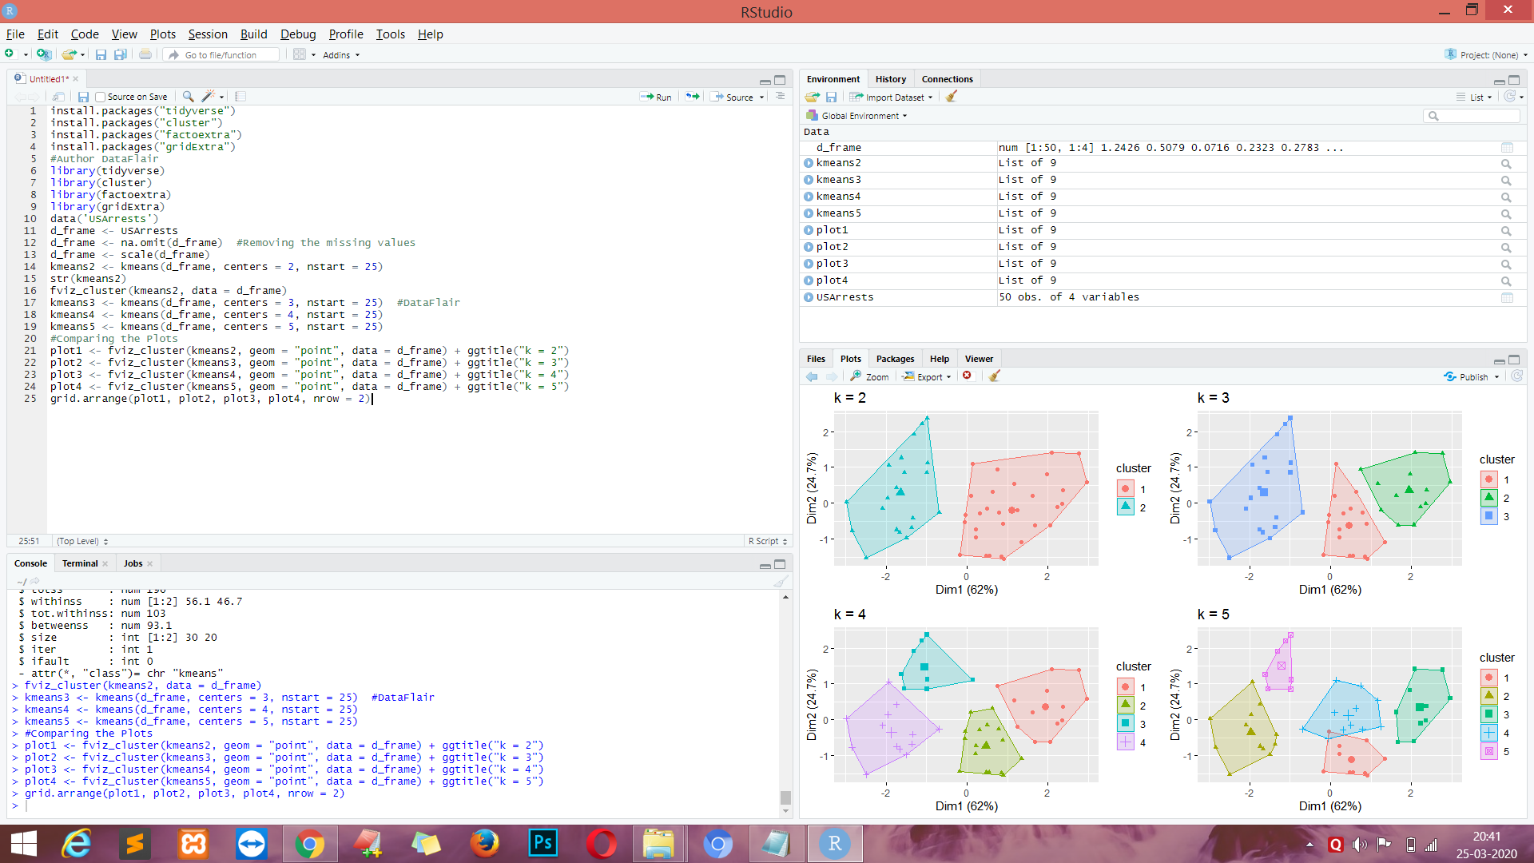

**EXPERIMENT NO. 11**

**AIM :-** Classification on Large & Noisy data set with R - Logistic regression , noise

Bayers.

**CODE :-**

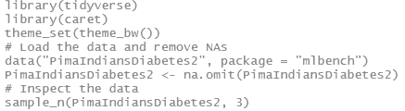

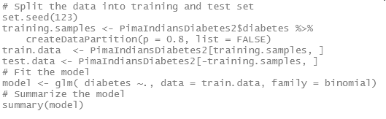

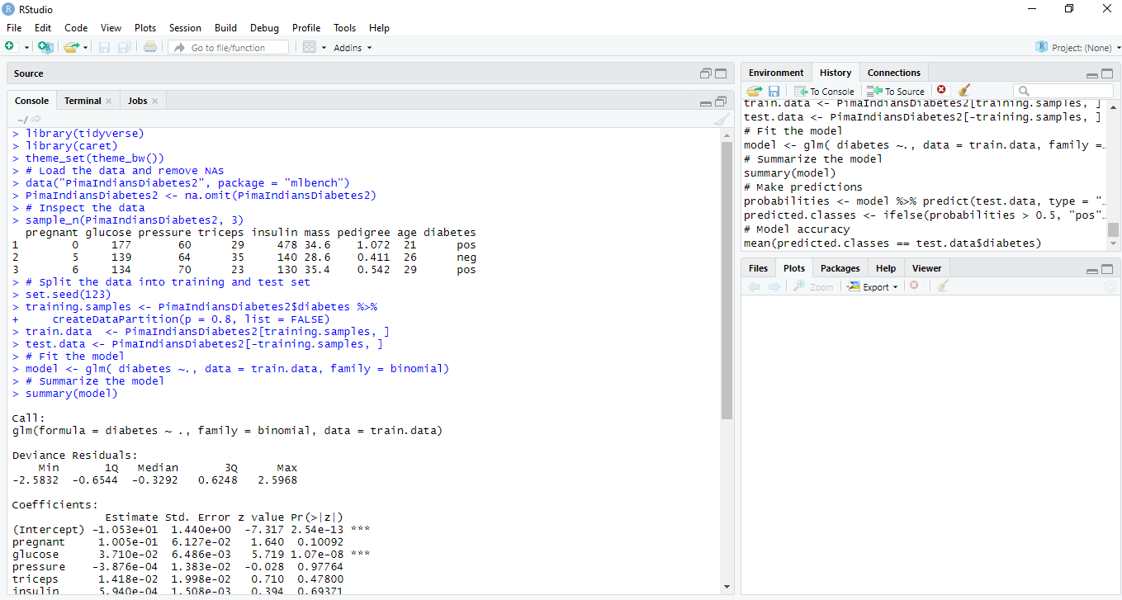

**CODE :-**

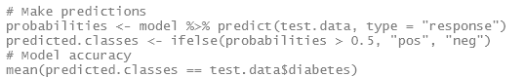

**OUTPUT :-**

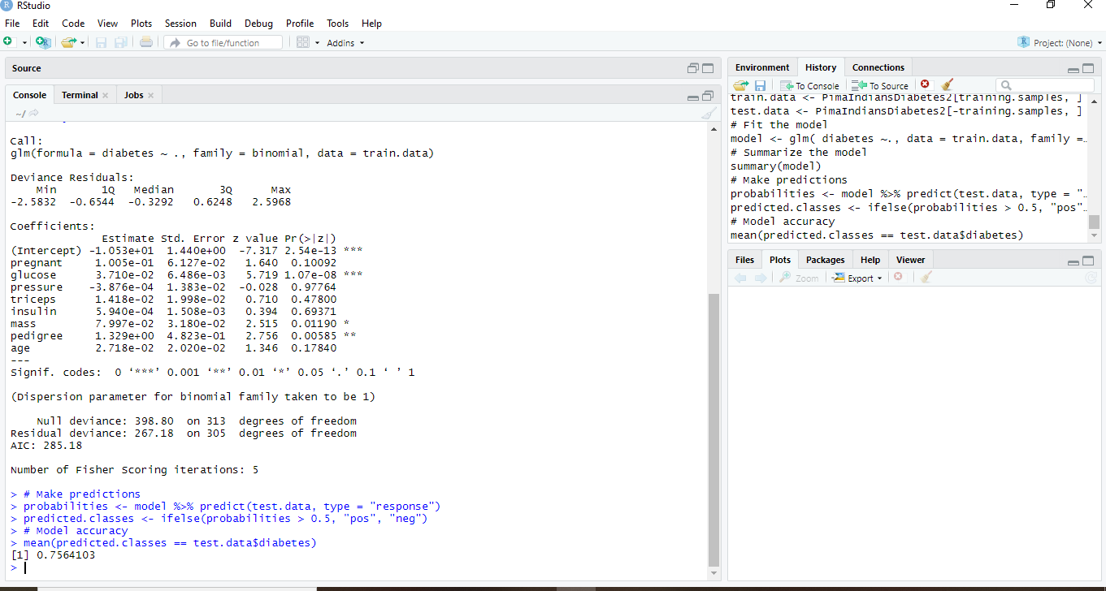

**CODE :-**

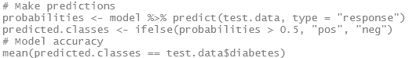



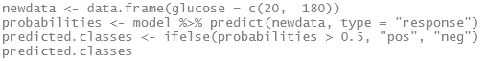

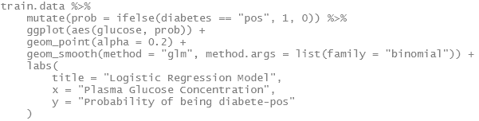

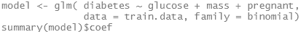

**OUTPUT :-**

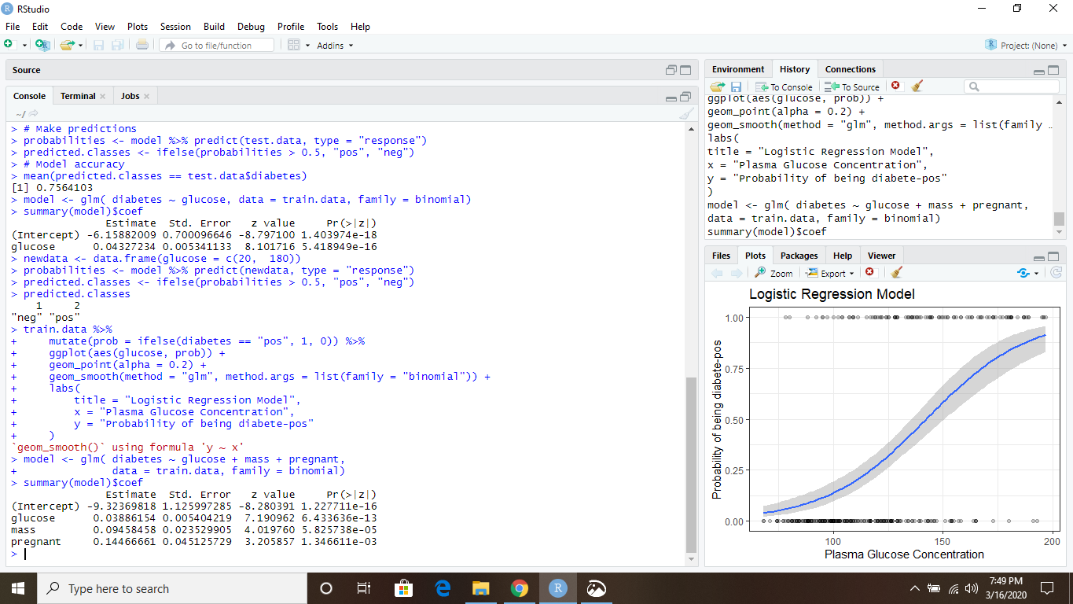

**CODE :-**







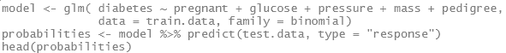

**OUTPUT :-**

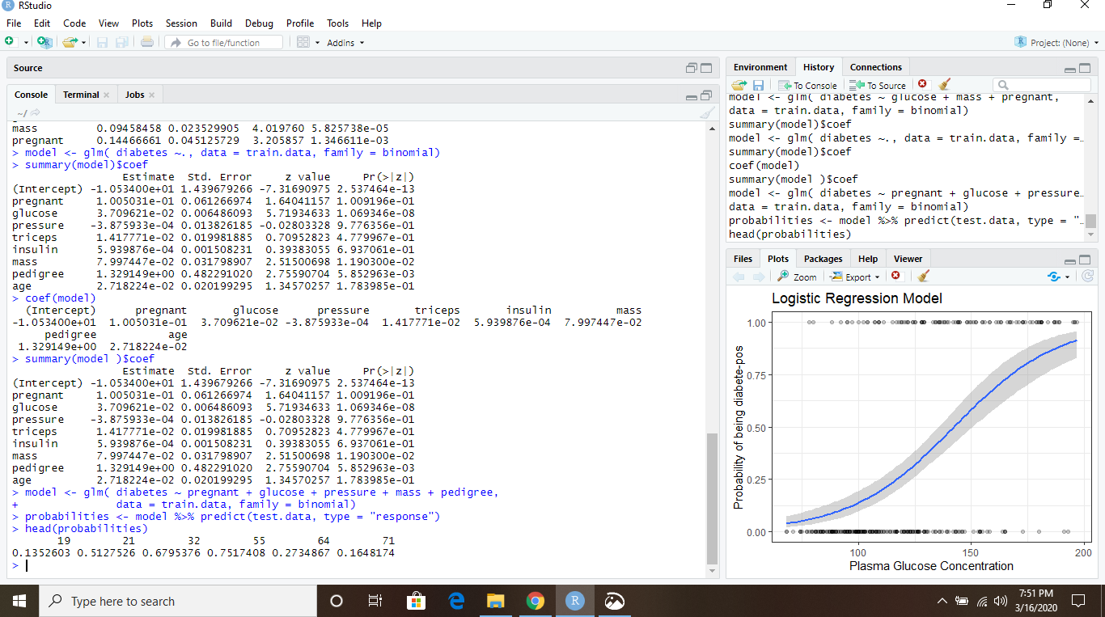

**CODE :-**

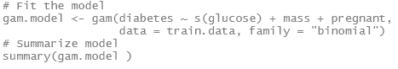

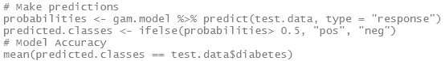

**OUTPUT :-**

